COVID-19 Data Project Analysis

# Introduction

At the beginning of this year 2020, a newly discovered coronavirus disease (COVID-19), which is an infectious and severe disease, is spreading all over the world. [Wuhan](https://en.wikipedia.org/wiki/Wuhan), China is the first identified place in the world to breakout COVID-19 in December 2019. The first identified COVID-19 case in United States is announced in January, 2020 and the first known deaths is recorded in February, 2020. As of May 21, 2020, the public announces that United States has the most confirmed active cases and deaths of COVID-19 in the world. Also, the death rate, which is the ninth-highest rate globally, recorded in public is 285 per million people. The US Centers for Disease Control and Prevention (CDC) updated the official statistics weekly. It provides the dataset of deaths and confirmed cases involving coronavirus disease (COVID-19) by age group, sex and state. The dataset is made available to researchers and the general public. I collect the data from the CDC website, cleaned and merged the data together to create the train and test datasets. My analysis will focus on Data Mining and Knowledge Discovery in prediction of factors affecting deaths of COVID-19 and do comparison of the performance of the approaches I applied.

My research question is to identify and quantify factors which impact the deaths of various factor types such as age, sex, state and so on by using R programming language. The data I collected is recorded from the beginning of February 2020 to the end of May 2020 from CDC website. Techniques for analyzing the project will include data cleaning of real-world dataset, exploratory analysis to identify relevant factors, anomaly detection, logistic regression, association rule, linear regression, clustering, classification, patterns and recommendation. I will apply RStudio as machine learning tools for statistical analysis and visualization analysis to create a predictive and recommender system.

# Literature Review

Covid-19 is a new disease, we need to better understand the factors to cause the death of it. This report is used to analyze and identify and quantify factors that affect the deaths of Covid-19, such as age, sex, state as well as some health conditions.

**Literature about Covid-19:**

* University of Oxford, May 7, 2020. "Risk factors for COVID-19 death revealed in world's largest analysis of patient records." Accessed on 5 June, 2020.

<https://medicalxpress.com/news/2020-05-factors-covid-death-revealed-world.html>

* This article summarizes that Asian and Black ethnic have more risk of death of Covid-19 than White people. Their results also showed that older men with uncontrolled diabetes and people with severe asthma have higher risk of death of Covid-19.
* Adam Y Li, Theodore C Hannah, John Durbin, Nickolas Dreher, Fiona M McAuley, Naoum Fares Marayati, Zachary Spiera, Muhammad Ali, Alex Gometz, JT Kostman, Tanvir F Choudhri, doi: https://doi.org/10.1101/2020.04.17.20069708, April 24, 2020. COVID-19 SARS-CoV-2 preprints from medRxiv and bioRxiv. "Multivariate Analysis of Factors Affecting COVID-19 Case and Death Rate in U.S. Counties: The Significant Effects of Black Race and Temperature." Accessed on 5 June, 2020.

<https://www.medrxiv.org/content/10.1101/2020.04.17.20069708v2>

* This article uses all U.S. counties publicly available data sources through April 14th, 2020. They applied t-tests, adjusted linear, multivariate regression analyses and logistic regression analyses. The result shows that black race has a higher risk than other factors. I can use this article’s statistical methods as the reference to perform my data analysis.
* Lauran Neergaard, updated March 29, 2020 1:34 pm. The Associated Press. "Coronavirus: Age isn’t the only factor in COVID-19 severity, experts say." Accessed on 5 June, 2020.

<https://globalnews.ca/news/6747664/coronavirus-age-risk-disease-severity-covid/>

* This article shows that men have higher risk affect than women. Heart disease, diabetics, asthma and hormones all are at particular risk with COVID-19.
* Rong-Hui Du, Li-Rong Liang, Cheng-Qing Yang, Wen Wang, Tan-Ze Cao, Ming Li, Guang-Yun Guo, Juan Du, Chun-Lan Zheng, Qi Zhu, Ming Hu, Xu-Yan Li, Peng Peng, Huan-Zhong Shi European Respiratory Journal 2020; DOI: 10.1183/13993003.00524-2020, March 30, 2020. "Predictors of Mortality for Patients with COVID-19 Pneumonia Caused by SARS-CoV-2: A Prospective Cohort Study." Accessed on 5 June, 2020.

<https://erj.ersjournals.com/content/early/2020/04/01/13993003.00524-2020>

* This article uses univariate and multivariate logistic regression to explore the association of clinical characteristics and laboratory parameters and the risk for death. The article applied descriptive statistics such as frequency analysis (percentages) for categorical variables and means ± standard deviations or medians and interquartile ranges (IQRs) for continuous variables. The comparison tests were determined by Student's t-test or Mann-Whitney U test for continuous variables and by the use of the Chi-square test or Fisher exact test for categorical variables. I keep this article because it can give me a good reference to apply statistical methods to do my data analysis.

# Dataset

I will use the CDC (Centers for Disease and Prevention) database. The website can be found here: https://data.cdc.gov/NCHS/Provisional-COVID-19-Death-Counts-by-Sex-Age-and-S/9bhg-hcku

Because this website updates the public data weekly, I only collected the data from the beginning of February 2020 to the end of May 2020. I will use the attributes of State, Sex, Age Group, COVID-19 Deaths, Pneumonia Deaths, Pneumonia and COVID-19 Deaths, Influenza Deaths as well as Pneumonia, Influenza, or COVID-19 Deaths in this project analysis.

The COVID-19 Deaths will provide to be the dependent variable for this analysis. The attributes of State, Sex, Age Group are independent variables. I am going to do the statistical analysis among State, Sex, Age Group, COVID-19 Deaths, Pneumonia Deaths and Influenza Deaths. I will also find out the relationship among them.

The following is the features’ descriptions. It helps to understand the meaning and usefulness for the data variables selections.

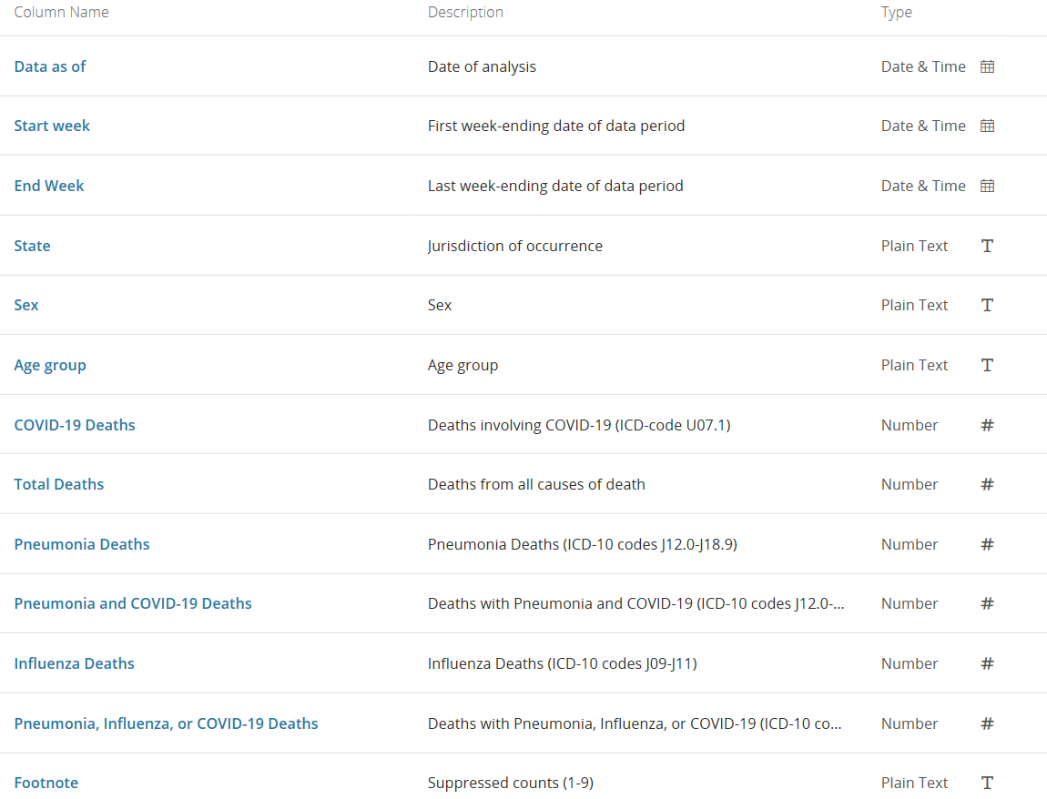

# Approach

Step 1

Initial Analysis

Step 3

Dimension Reduction

Step 2

Exploratory Analysis

Step 5

Evaluation Improving

Step 4

Design & Modeling

Step 6

Conclusions

# Data Analysis

**Step 1**: **Initial Analysis & Step 2: Exploratory Analysis**

I downloaded the data in CSV format to RStudio with the following summary and structure:

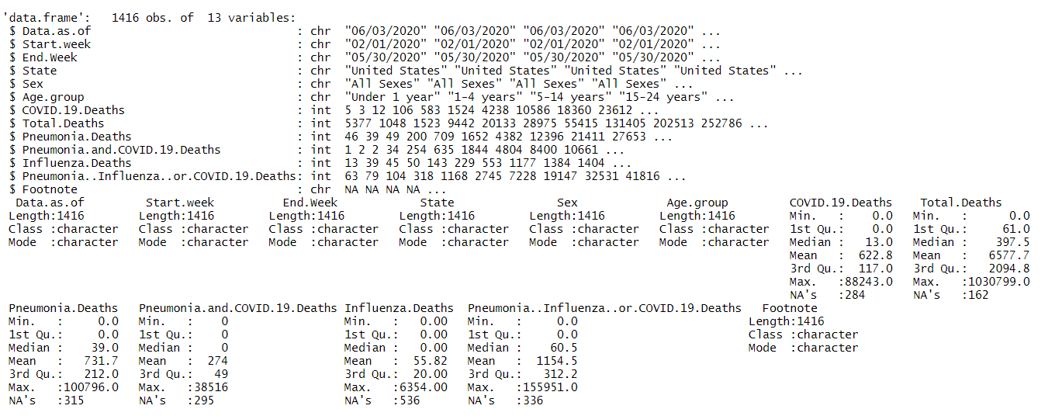

According to each feature’s description, the variables of “Data.as.of”, “Start.week” and “End.week” all have the same value for each of them; “Total.Deaths” and “Footnote” both are not quite useful to predict the target variable COVID.19.Deaths. Therefore, these 5 variables have been deleted. I make all character variables be as lower case and reassign them as factor data type. There are no duplicated rows in this dataset.

There are too many NA’s values in the numeric variables. The rules to impute inconsistency and missing values for each state in USA as following: the each state’s value of all sexes’ equals to the sum of female total and male total for each state. For each state, the result of the female/male total minus the available female /male values divided by the number of empty cells, and then the final result will be assigned to each empty cell. After imputing inconsistency and missing values for each state in USA, the following graphs are for whole USA COVID-19 deaths and other diseases’ deaths for all sexes, all males and all females.

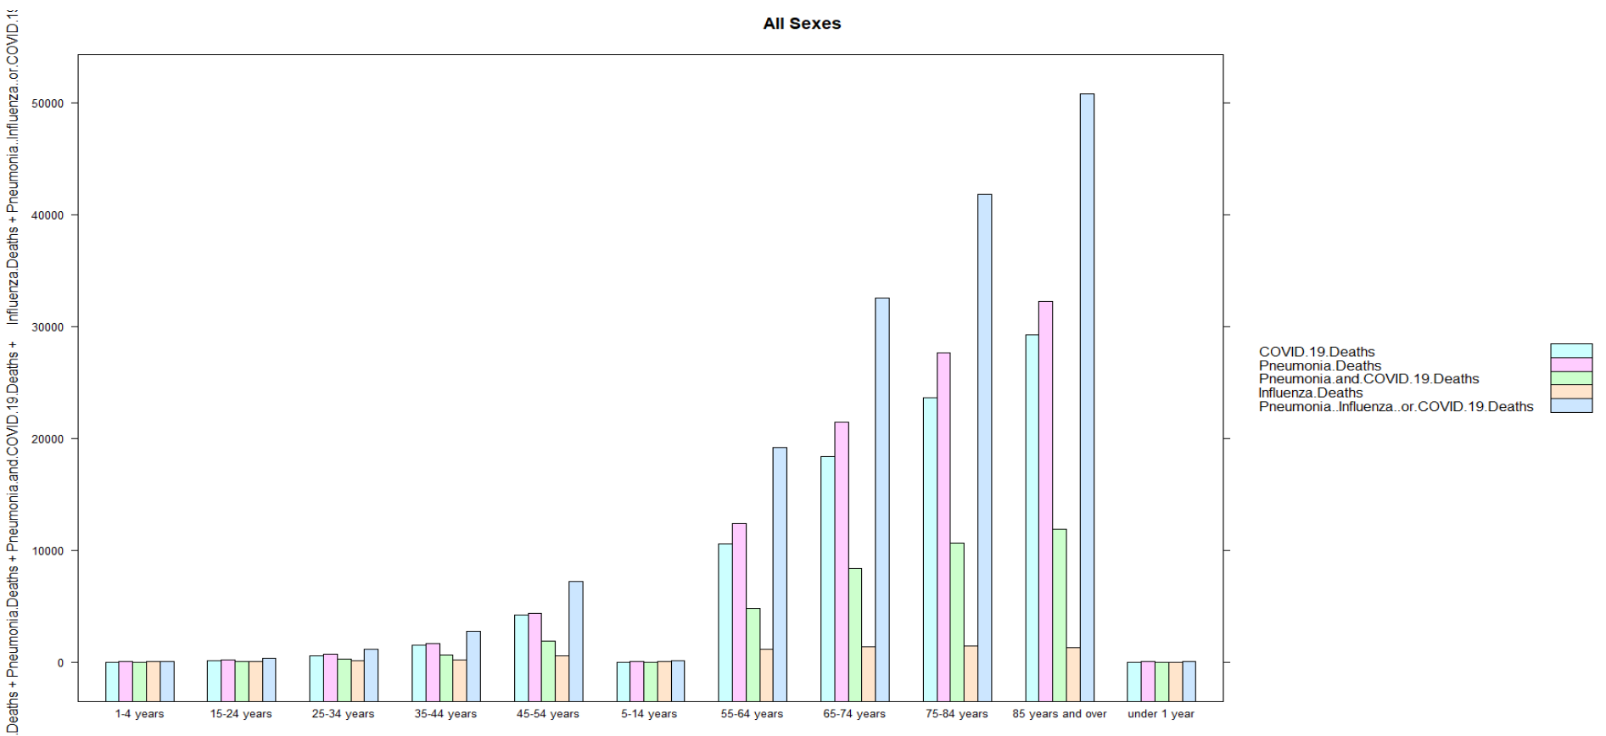

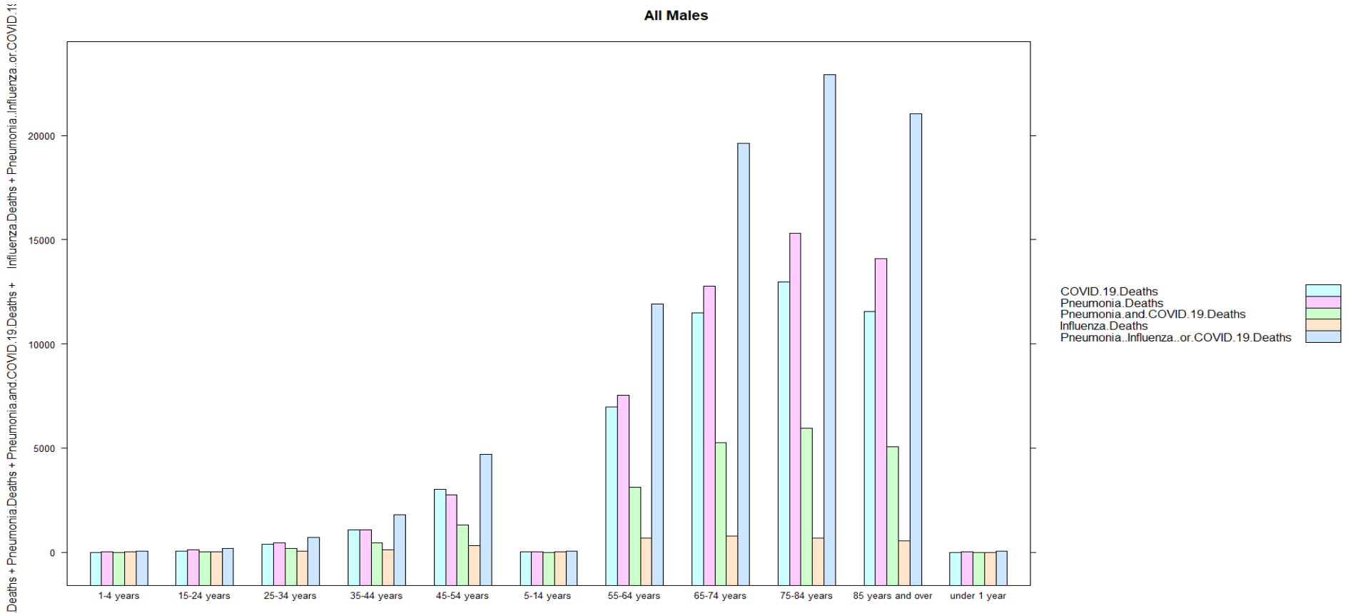

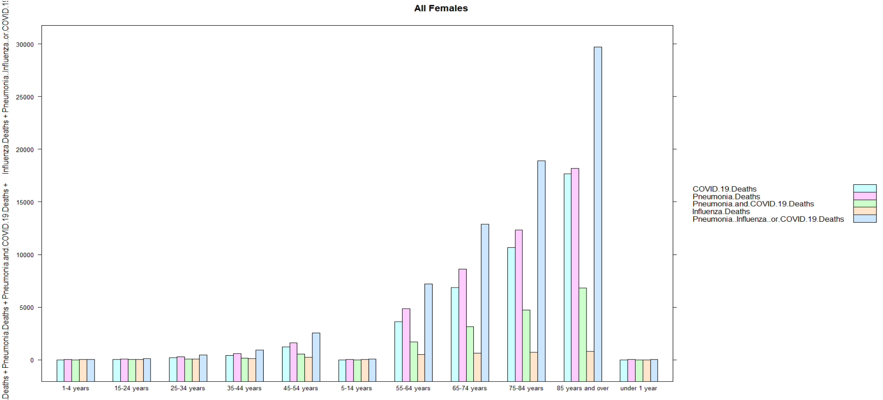

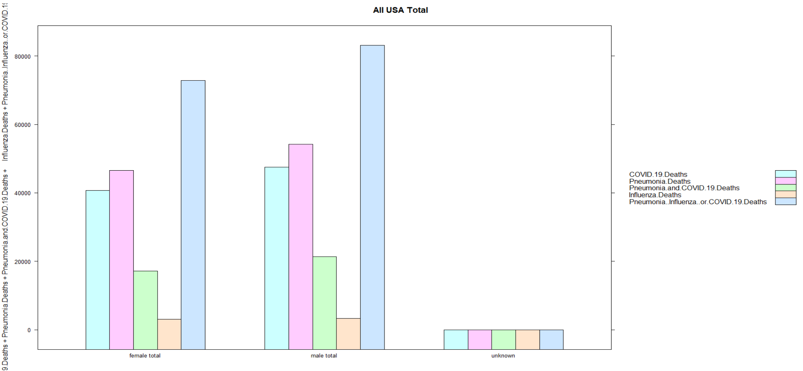

For all sexes in USA, the older the people, the higher number of deaths in COVID-19. For males, the age of 75-84 years has highest number of deaths in COVID-19. For females, the age of 85 years and over has highest number of deaths in COVID-19. The highest number for female death is higher than the highest number for male death. The total number of deaths of male in USA is higher than female’s deaths.

Exclude the rows with column State equals “united states” and "united states total" and column Sex equals "male total", "female total" and "all sexes". We get the following data structure:

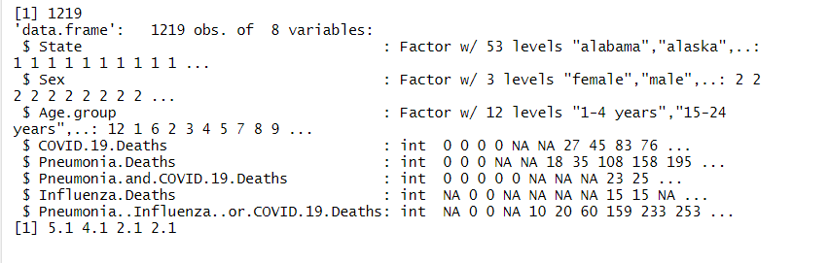

The distribution of variables of COVID.19.Deaths, Pneumonia.Deaths, Pneumonia.and.COVID.19.Deaths, Influenza.Deaths as well as Pneumonia..Influenza..or.COVID.19.Deaths all have p-values < 2.2e-16. Therefore, they are not normally distributed but they are skewed distribution.

We can tell the shapes from adding a fit curve to the density and adding a normal curve to the histogram. All of the variables are right tailed skewed and not normally distributed. We can also check Boxplots to see the data distribution. The graphs are showed as following:

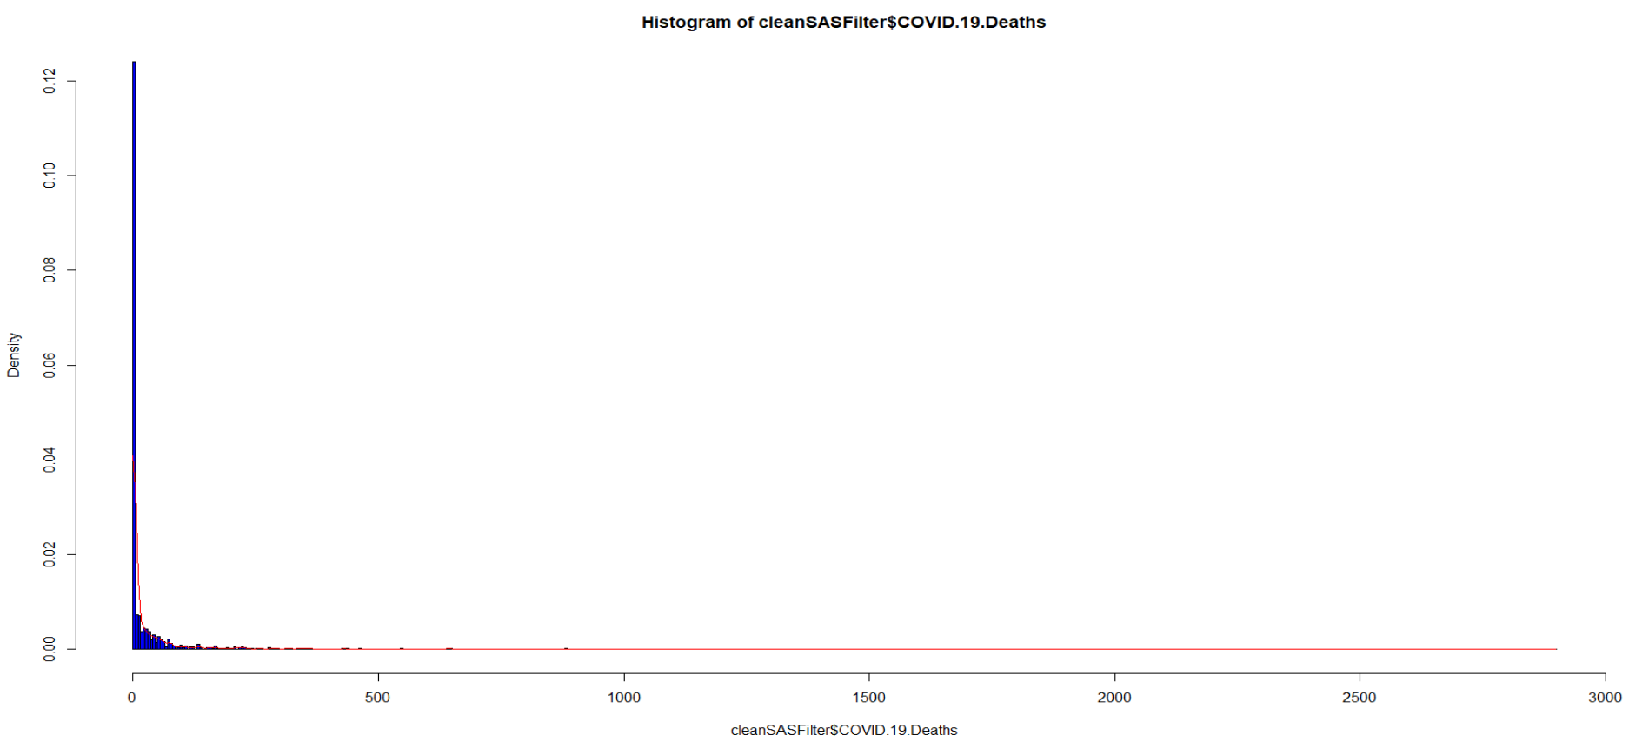

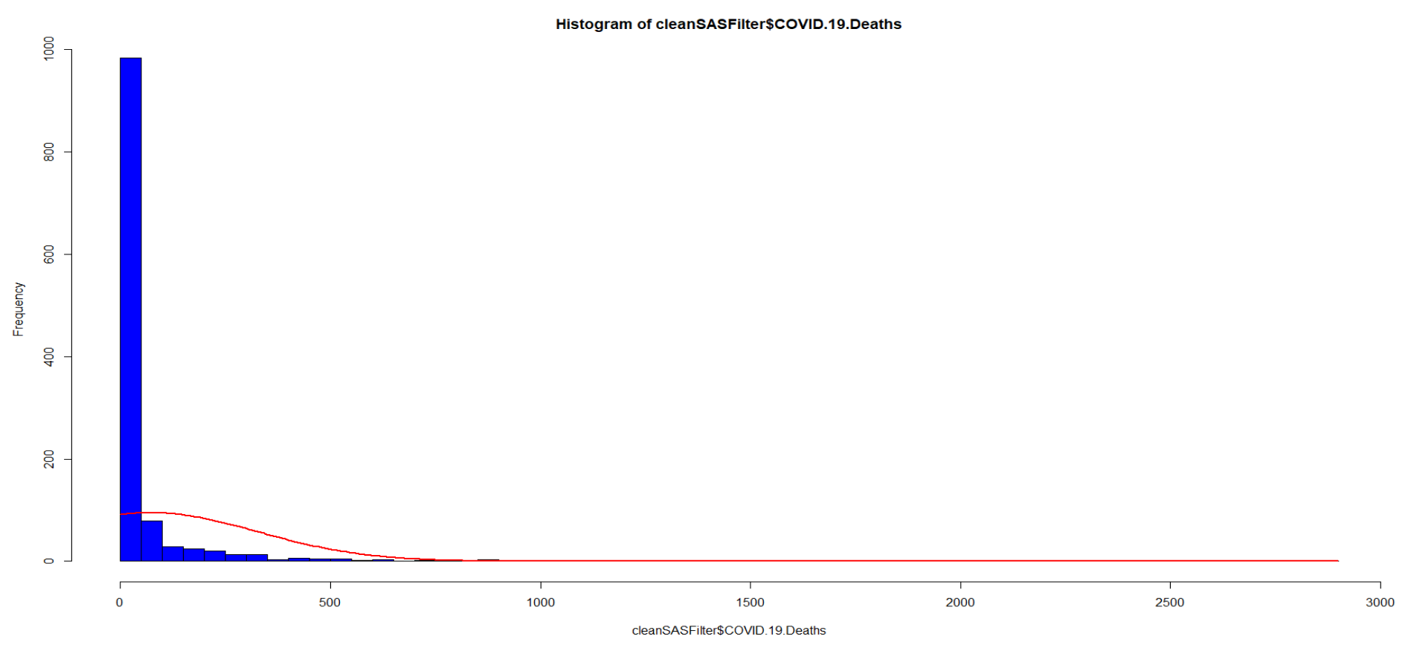

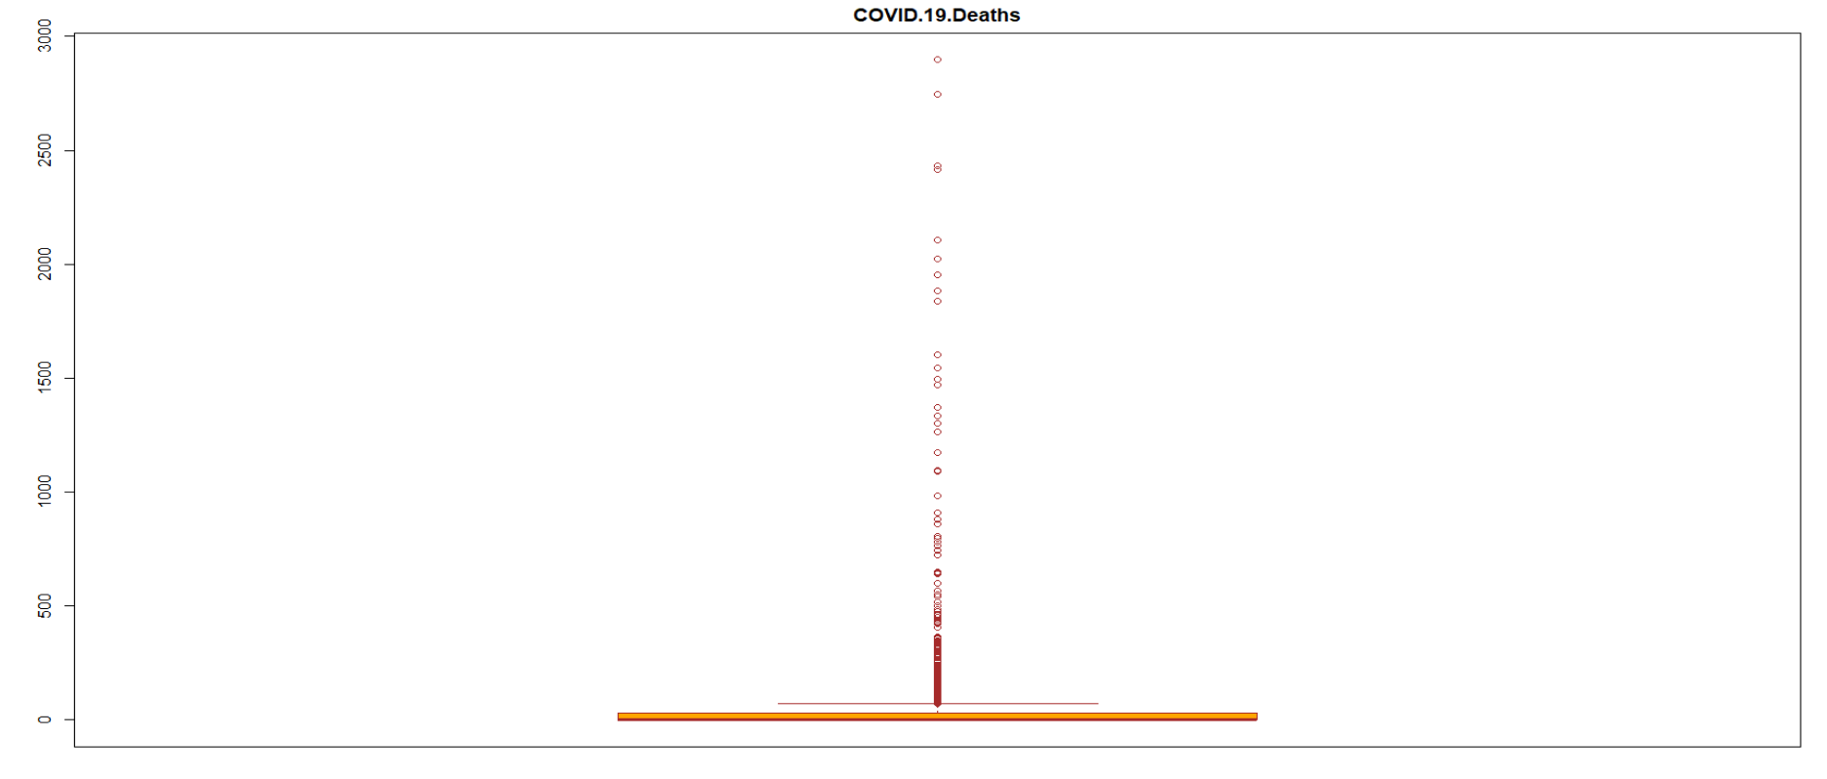

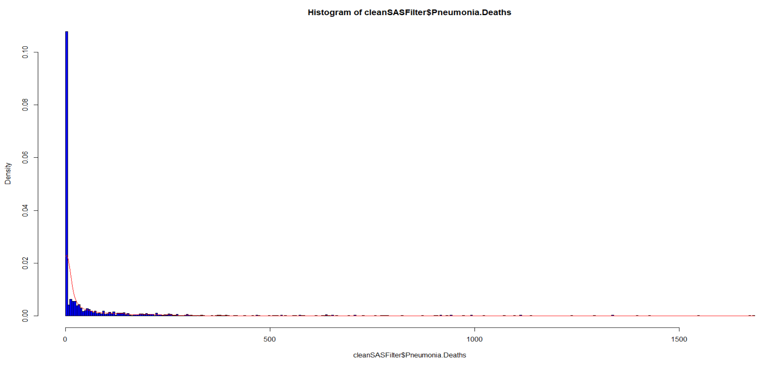

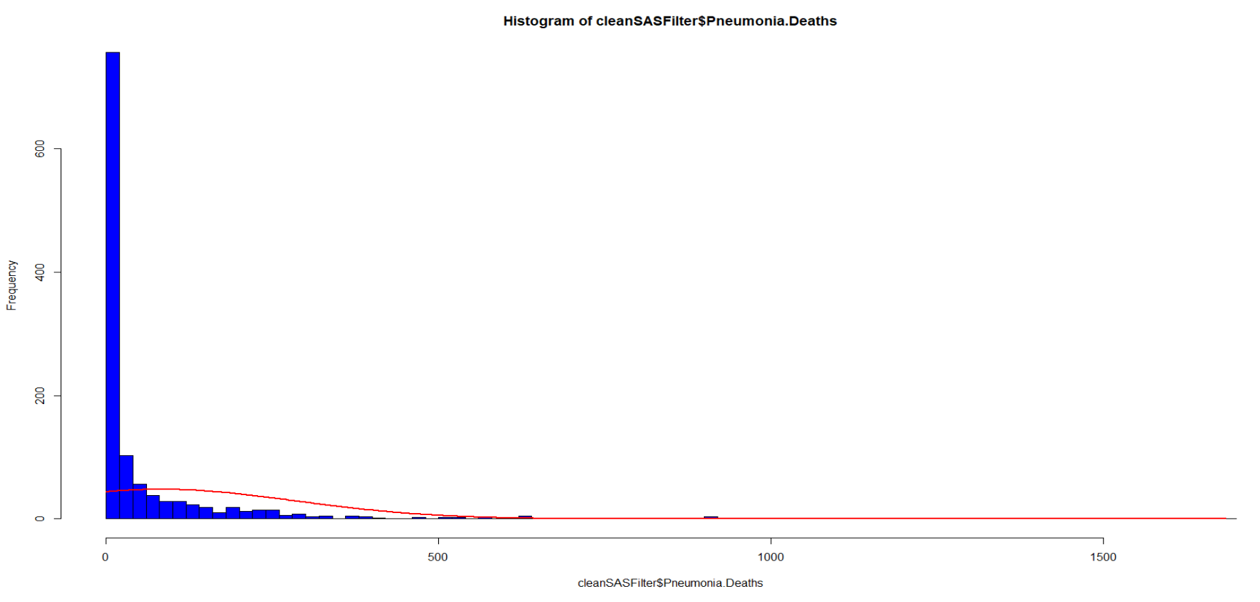

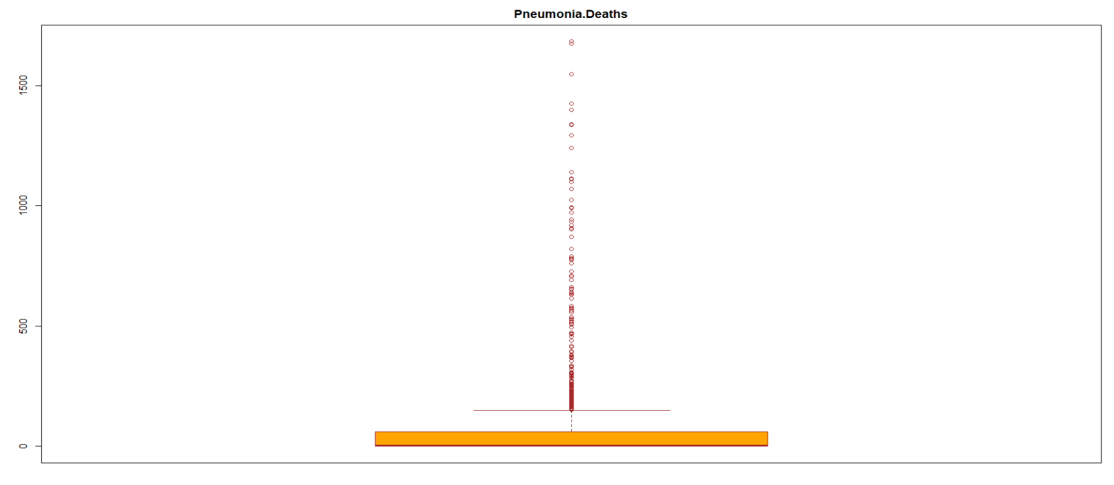

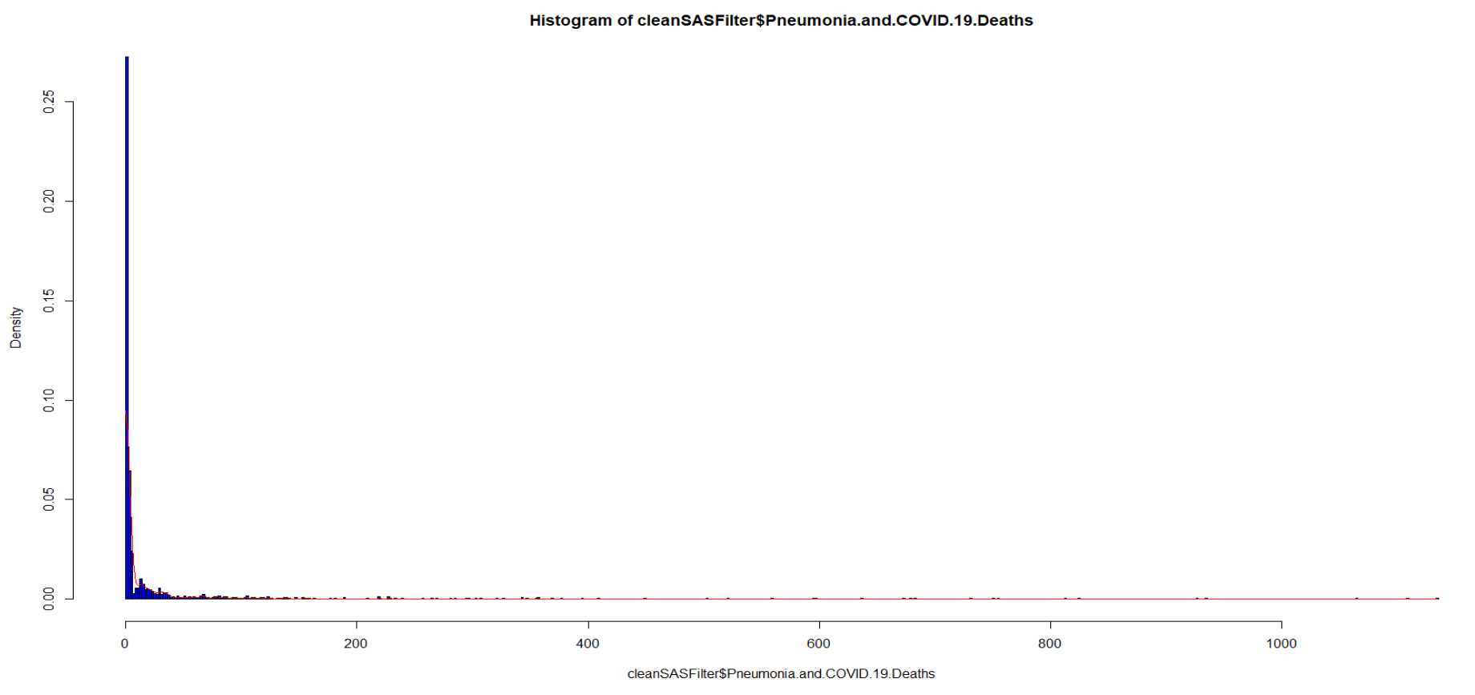

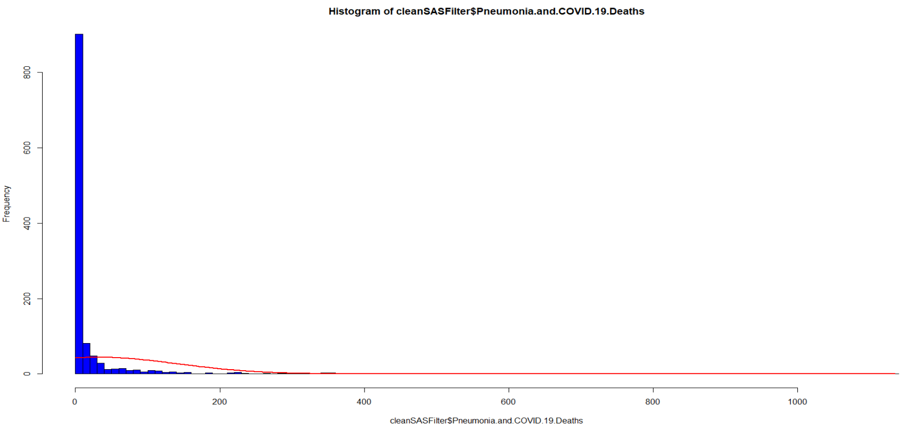

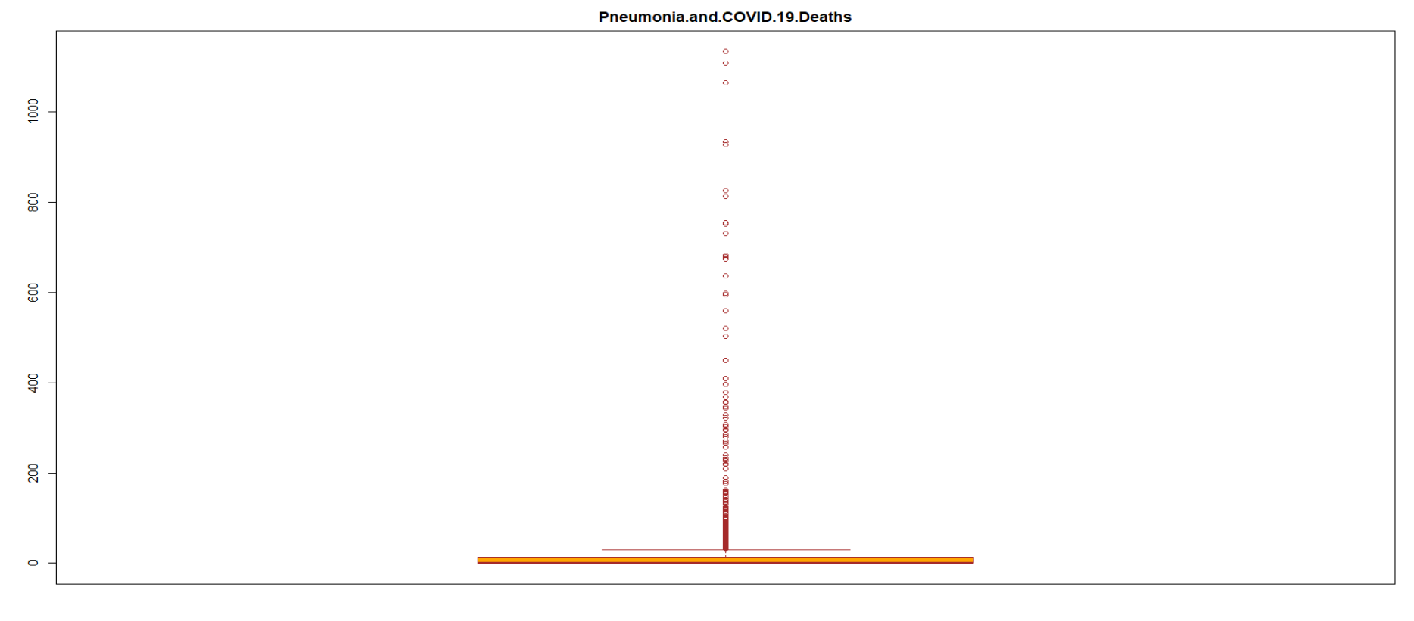

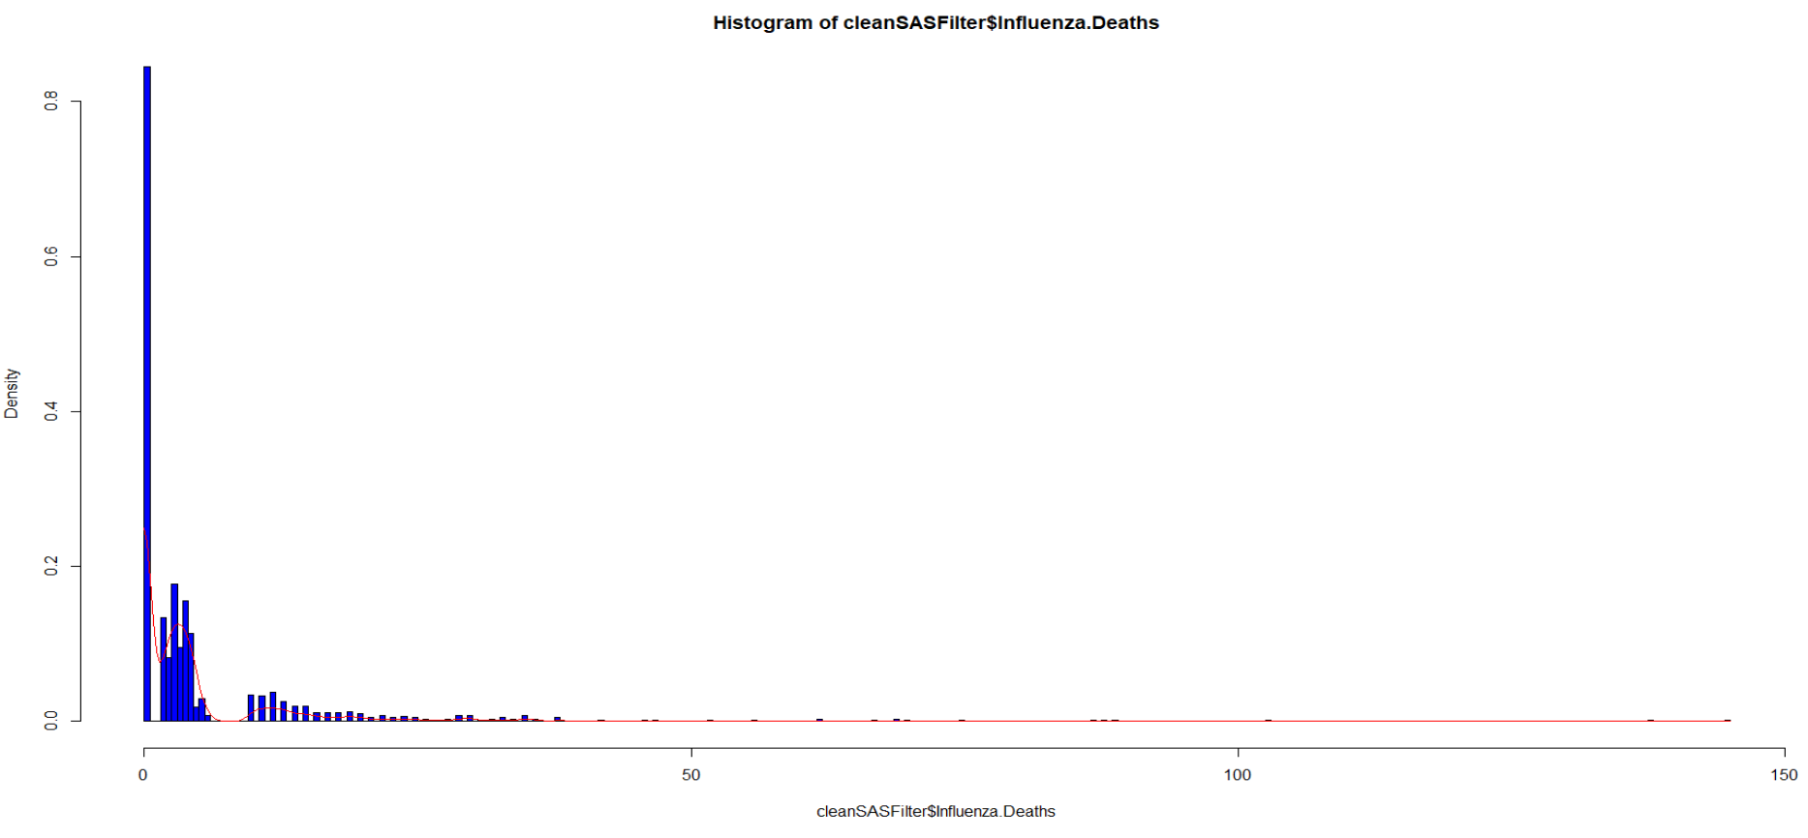

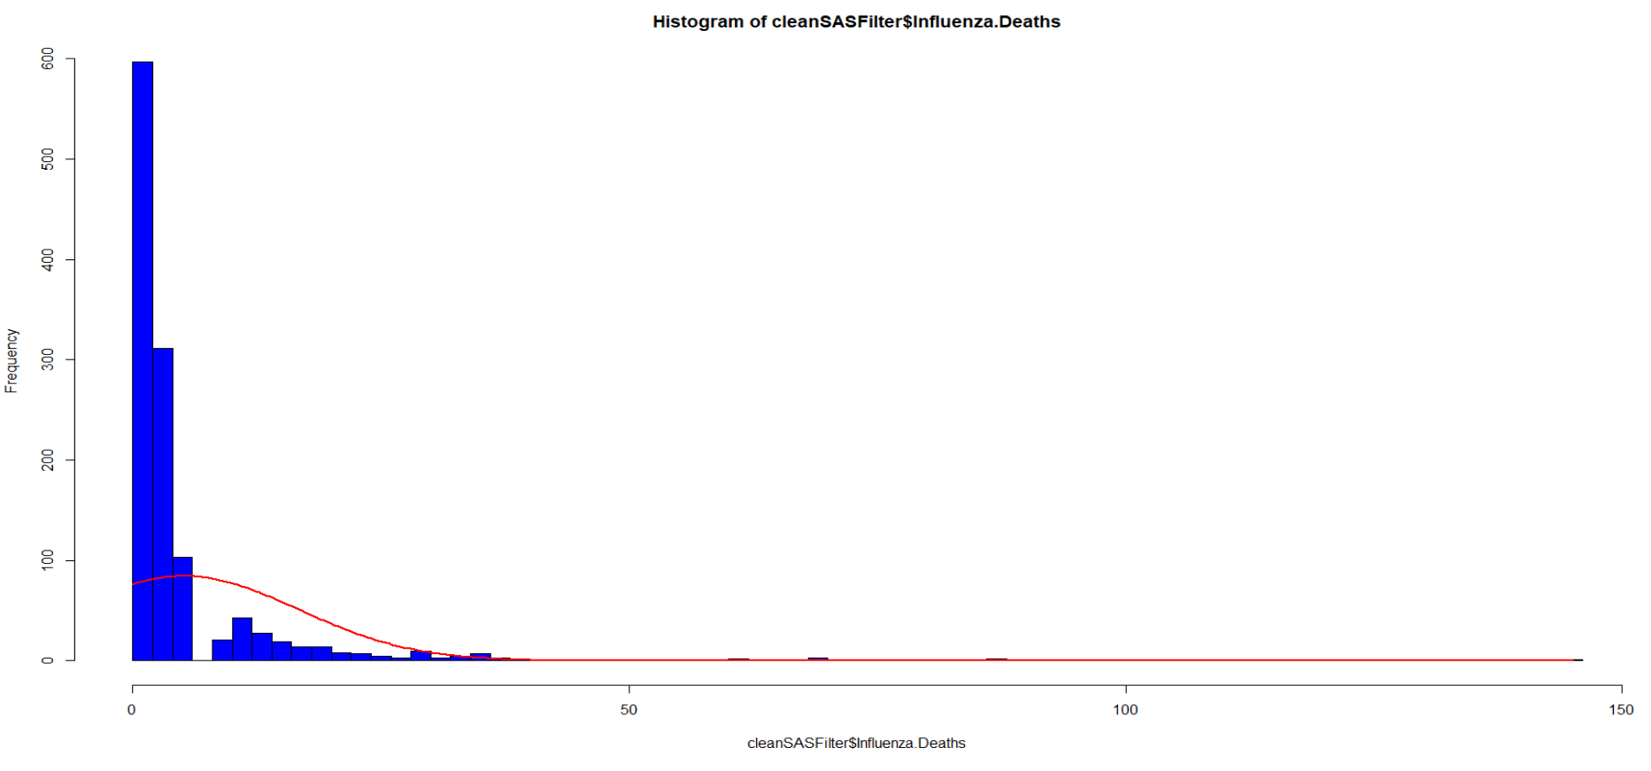

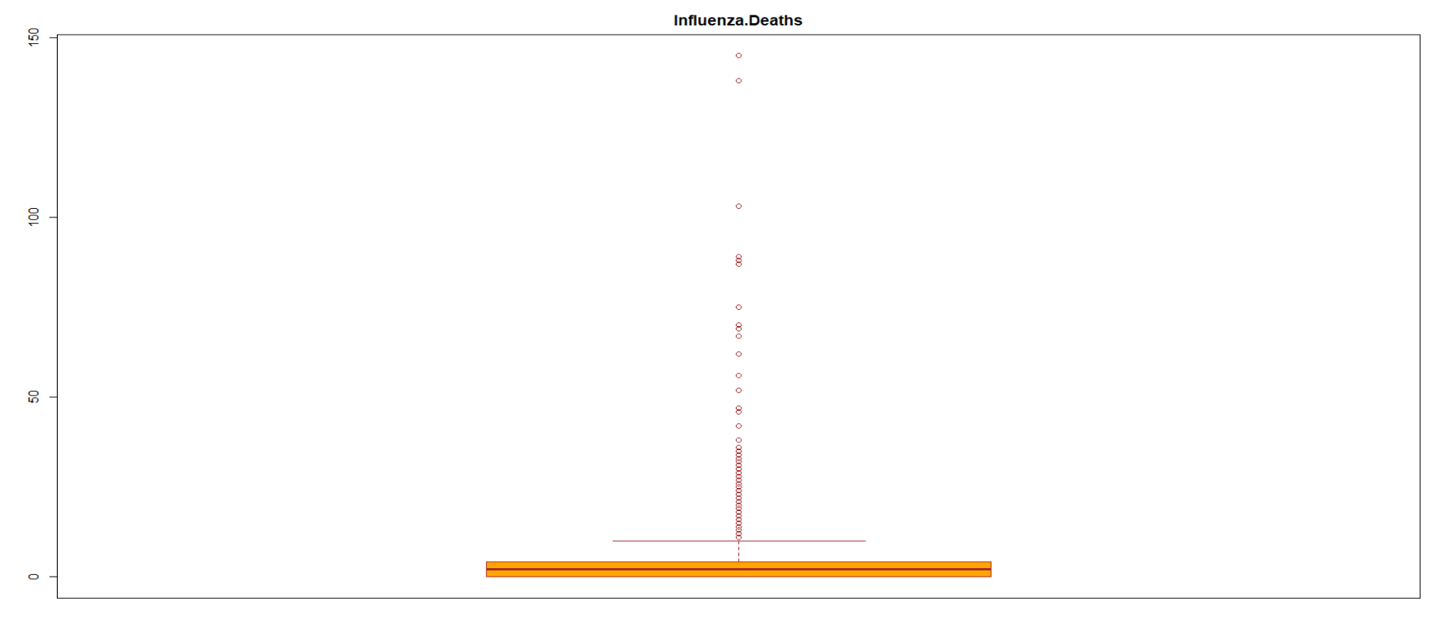

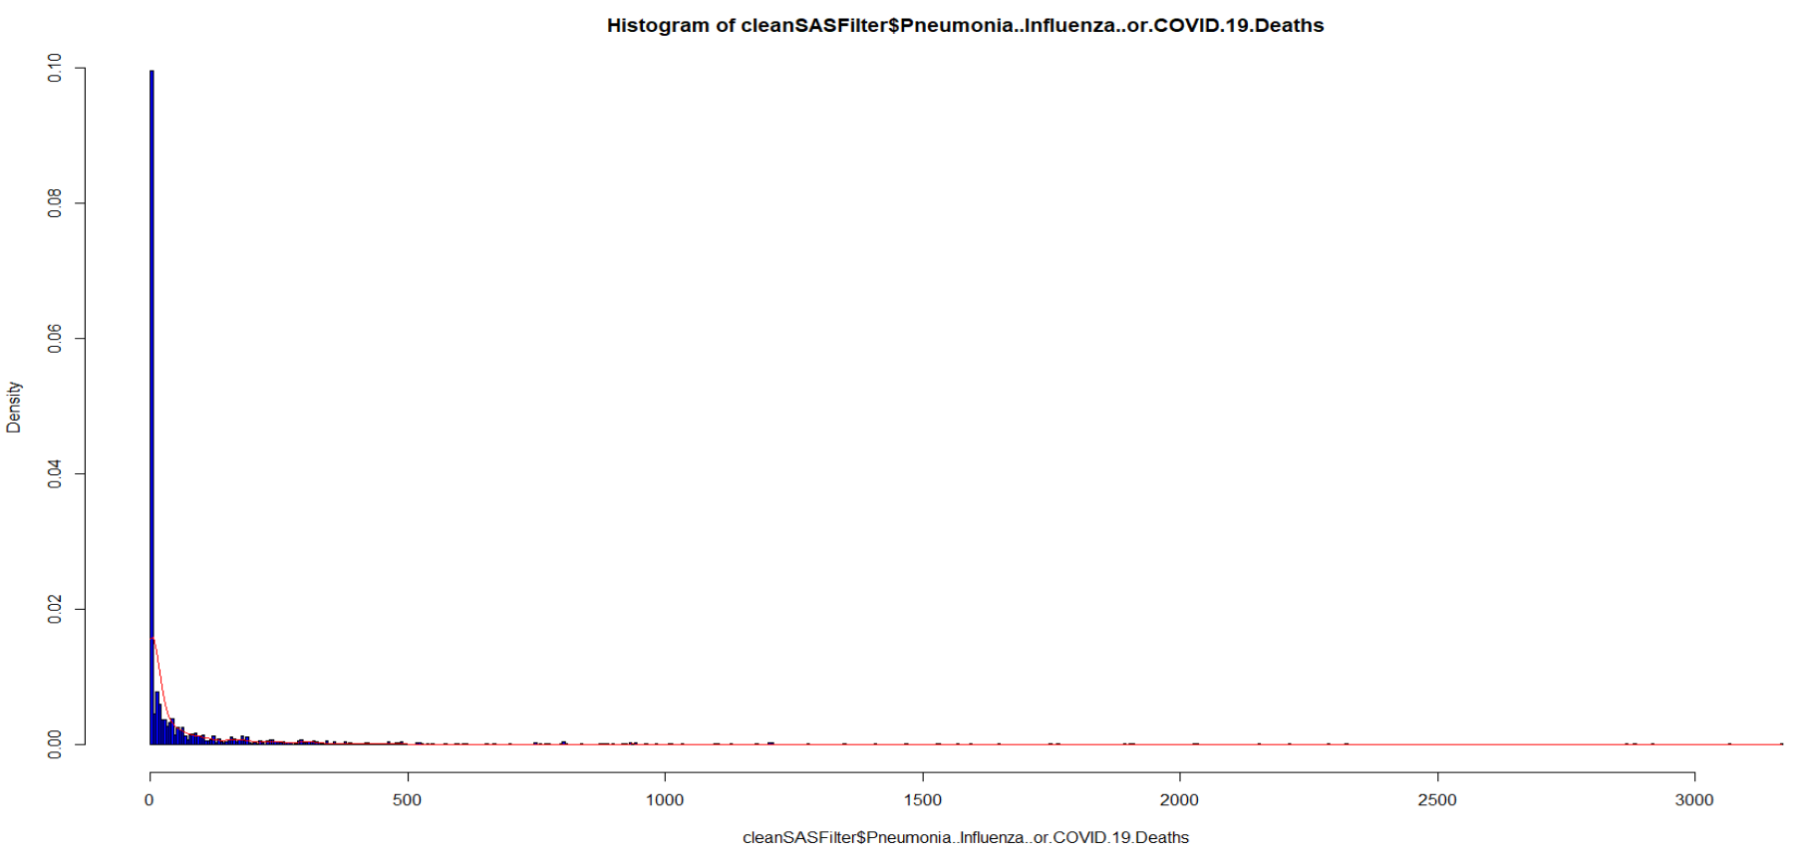

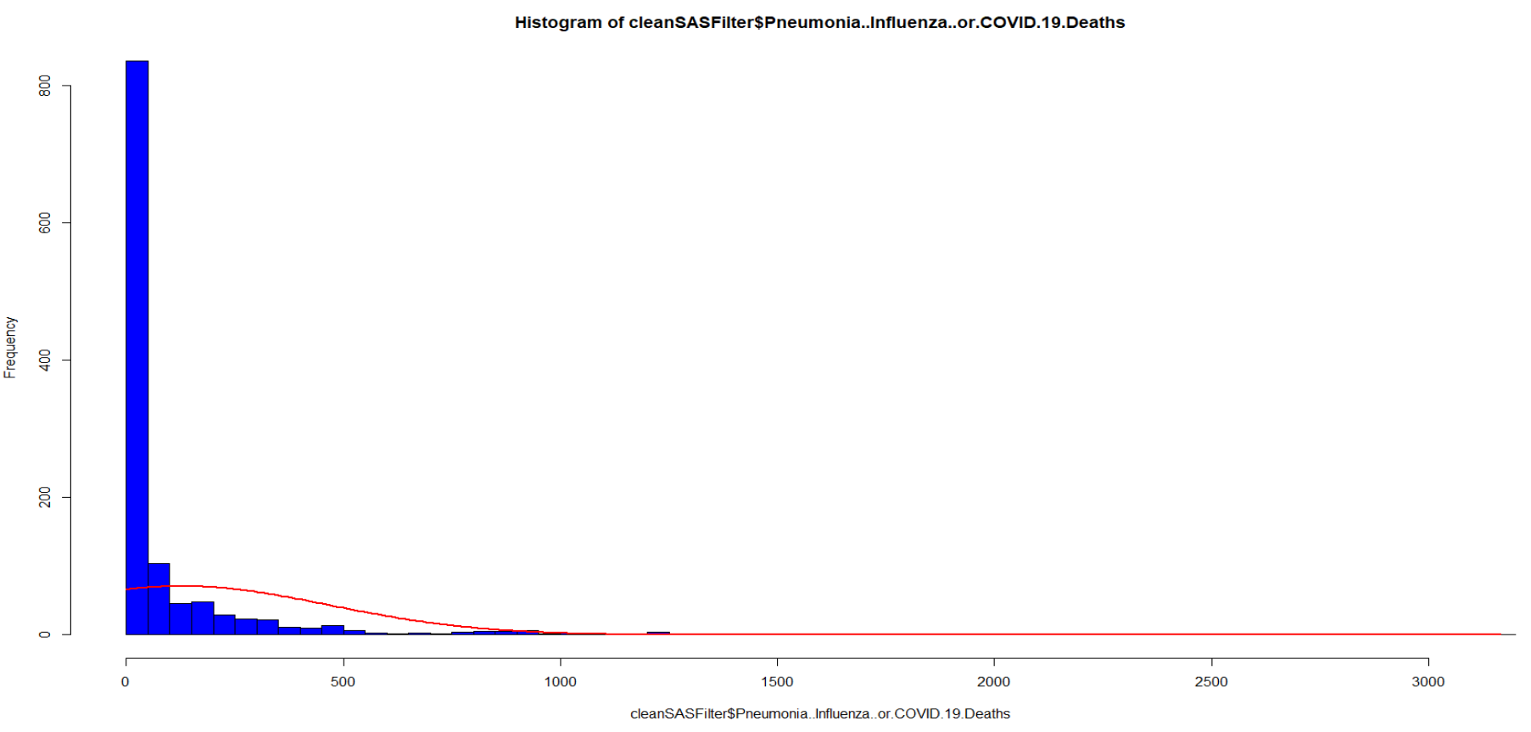

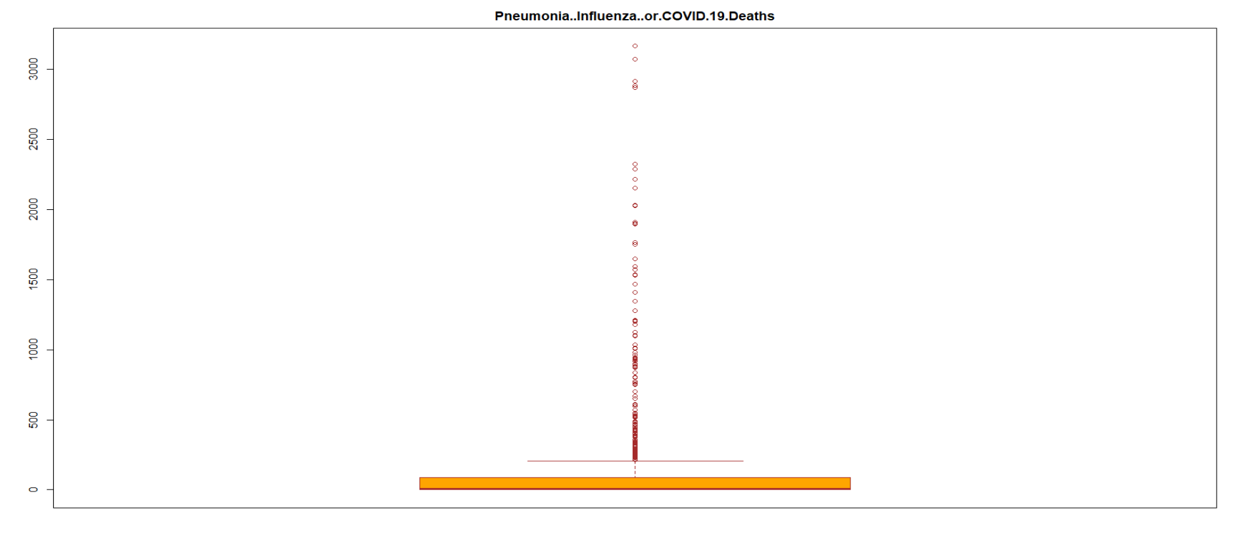

The correlations among dependent variable and independent variables are highly correlated because all values are over 0.7. Multicollinearity does exist.

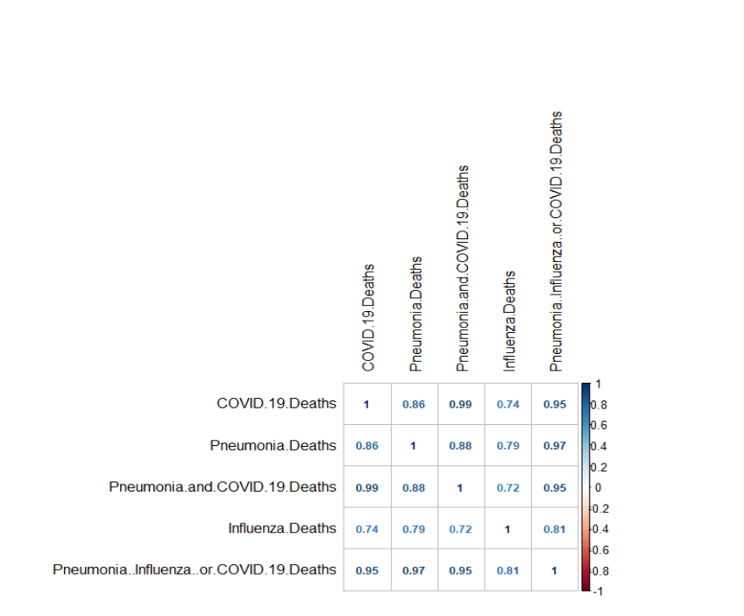

Find the maximum COVID-19 deaths, we find the following information:



Find the maximum COVID-19 deaths for male, we find the following information:



Find the maximum COVID-19 deaths for female, we find the following information:



New York City has both female and male maximum numbers of COVID-19 deaths. We can also check the following charts for better visualizations and comparison.

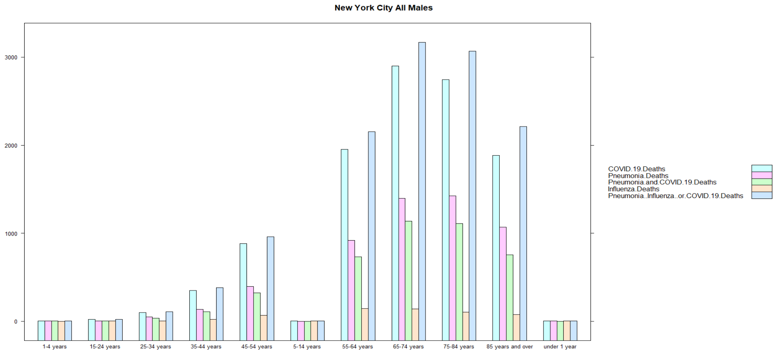

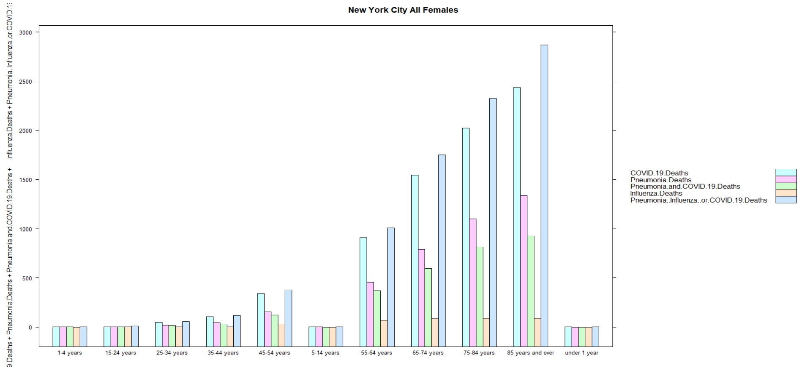

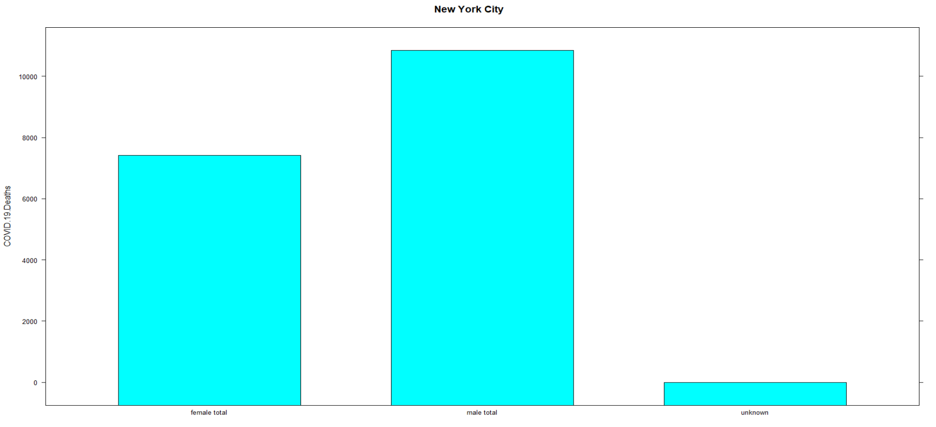

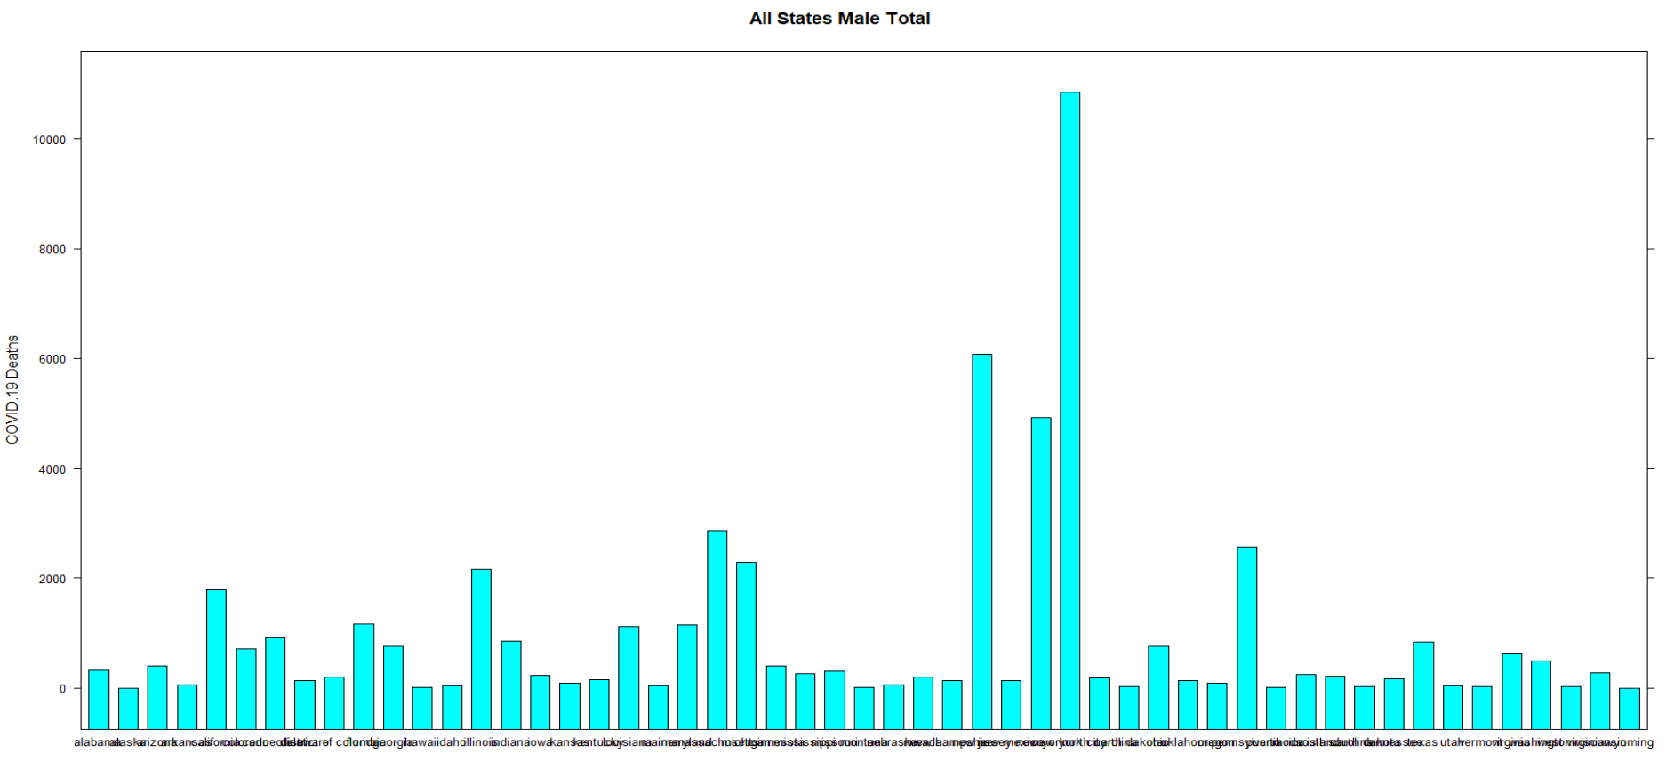

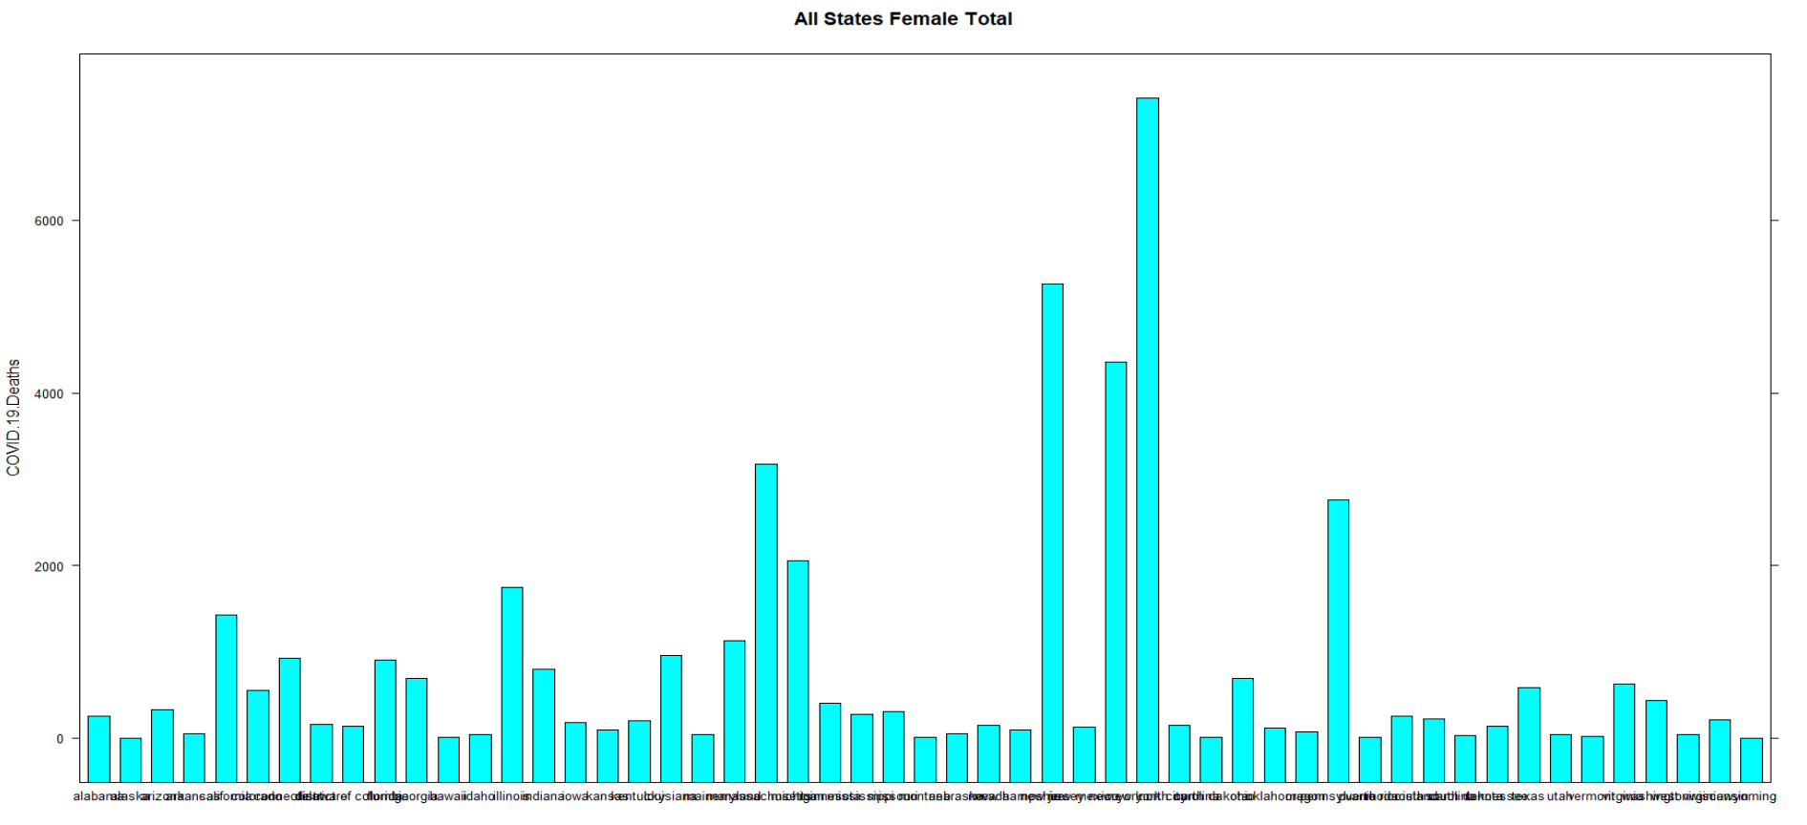



States of New Jersey and New York are 2nd and 3rd, respectively for highest numbers of COVID-19 deaths. The following charts for better visualizations and comparison.

Now, when someone says New York, they could be referring to the state or the city. New York State is the 27th largest state but the 4th in population (mostly in NYC). Most of the state is referred to as 'upstate' to distinguish from the city. Upstate and its people are totally different from NYC. It extends to the Canadian border all the way to Buffalo and Niagara Falls to the west. That is why the New York and New York City are shown separately.

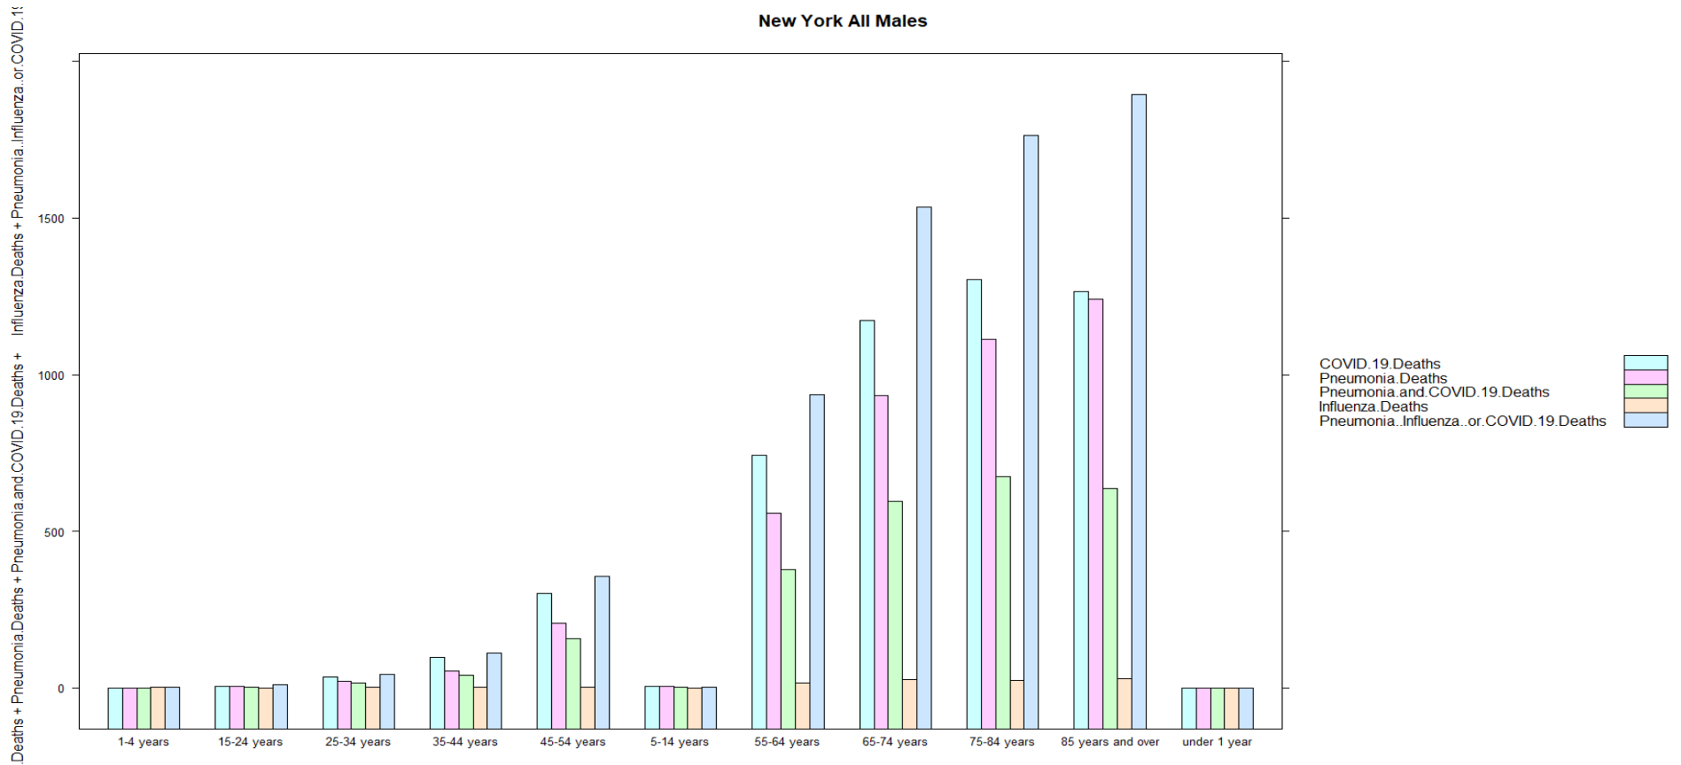

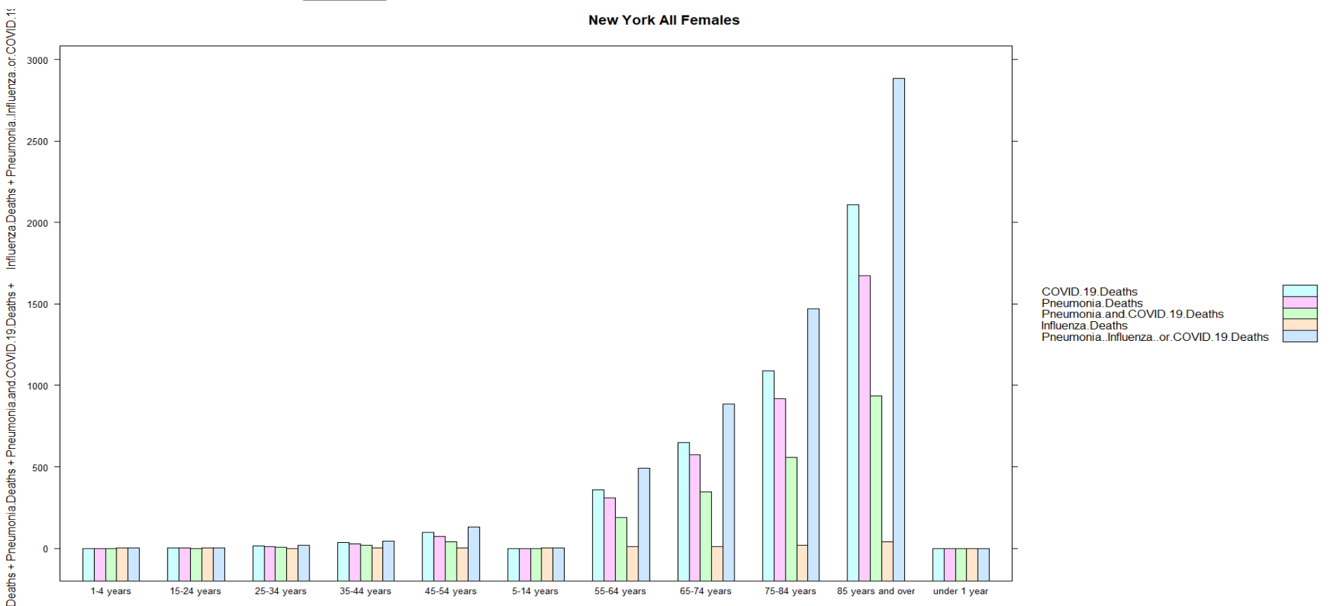

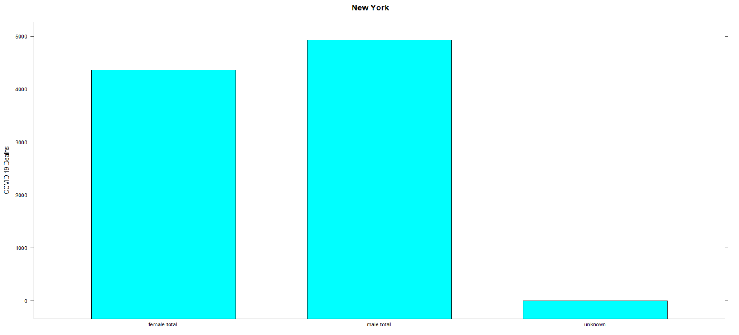

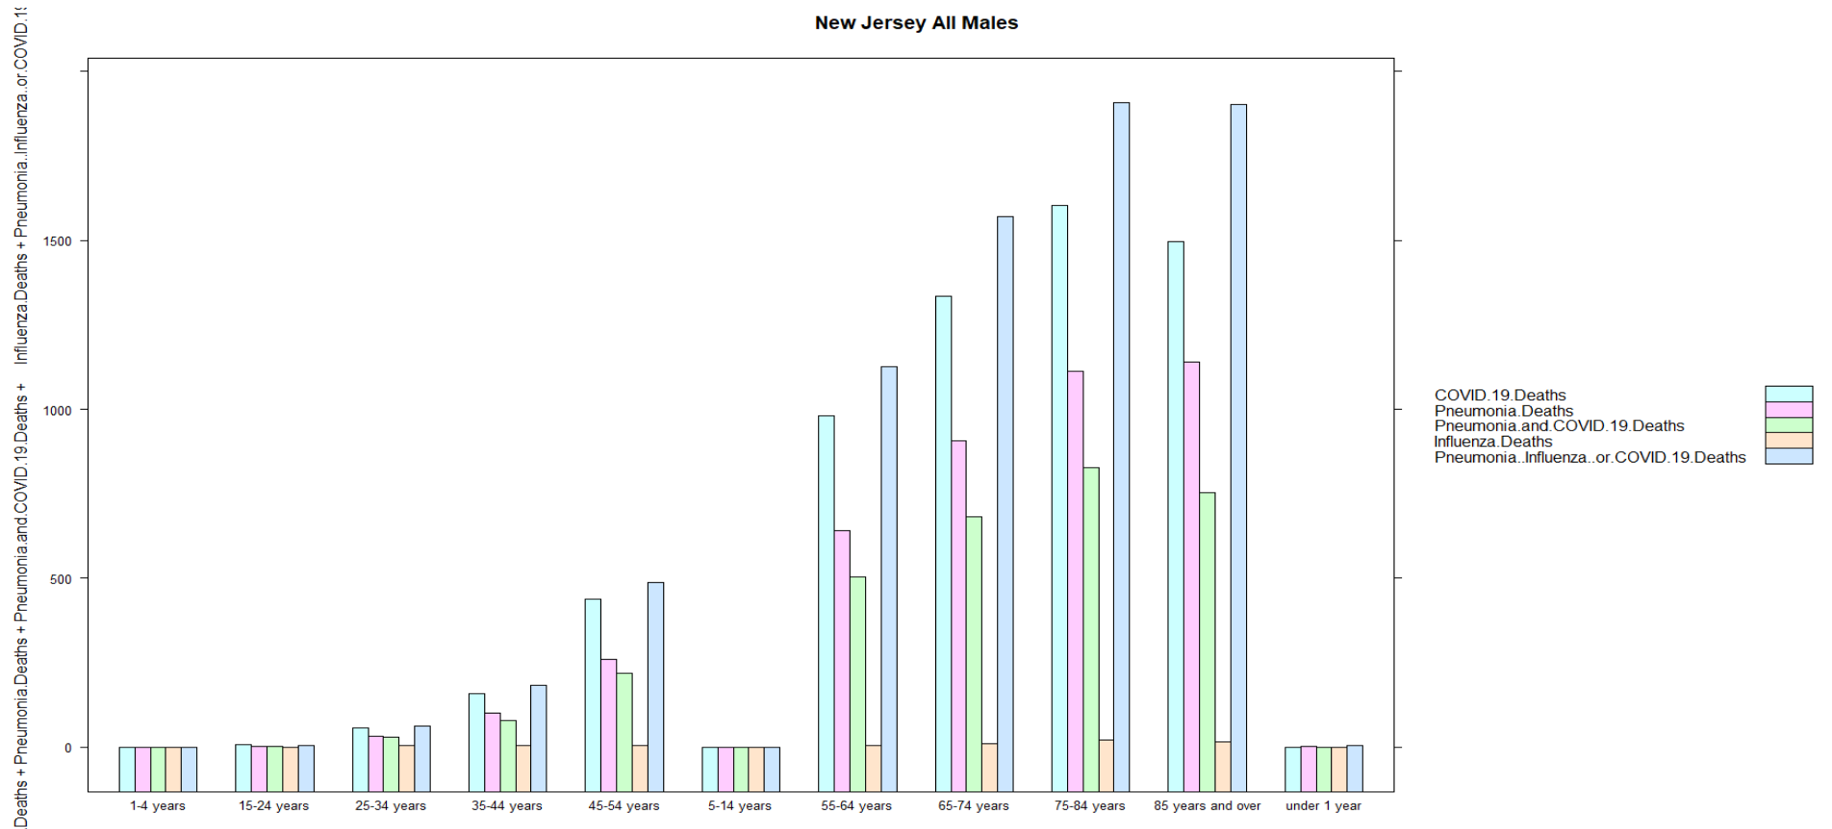

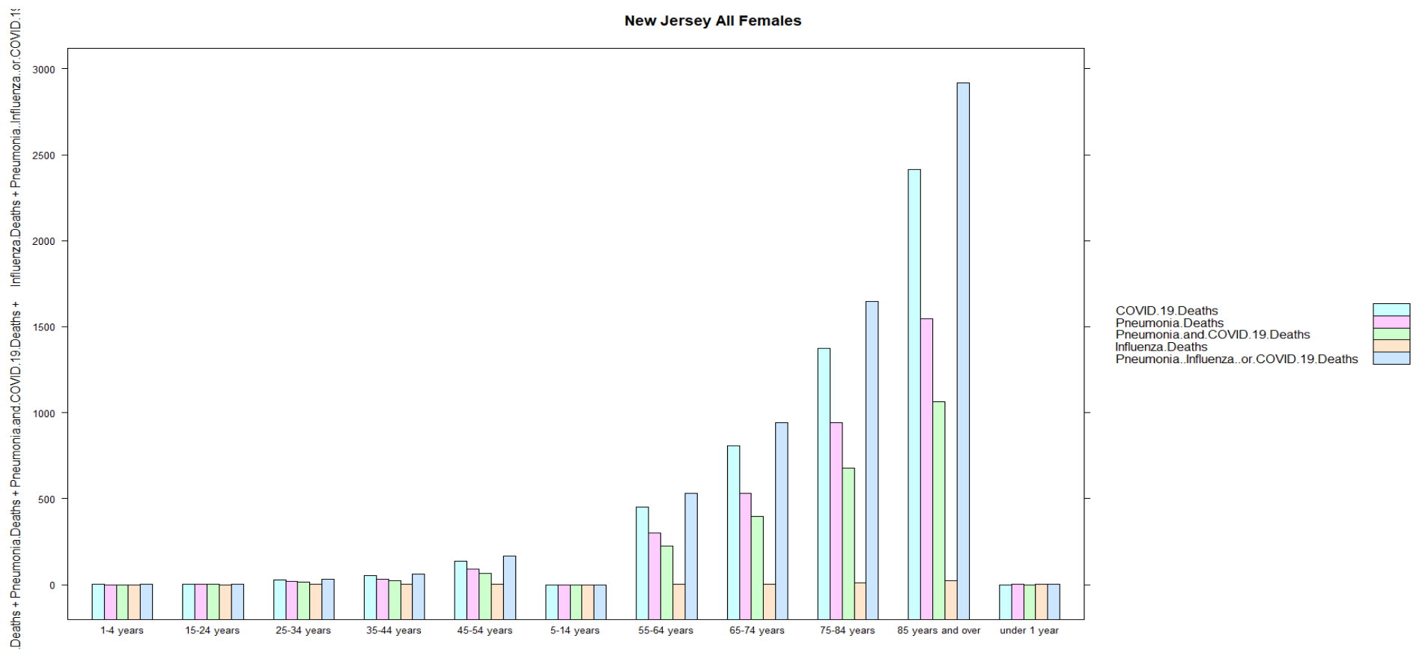

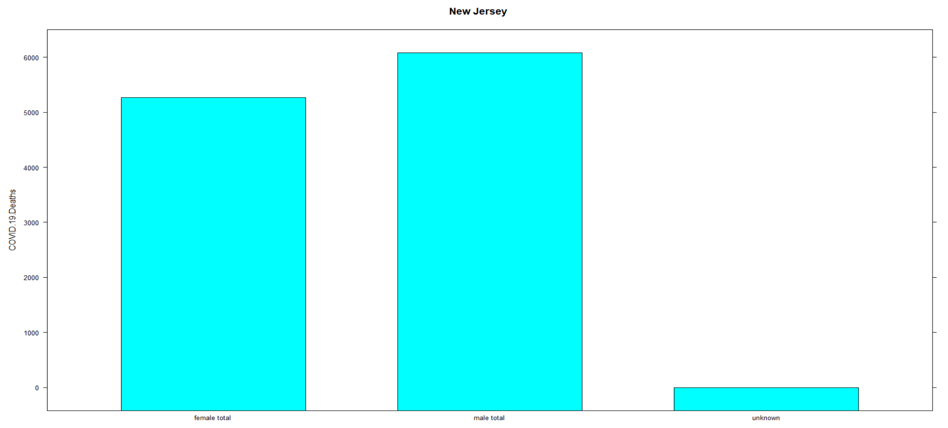

**Step 3: Dimension Reduction & Step 4: Design & Modeling**

Before applying any machine learning algorithm, Principal Component Analysis (PCA) is applied to remove the variables of highly correlated. Backward feature elimination and Forward feature construction are used to select the best variables in the model. Any dataset is spitted into training part with 70% and testing part with 30%.

**Linear Regression Tests Analysis:**

The Linear Regression Model has statistical assumptions: the error terms are normally distributed and with constant error variance. But the COVID-19 Deaths is not normally distributed. We use Box-Cox (BC) transformations to solve this issue. We choose COVID-19 Deaths as dependent variable. Therefore, I am going to transform the data with (COVID.19.Deaths+1-min (COVID.19.Deaths)) if variable has negative values or (COVID.19.Deaths+1) if variable has zero values. Because in my dataset, COVID.19.Deaths has zero values, so I will use (COVID.19.Deaths+1) as my new dependent variable. We use the data set with alpha = 0.05.

Due to the original dataset is quite messy. I merged some parts of the data as a new dataset called cleanSASFilter with the R code:



The dataset structure is as following:

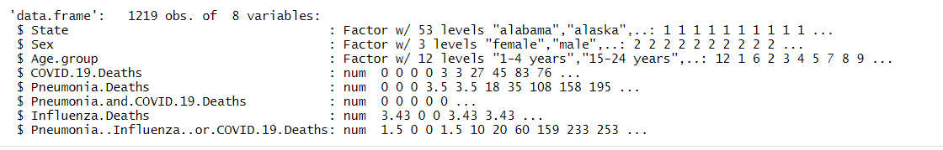

After applying PCA, the new variables will be PC1 and PC2 because both together have 97.32% variance covered the original variables of Pneumonia.Deaths, Pneumonia.and.COVID.19.Deaths, Influenza.Deaths, Pneumonia..Influenza..or.COVID.19.Deaths. We can see that the result of new transformed values have very small correlation values. The following tables and plots can approve it.

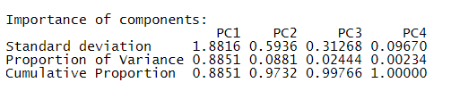

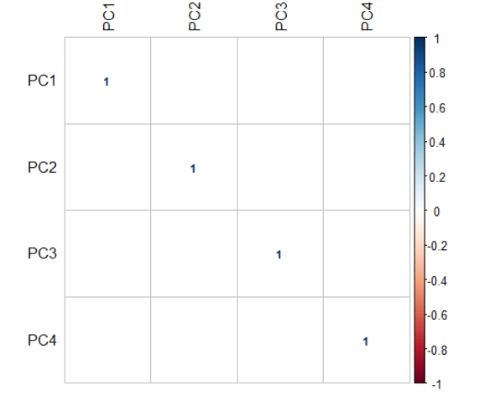

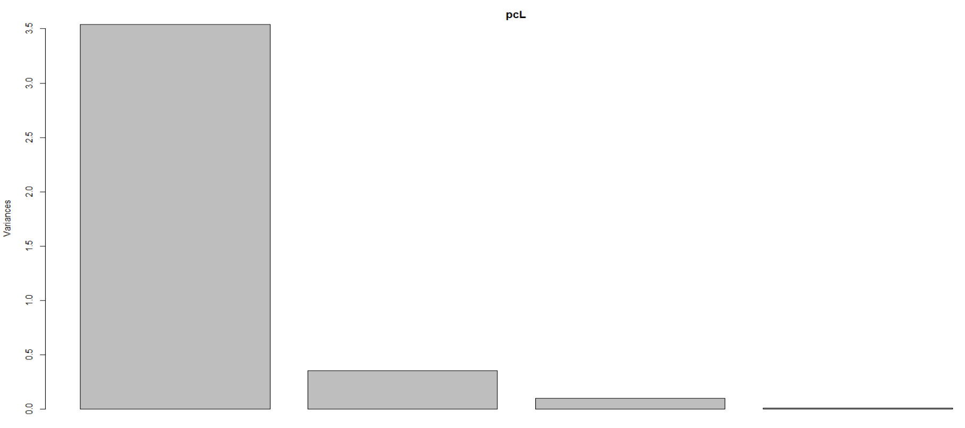

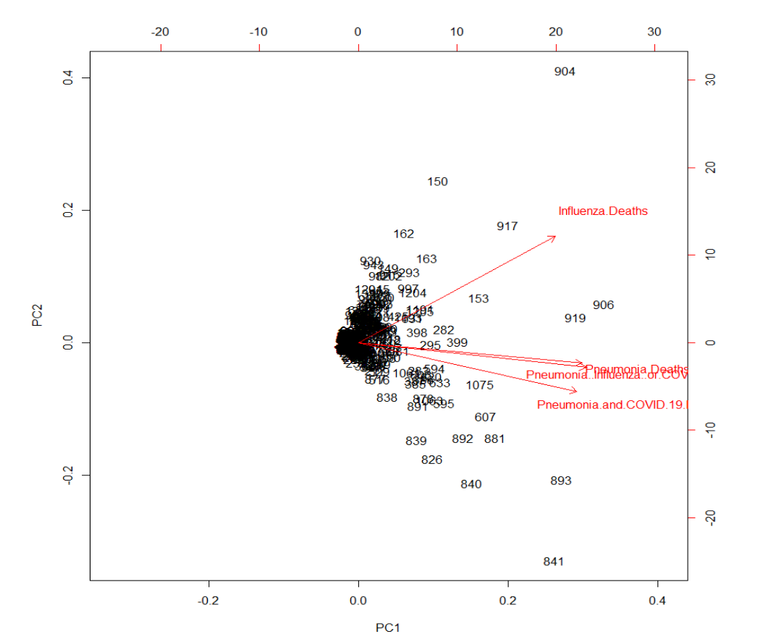

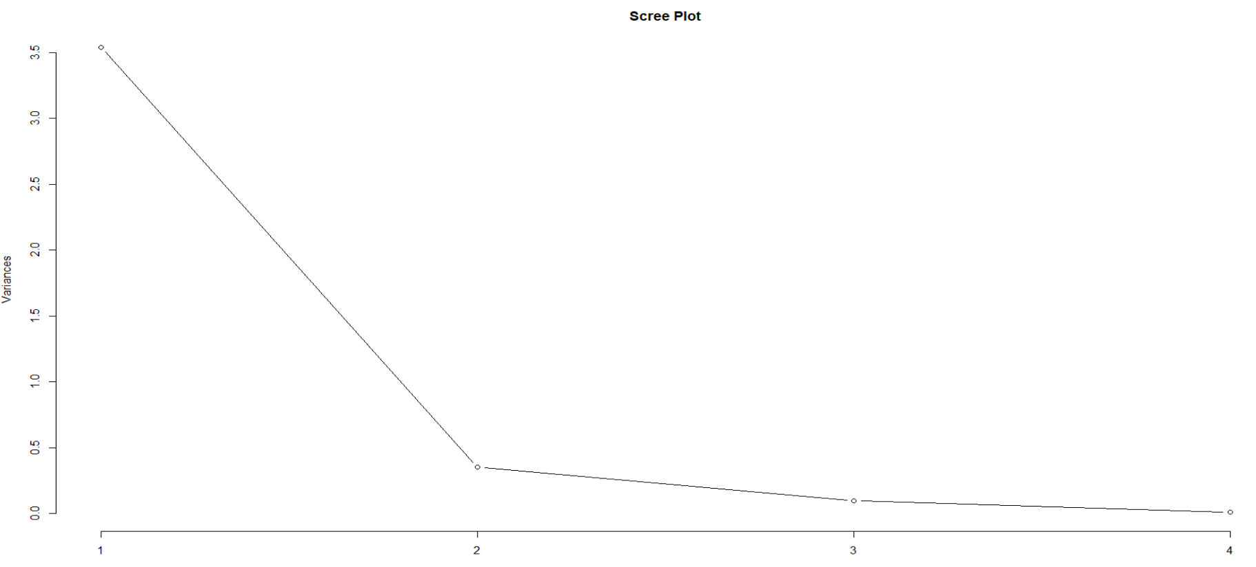

We build the new train dataset by PCA result with the following R code and then create the linear model:

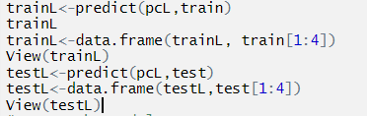

First of all, we choose all three categorical independent variables, paired-intersections of categorical independent variables and PC1 and PC2 variables together to build my initial linear model:



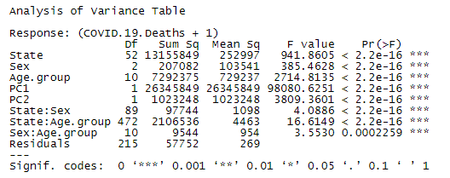

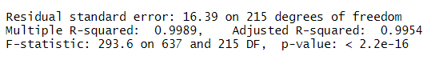

The following 4 diagnostic plots are for initial linear model analysis:

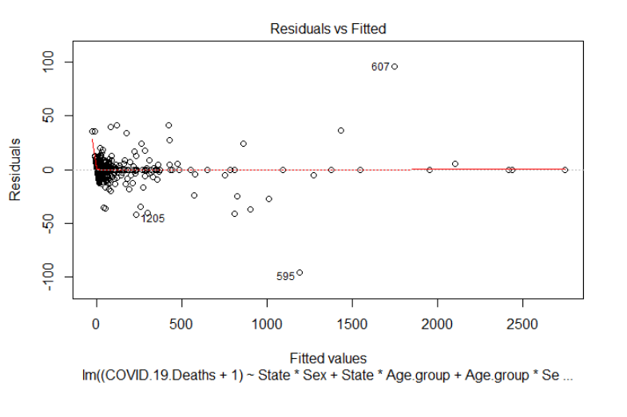

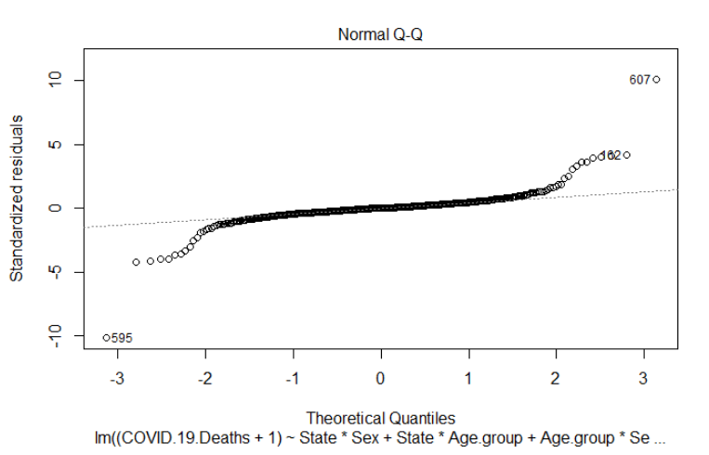

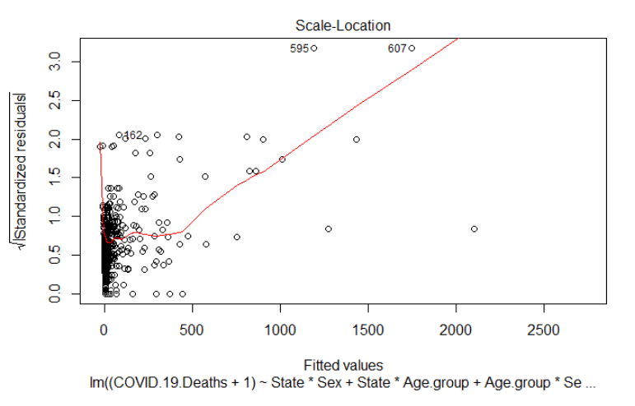

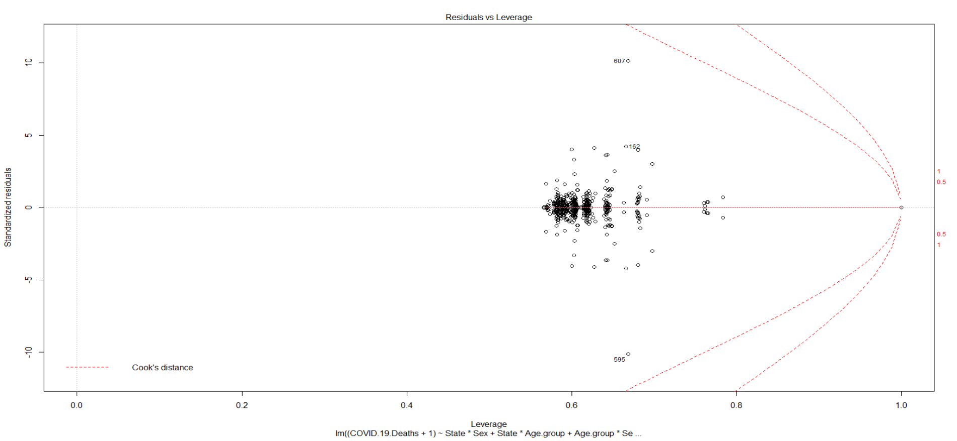

Because we need to check if the model works well for the data or not. That also means we need to detect potential problems and to check whether the assumptions made by the linear regression model are met or not. The above diagnostic 4 plots show residuals in four different ways:

Residuals vs Fitted: the residuals have no equally spread around a horizontal line, it indicates we don’t have linear relationship.

Normal Q-Q: the residuals are not lined well on the straight dashed line, it indicates we don’t have linear relationship.

Scale-Location: horizontal line with equally spread points is a good indication of homoscedasticity. This is not the case in our model, where we have a heteroscedasticity problem.

Residuals vs Leverage: there are no data points outside of a dashed line, Cook’s distance. In this case, the values are not influential to the regression results.

We apply Box-Cox transformation and extract the best lambda: -0.03030303. We get the following linear model: 

We then again apply the new diagnostic 4 plots as shown below: they are much better but not perfect.

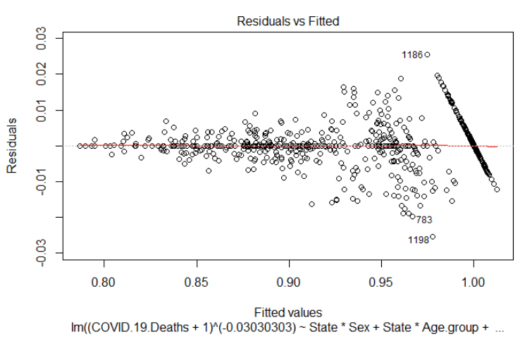

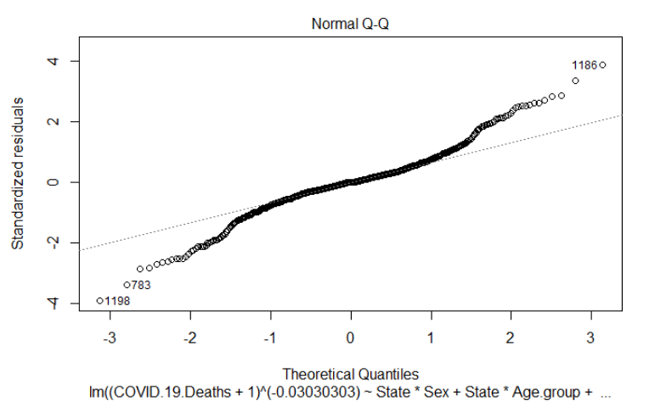

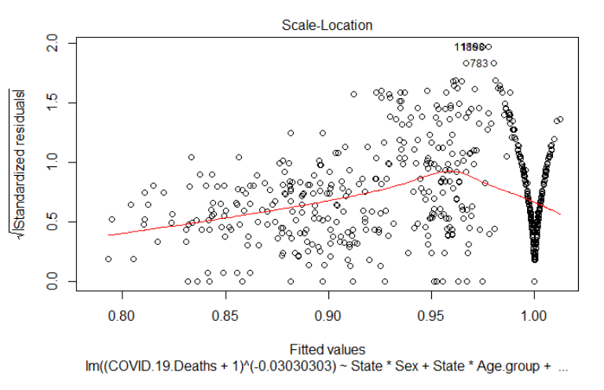

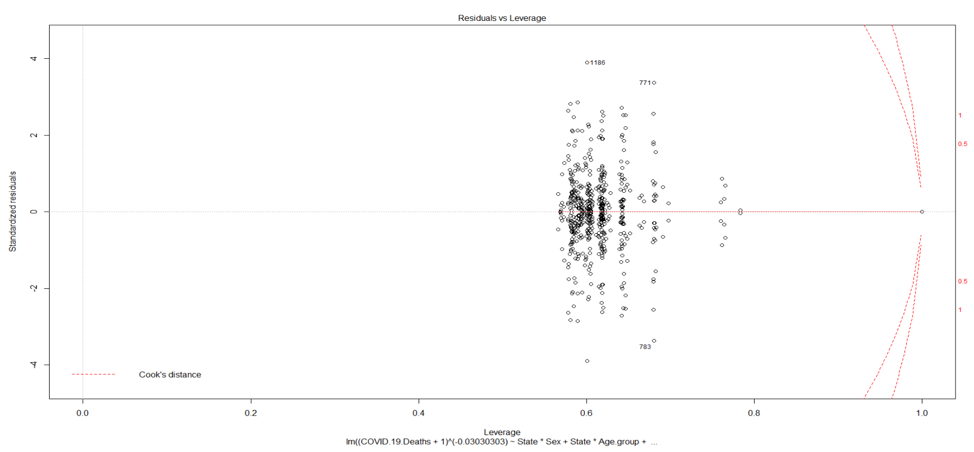

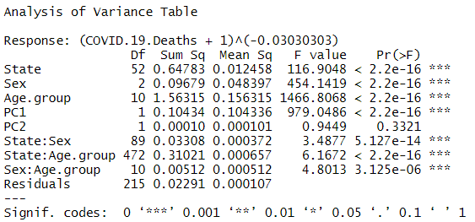

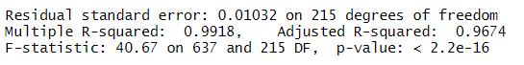

After applied backward feature elimination and forward feature construction, we get the following final model to be used to do linear regression:



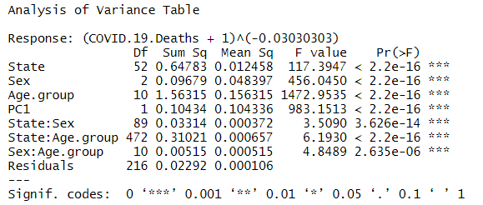

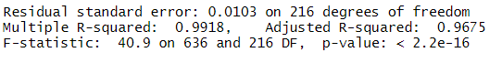

Adjusted R Square value in the summary output is a correction for the number of x variables included in the predictive model. Adjusted R-squared: 0.9675 indicates that a 96.75% of the variability in the outcome has been explained by the regression model. The F-statistic gives the overall significance of the model. It assess whether at least one predictor variable has a non-zero coefficient. A large F-statistic will corresponds to a statistically significant P-value (P < 0.05). In our case, the F-statistic equal 40.9 producing a P-value of < 2.2e-16, which is highly significant. But we also find out the higher the COVID-19 Deaths number, the lower value of the linear equation model. Therefore, the higher P-value, the more significant to the number of COVID-19 Deaths. We get the following result, which is the highest P-value (0.996746) in the model. Disregarding the sex variable, we know from our initial analysis and exploratory analysis parts, New York City has highest number of COVID-19 Deaths for age groups of 65-74 and 85 and over. The result matches our initial analysis and exploratory analysis part: the mid-range of the age group: 75-84 has been picked up.





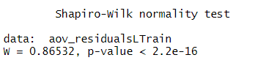

We can see the model residual is not normally distributed. Because the P-value is less than 0.05. Therefore, this model is good but not perfect model to do prediction.

We applied our model to the training data and calculated the errors of predicted vs. actual values: P-value is less than 0.05. It is not normally distributed.

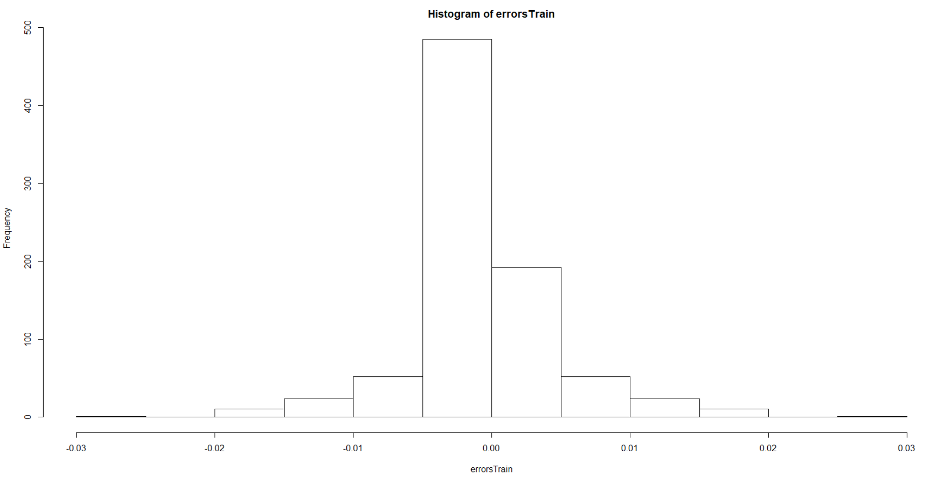

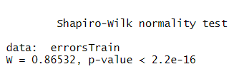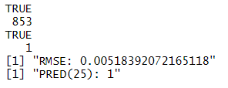

We calculated the RMSE and find the percentage of cases with less than 25% error, we get: 100% for all training dataset:

The overlap of predicted (red color) and actual (blue color) values is good match but not perfect match.

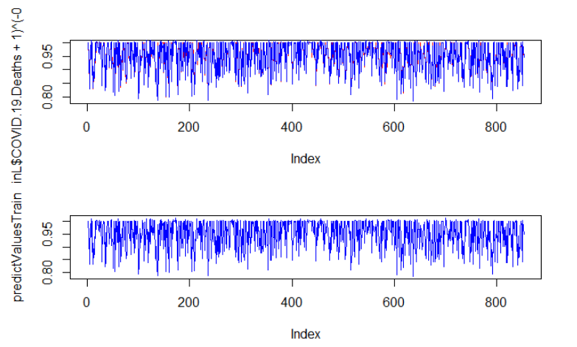

Training dataset model accuracy: the model RMSE is 0.02251613 to get 0.02374444, around 2.4% model error, which is low. The model is good.



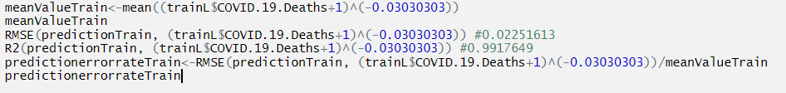

We also applied the model from training data to testing data, we get the following results:

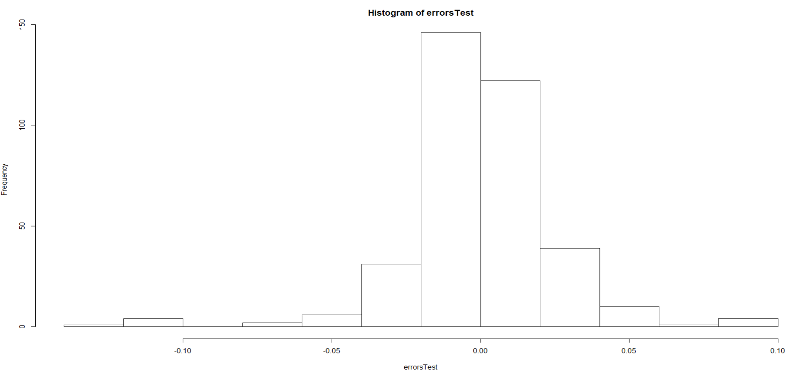

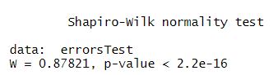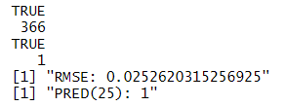

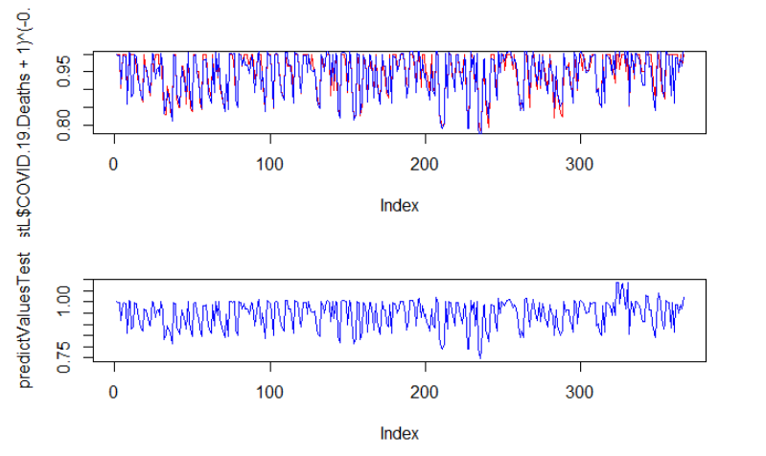



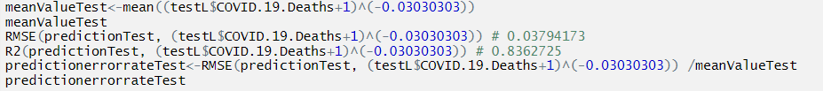

Testing dataset model accuracy: the model RMSE is 0.03794173 to get 0.04008653, around 4% model error, which is low. The model is good but not perfect.

**Non-parametric Tests Analysis:**

The reasons behind applying non-parametric tests and the assumptions of applying such tests are that data is not normally distributed and the data sample size is small. Because our data is not normally distributed so we are going to apply non-parametric measure to do the modelling to predict the results.

Wilcox Rank Sum Test:

We first choose 2 independent data groups (female and male in each state) to apply Wilcox rank sum test to predict the results of COVID-19 Deaths. The data I extracted from original dataset with the following R code and the results showed as following:

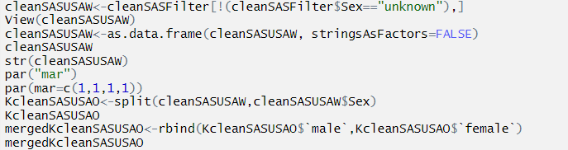

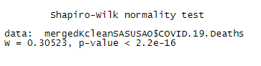

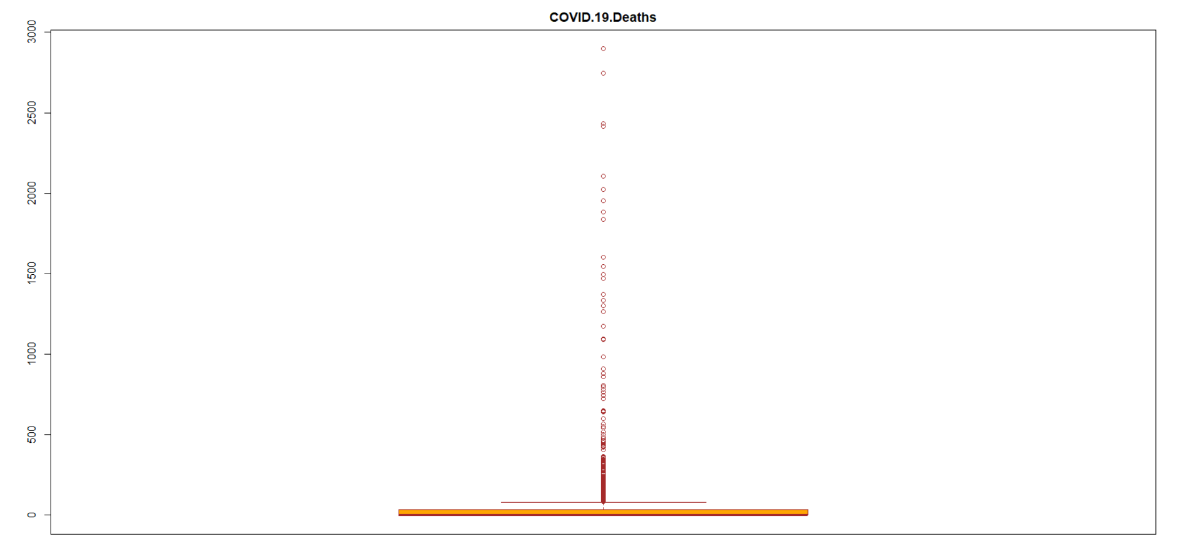





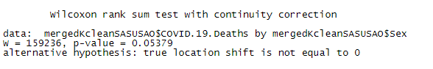

We can conclude that whole USA's female's death does NOT significantly differ with male's death with a p-value = 0.05379. We also do the pairwise test to prove our results: the same P-value showed.



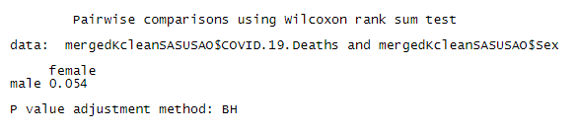

Both sexes have same distribution of the data. We can also inference that both sexes have same significant affect to COVID-19 Deaths. Sex variable is not quite informative to predict the COVID-19 Deaths.

Kruskal-Wallis Test:

We can apply 3 or more independent groups of data (Age.group in each state) to see the results by applying Kruskal-Wallis test.

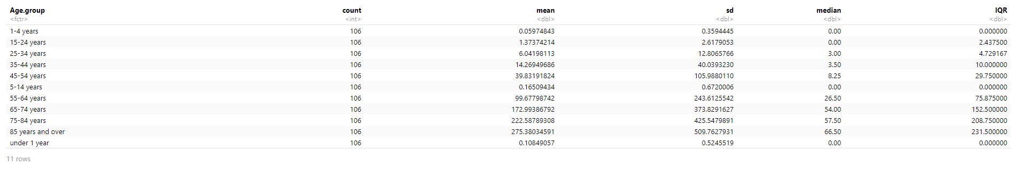

I reform the dataset and get the new dataset with following R code:



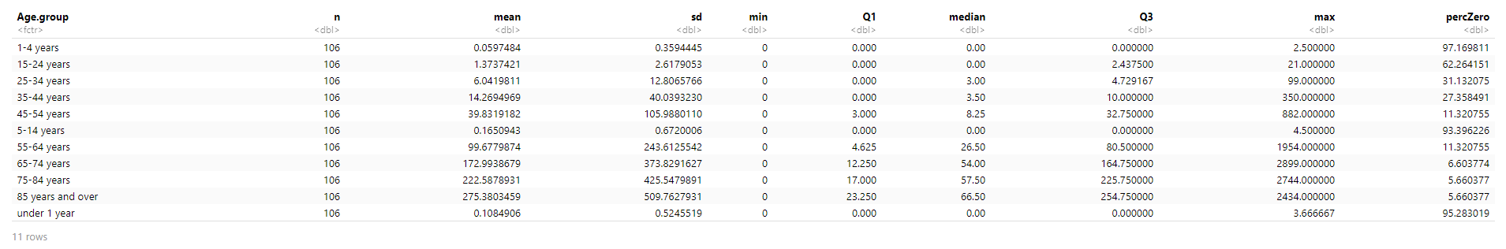

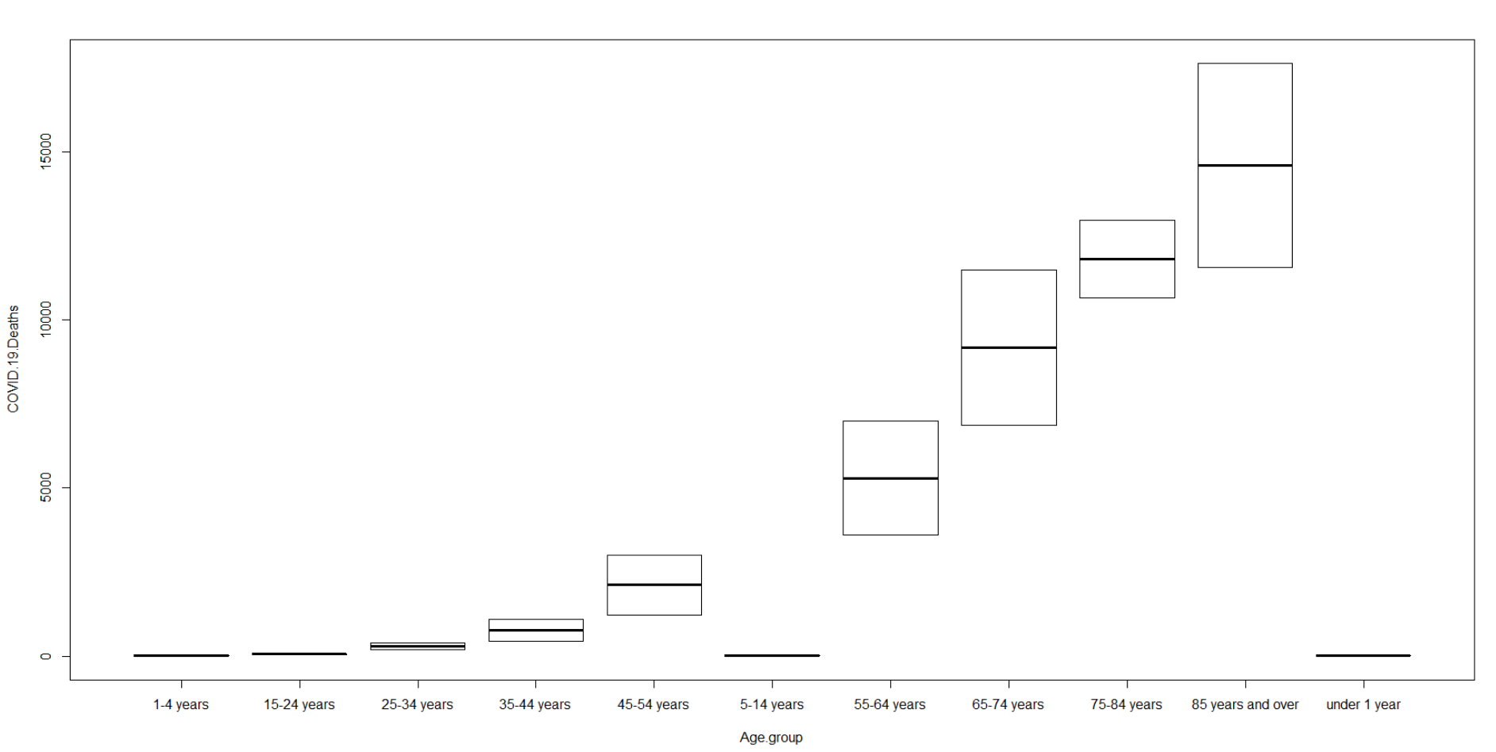



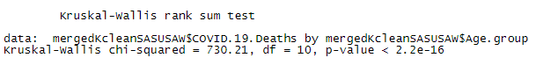

As the p-value< 2.2e-16 is less than the significance level 0.05, we can conclude that there are significant differences distributions between the treatments of age groups. But we don’t know which pairs of age groups are different. Therefore, we are going to apply post-hoc tests:



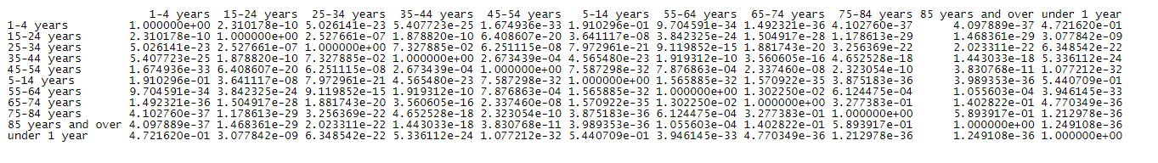

The Kruskal-Wallis test result and post-hoc tests results are same. We can see age group of 85 and over, which P-value (4.097889e-37) is smallest, has the most significant effect to COVID-19 Deaths.

We can also check variable State to apply Kruskal-Wallis test to see the result:

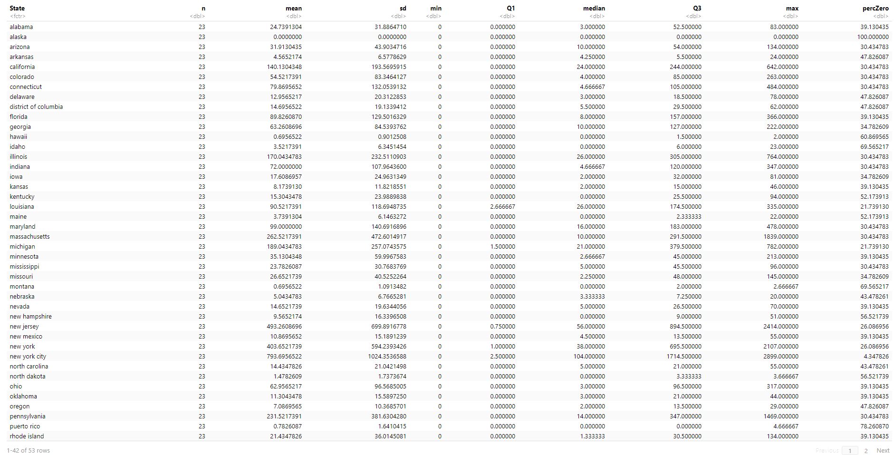

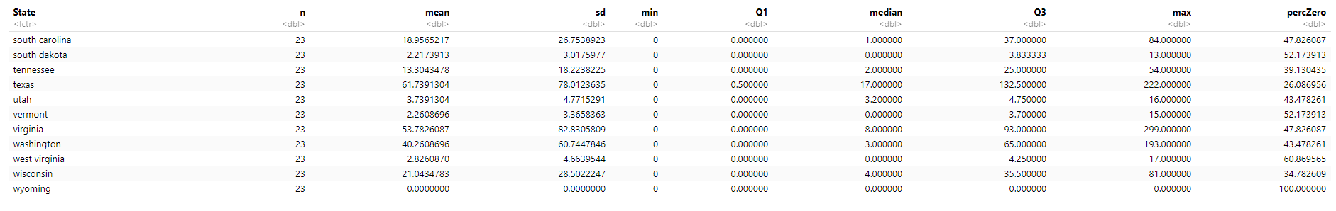

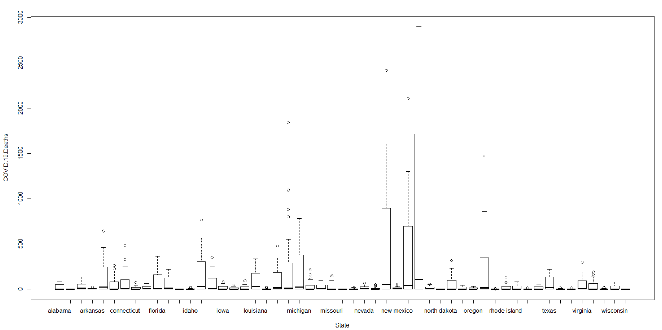



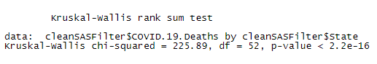

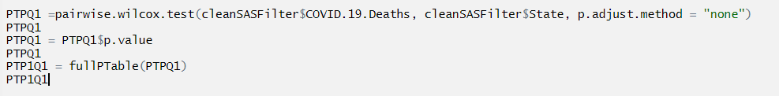

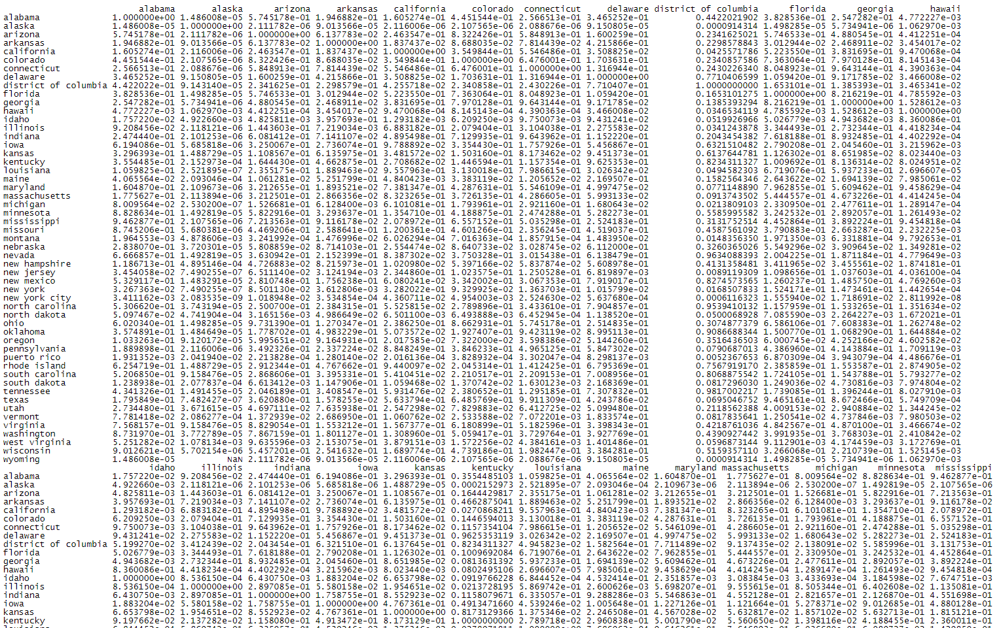

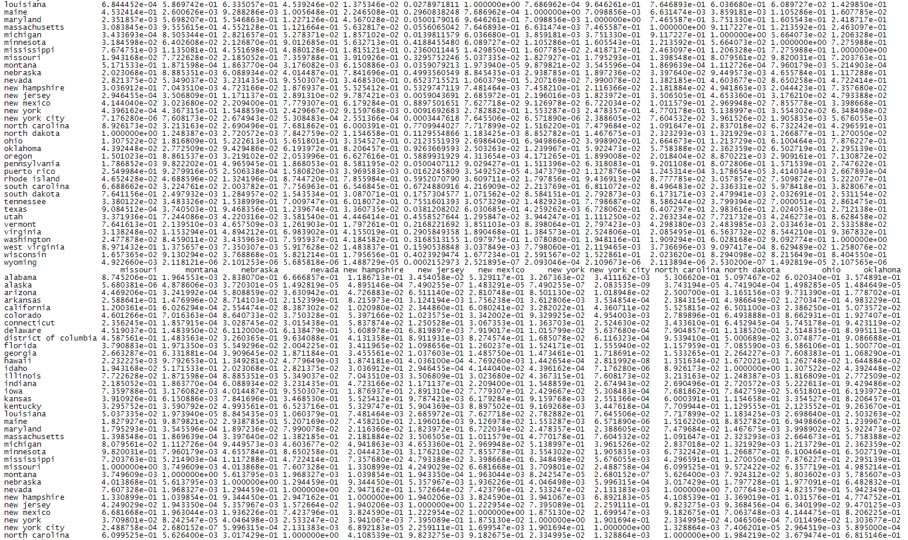

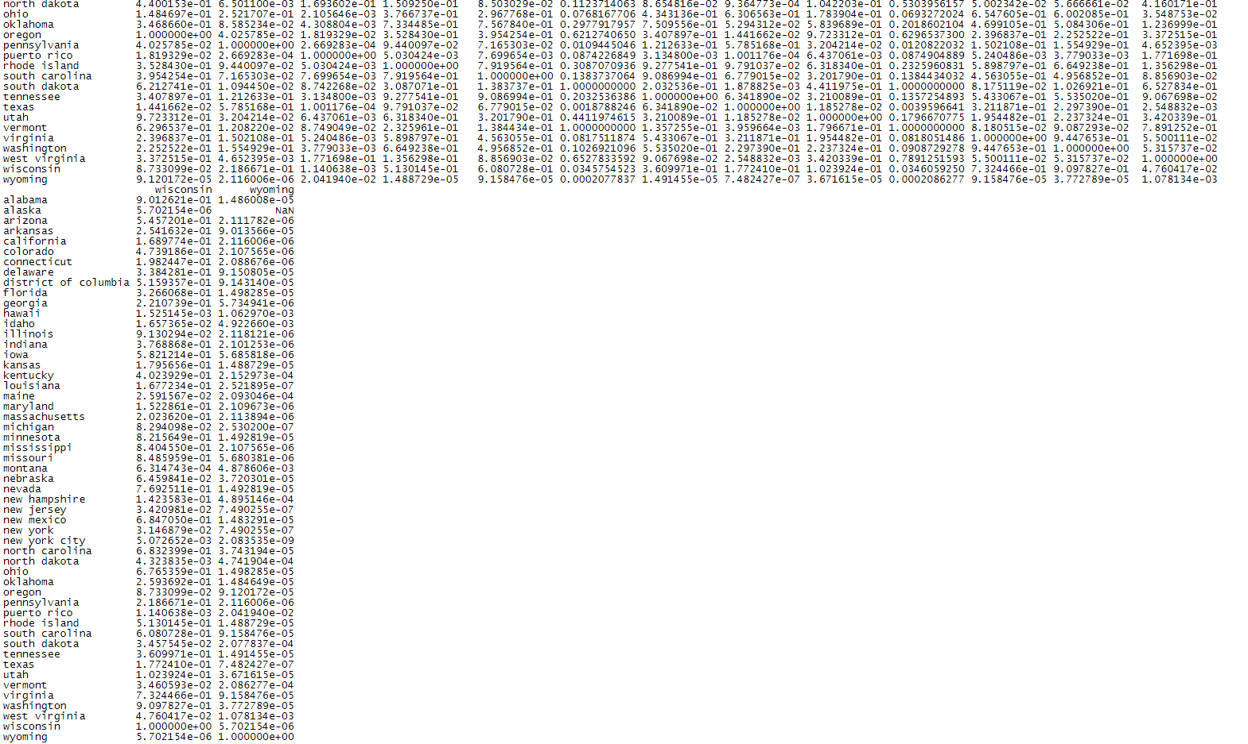

The Kruskal-Wallis test result and post-hoc tests results are same. We can see that State of New York City, which P-value (2.083535e-09) is smallest, has the most significant effect to COVID-19 Deaths.

Friedman Rank Sum Test:

We can treat each Age.group as blocks and COVID.19.Deaths, Pneumonia.Deaths, Influenza.Deaths as treatments for each Age.group. The Friedman test determines if there is a difference in medians among groups for symmetrical OR the test determines if there is a systematic difference in the values among the groups. Therefore, we apply Friedman Rank Sum Test to each Age.group all sexes dataset include Age.group.

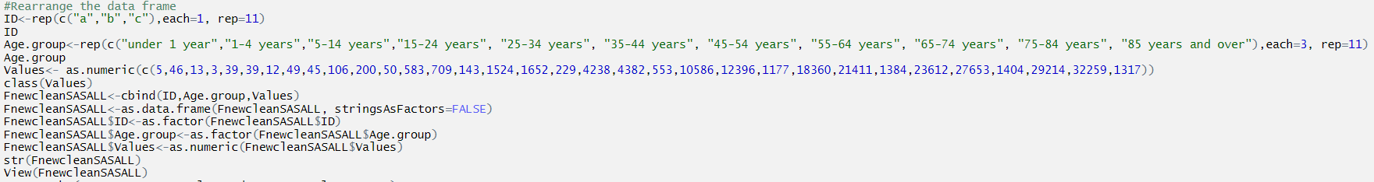

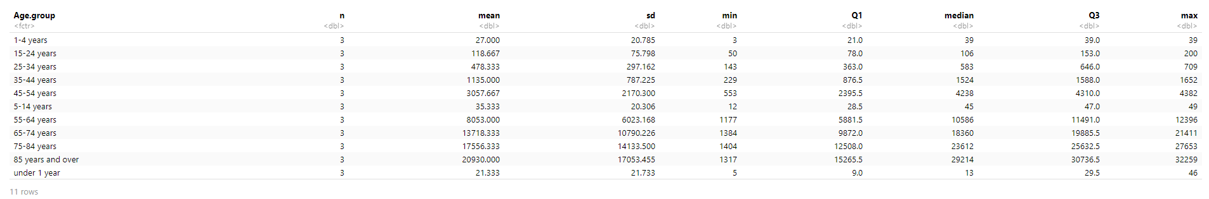



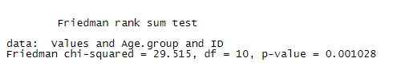

The outcome of the Friedman test tells there are differences among the groups, but doesn’t tell which groups are different from other groups. In order to determine which groups are different from others, post-hoc testing can be conducted. For a post-hoc analysis, the function pairwise.wilcox.test.



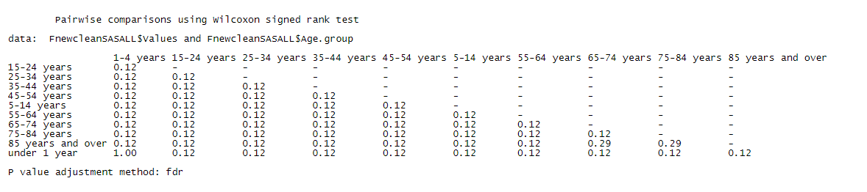

All p-values are > 0.05. No significant difference among groups. We can conclude that the Friedman test is a lower power test to be applied because the treatment groups are small, which in our example is 11.

We can also inference that all COVID-19 DEATHS, Pneumonia Deaths and Influenza Deaths have same distributed data for all age groups. COVID-19 DEATHS, Pneumonia Deaths and Influenza Deaths have strong correlations.

**Supervised Classification Methods Analysis:**

Binomial Logistic Regression:

Logistic Regression/binary logistic regression/binomial logistic regression/logit model. It is used to model a binary outcome, which is a variable, which can have only two possible values: 0 or 1. A positive b1 indicates that increasing x will be associated with increasing P. Conversely, a negative b1 indicates that increasing x will be associated with decreasing P. The odds reflect the likelihood that the event will occur. It can be seen as the ratio of “successes” to “non-successes”. Technically, odds are the probability of an event divided by the probability that the event will not take place. P = Odds/ (1 + Odds). Odds=P/ (1-P). If the odds ratio is 2, then the odds that the event occurs (event = 1) are two times higher when the predictor x is present (x = 1) versus x is absent (x = 0). For a well fitted model: the residual deviance = df = n-1. P=0.5, we got the median value of independent variable.

In this dataset, we use male and female as binary outcome to see the result. The process is quite similar as linear regression analysis. After apply PCA and data splitting as training and testing datasets, we get the following:



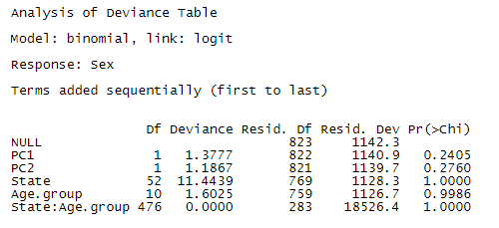

After applying Forward feature construction, we get:

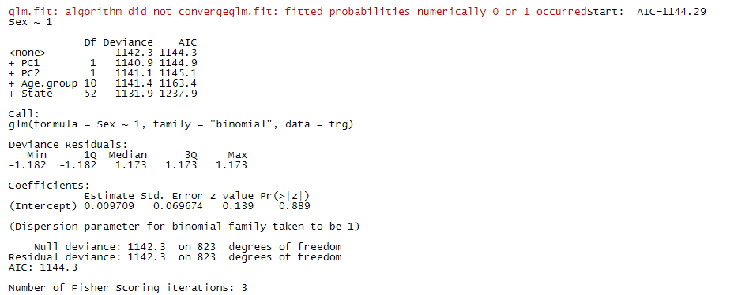

It means Sex is not an informative variable to be predicted. It also means the variable Sex is not useful to do prediction on COVID.19 deaths.

Multinomial Logistic Regression:

Multinomial Logistic Regression requires a large sample size. We make COVID.19.Deaths as categorical variables. We divide the numerical variables COVID.19.Deaths as 4 factorial variables:



We treat COVID-19 Deaths categorical “0” as reference level:



The initial model as following:

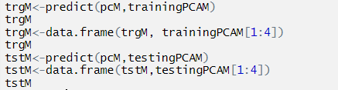



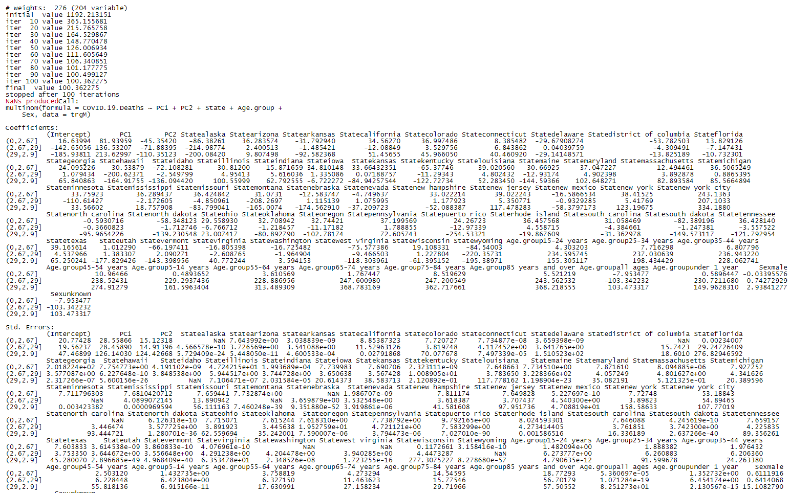



For best fitted model: we have to exclude the variable Sex.



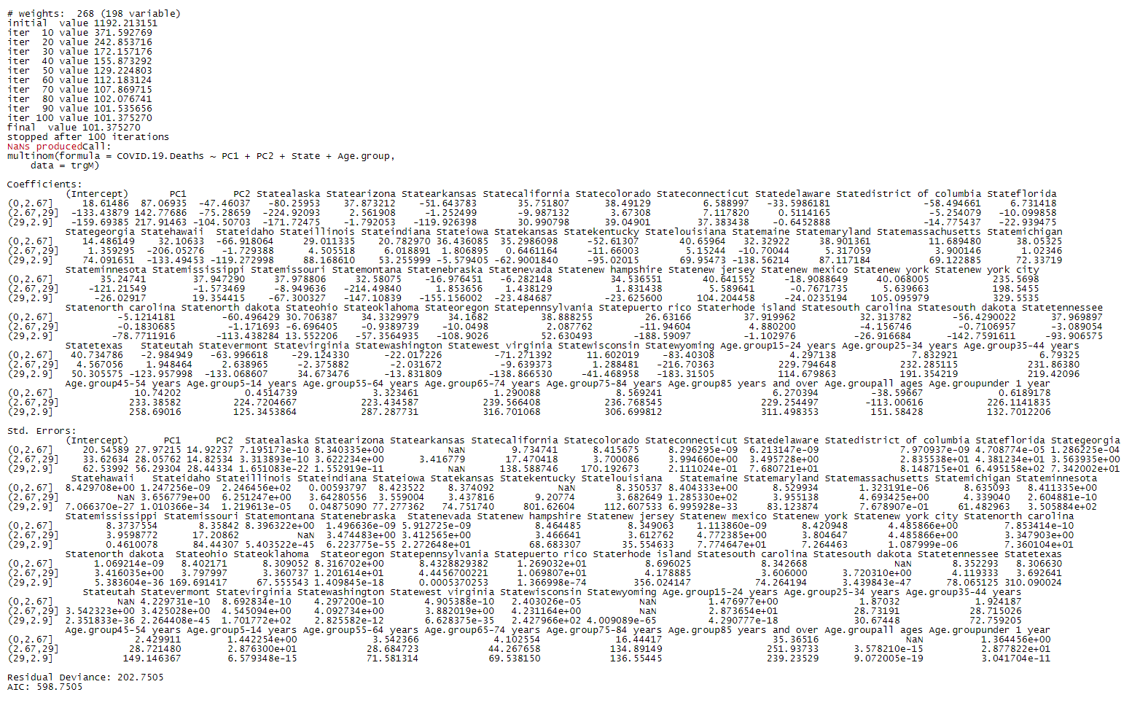

The relative risk (odds), we got following:



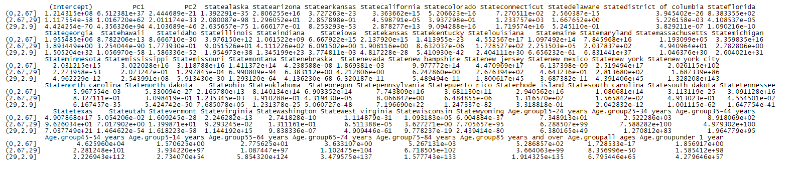

I use quick plot to see the data:

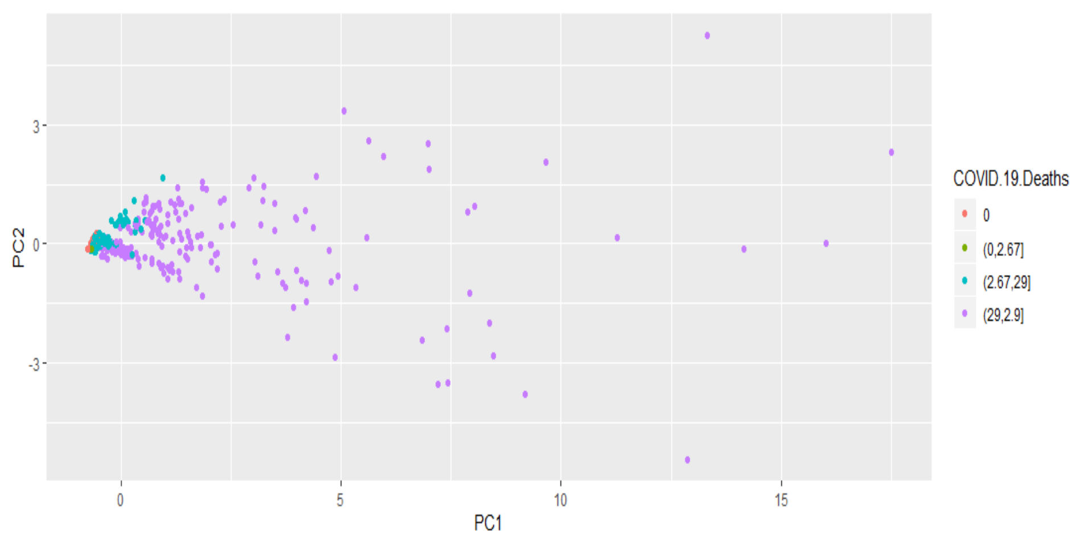

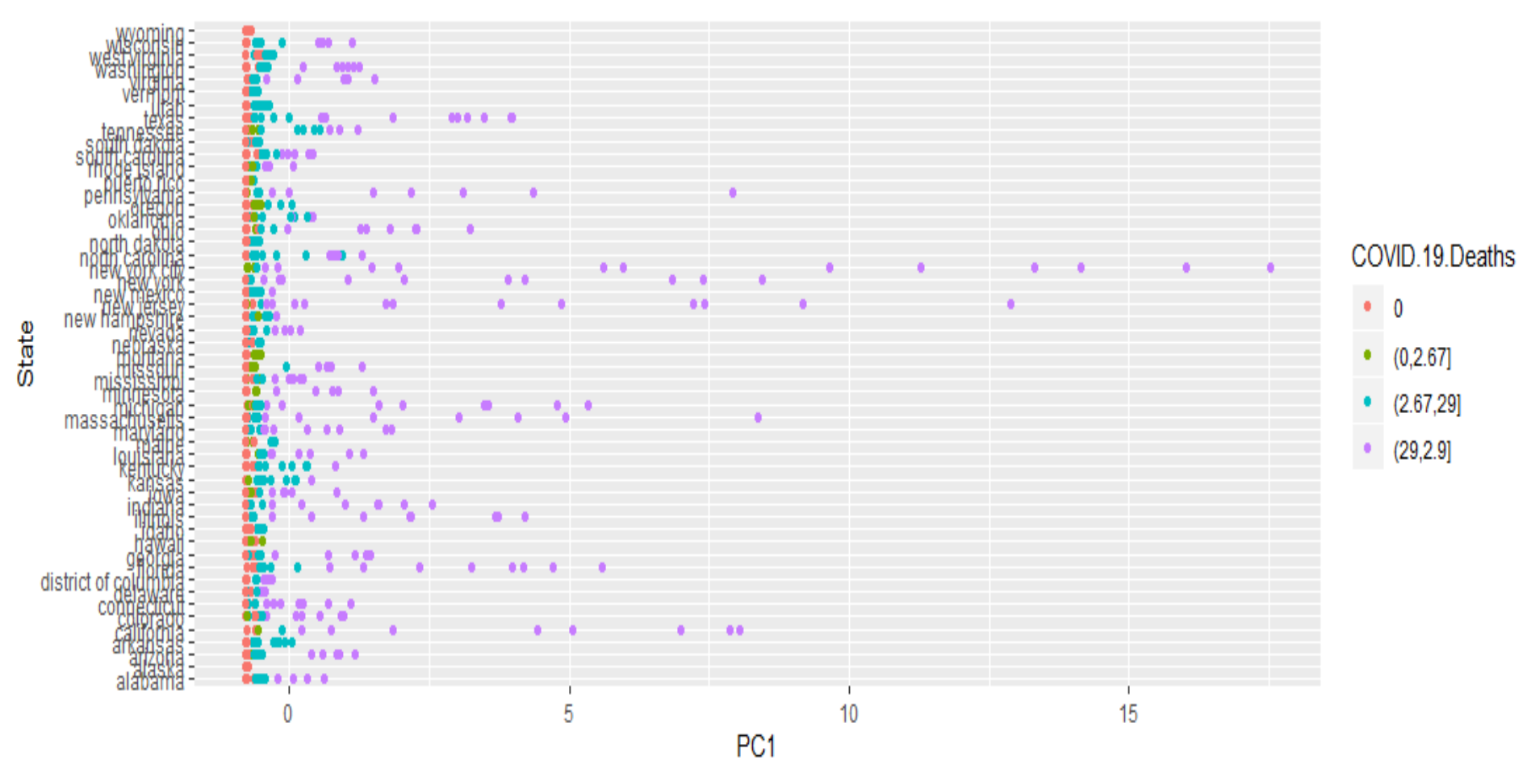

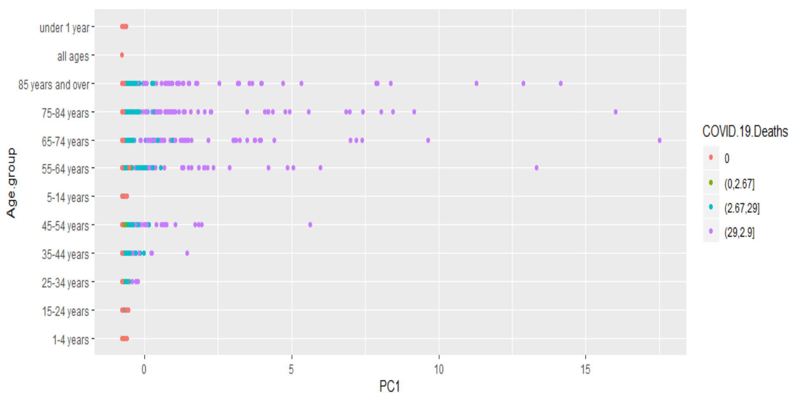

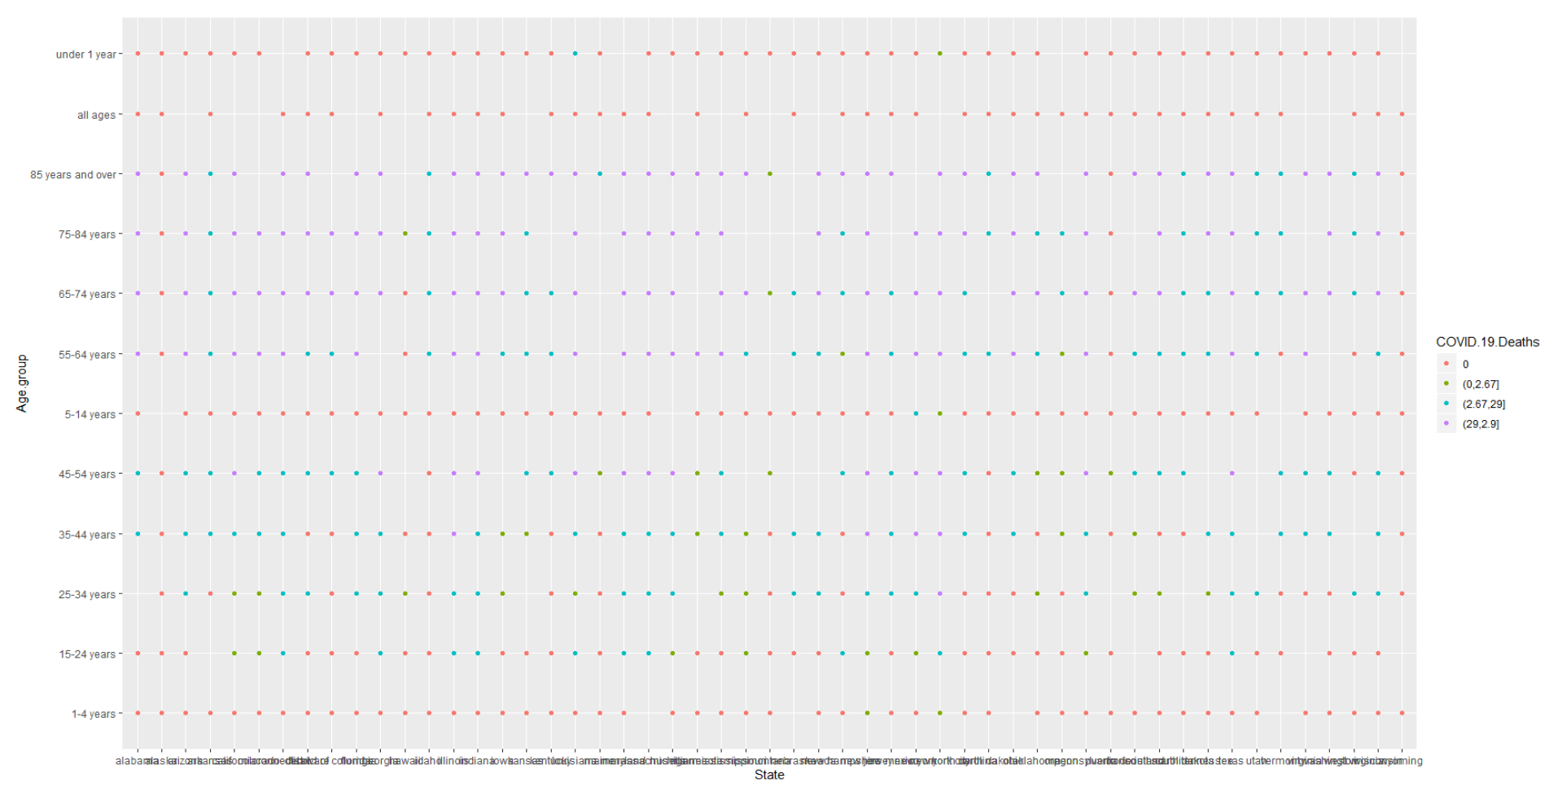

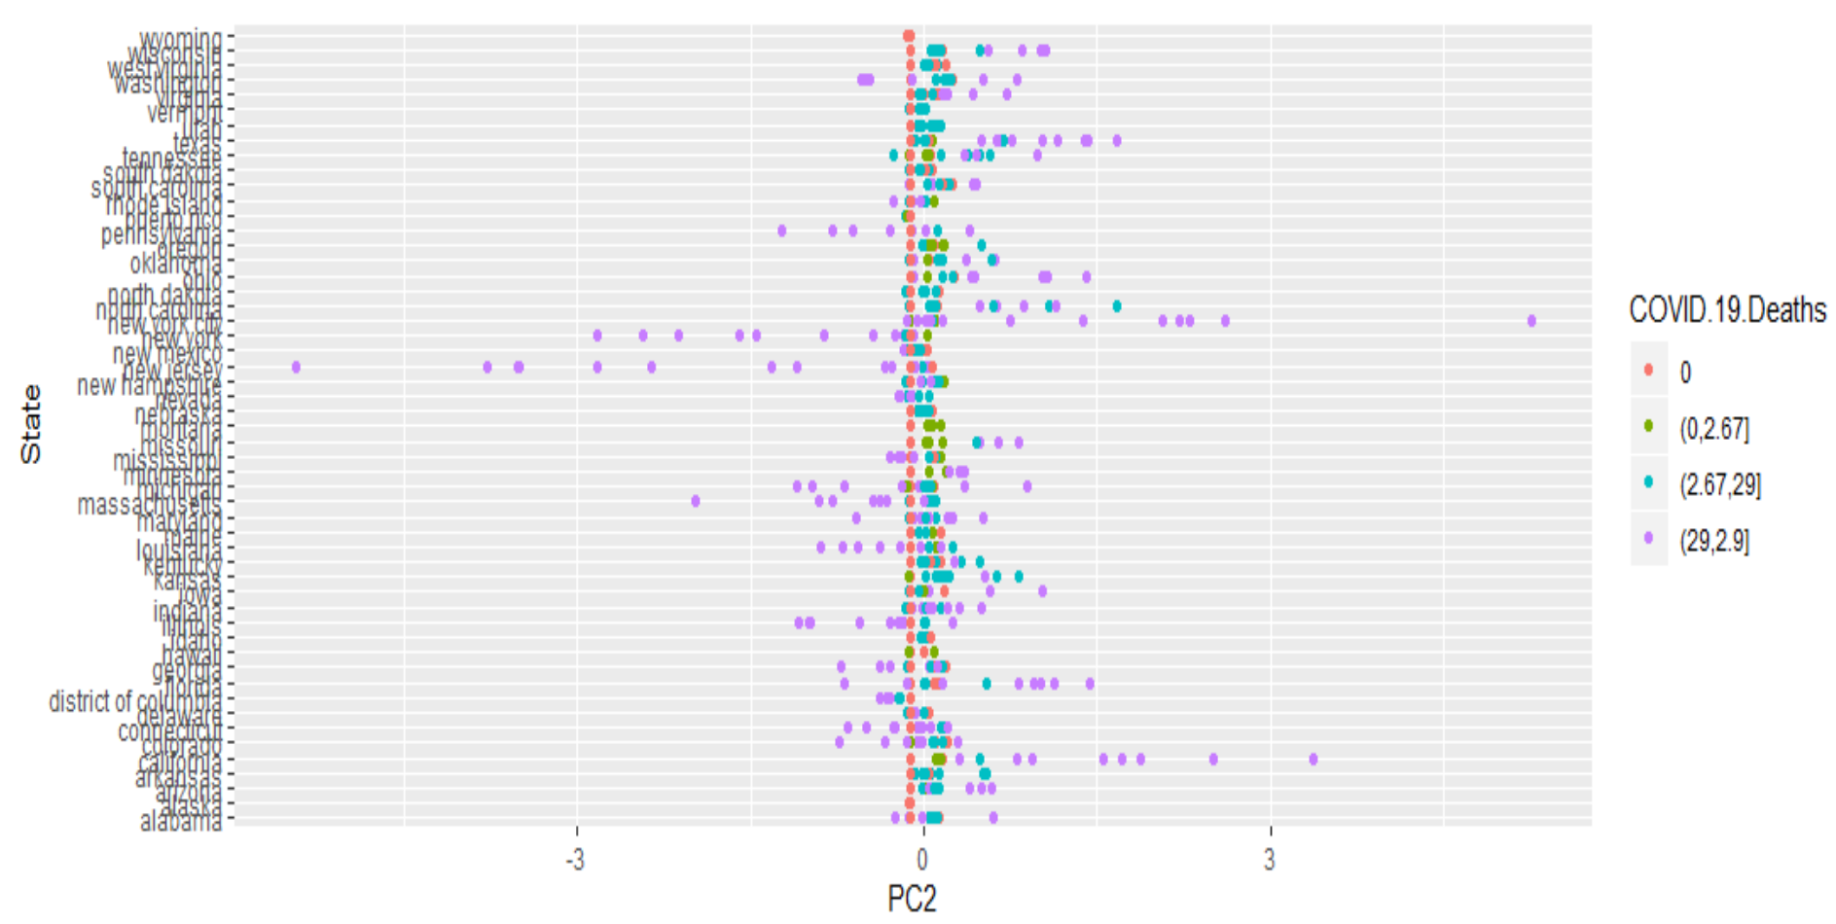

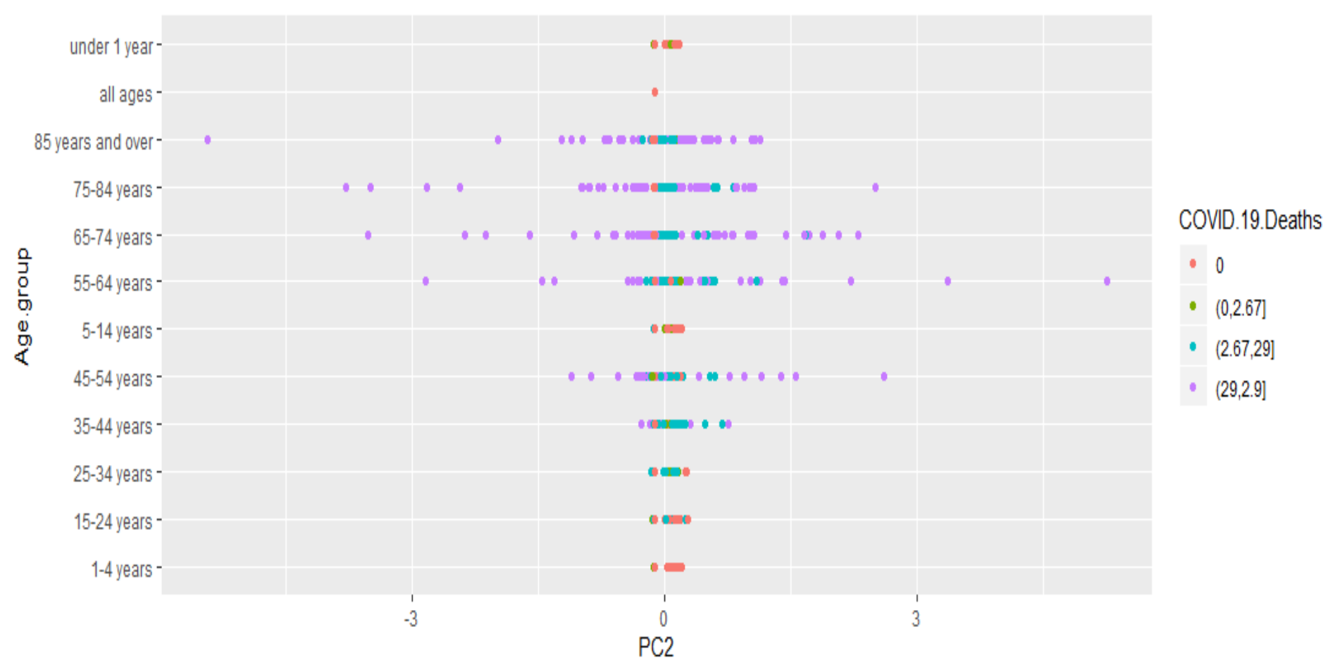

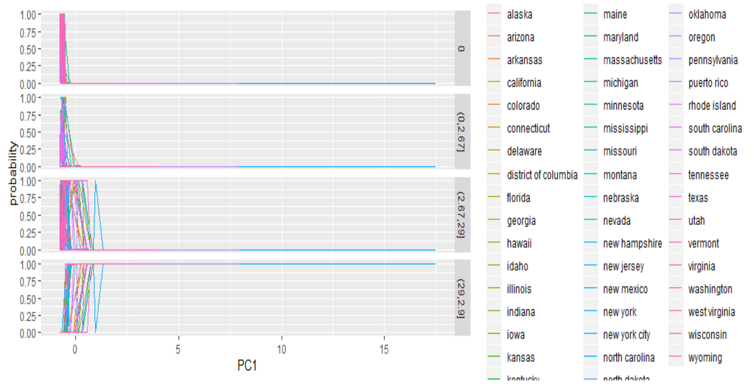

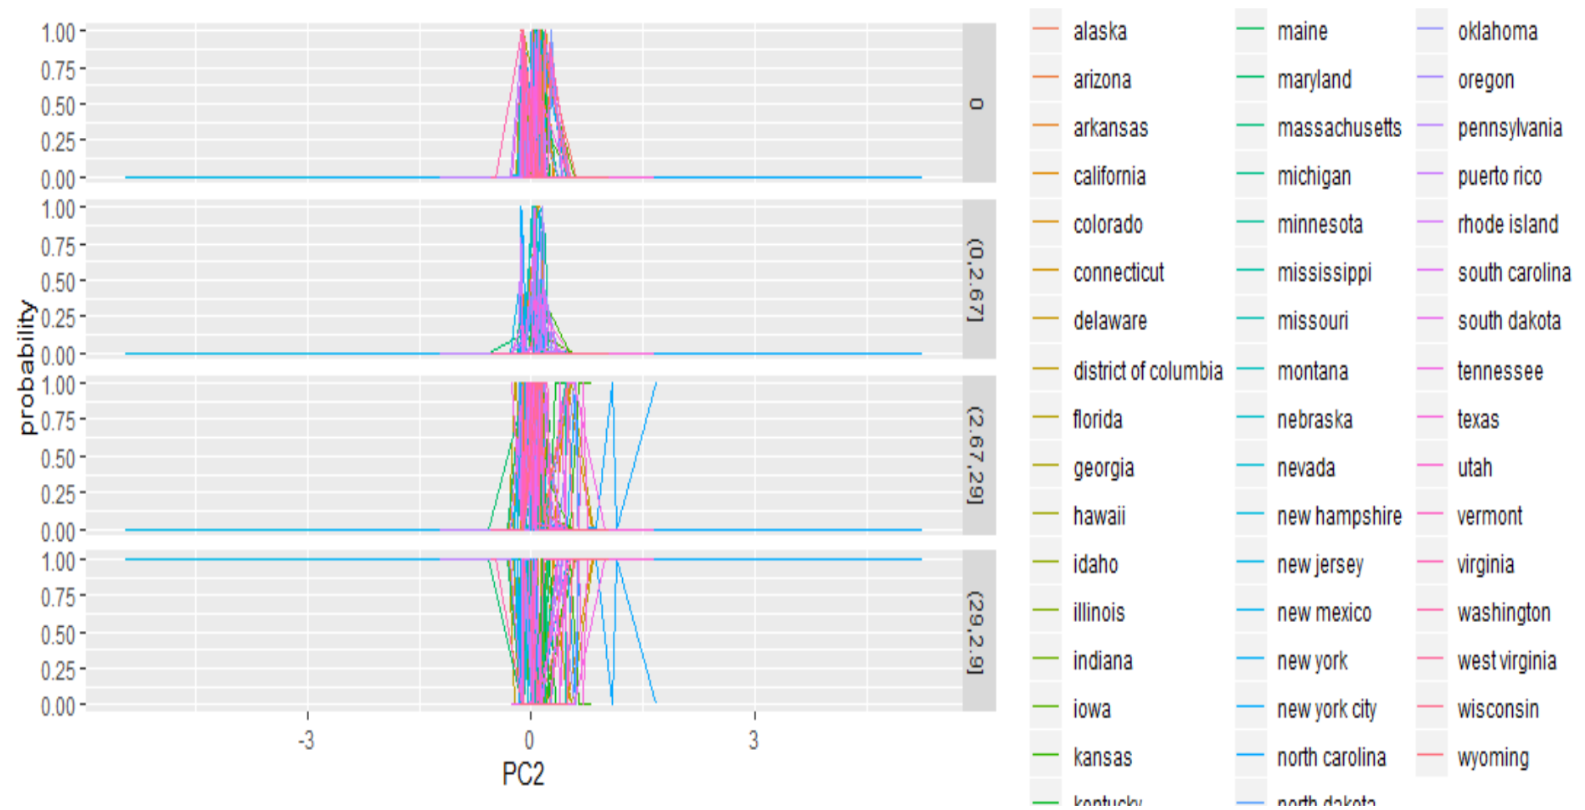

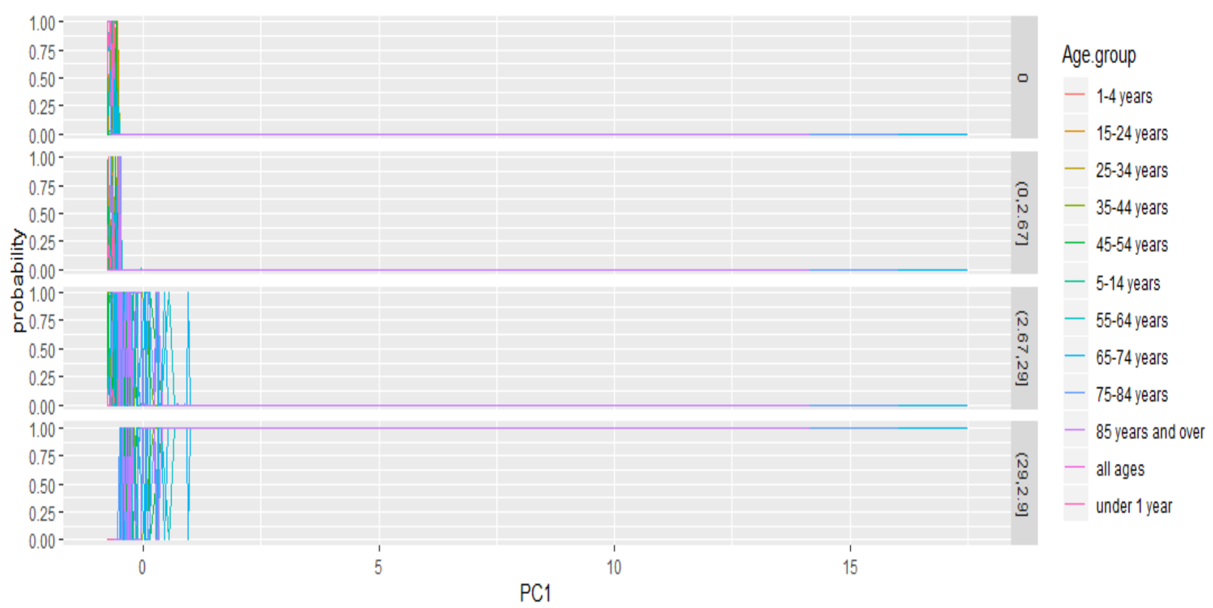

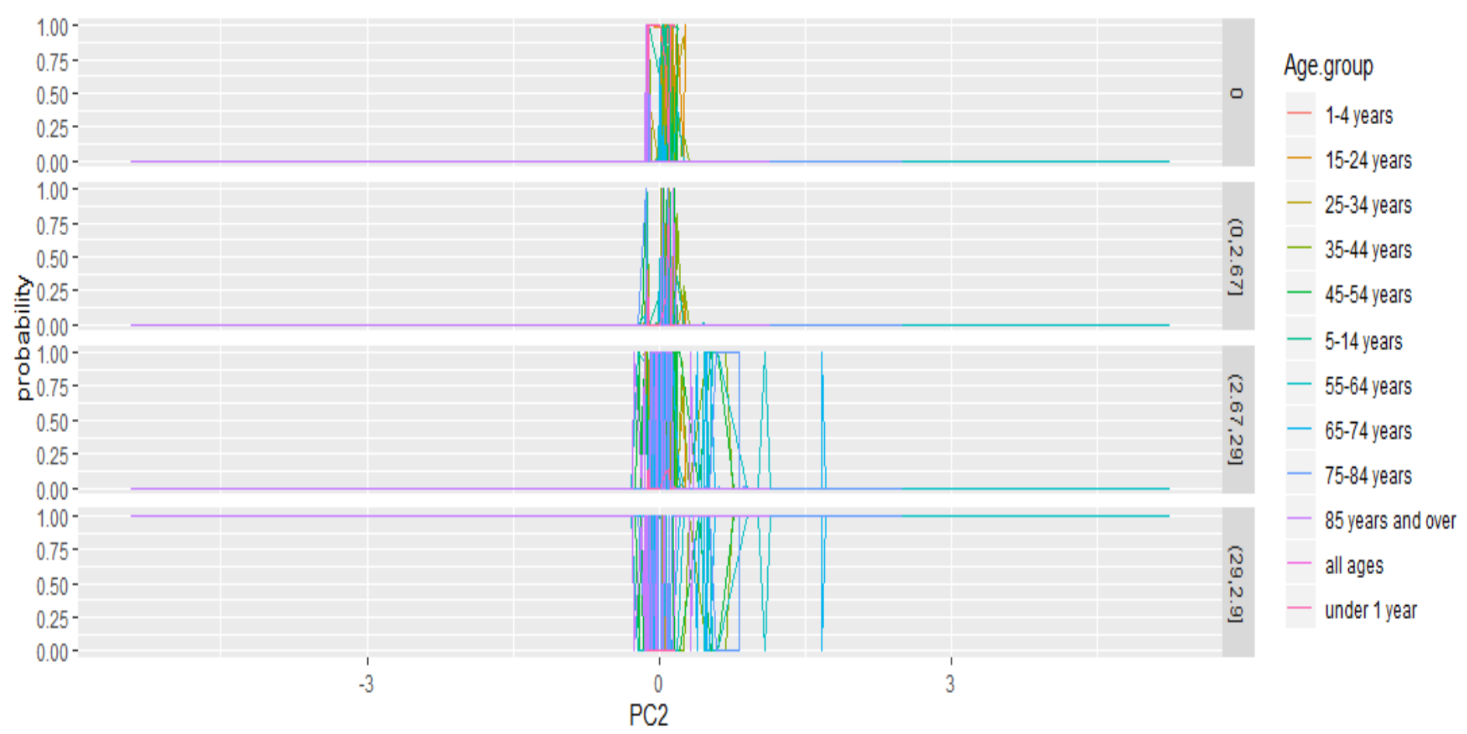

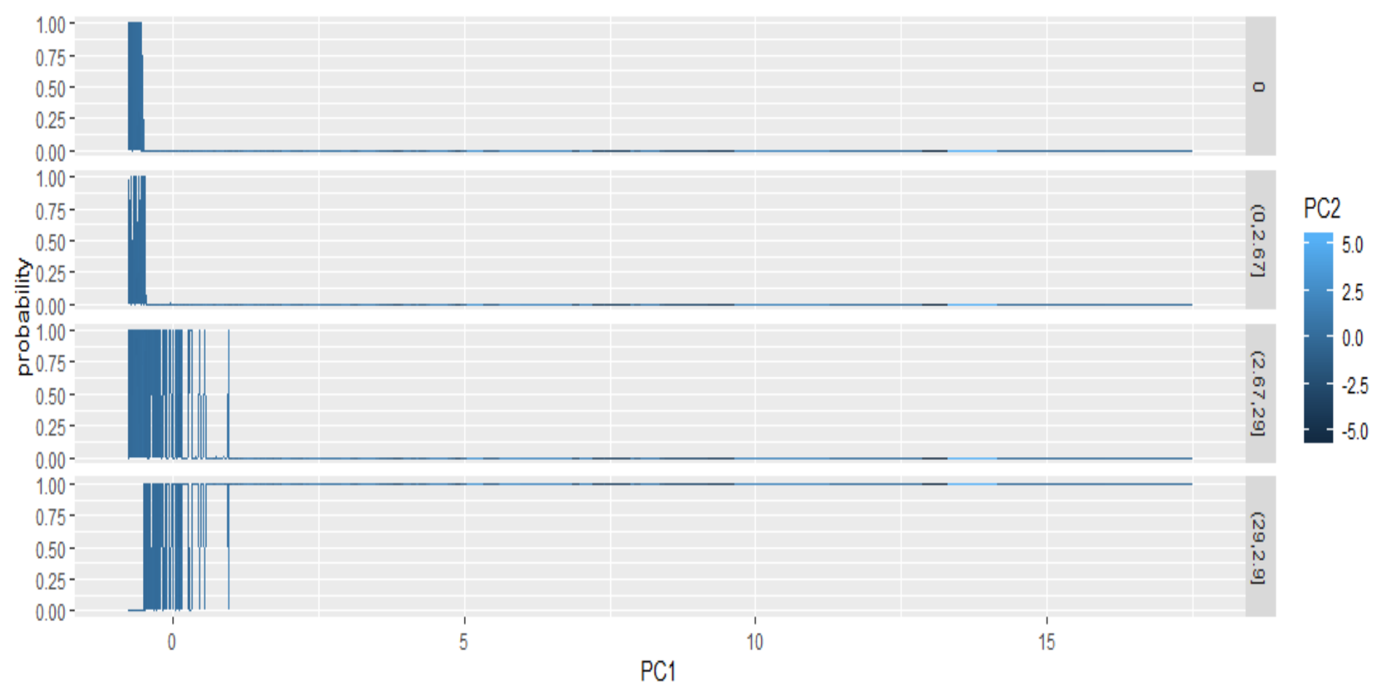

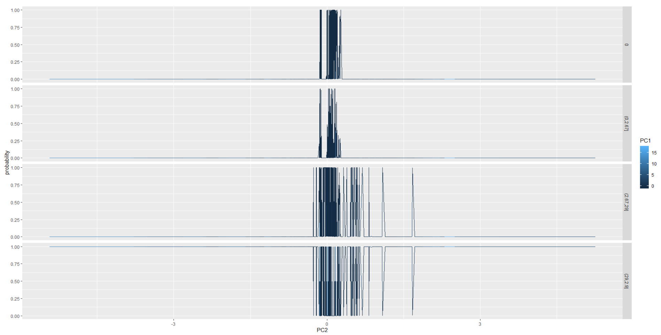

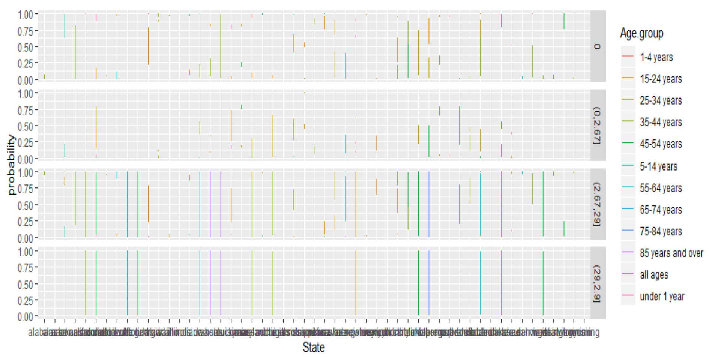

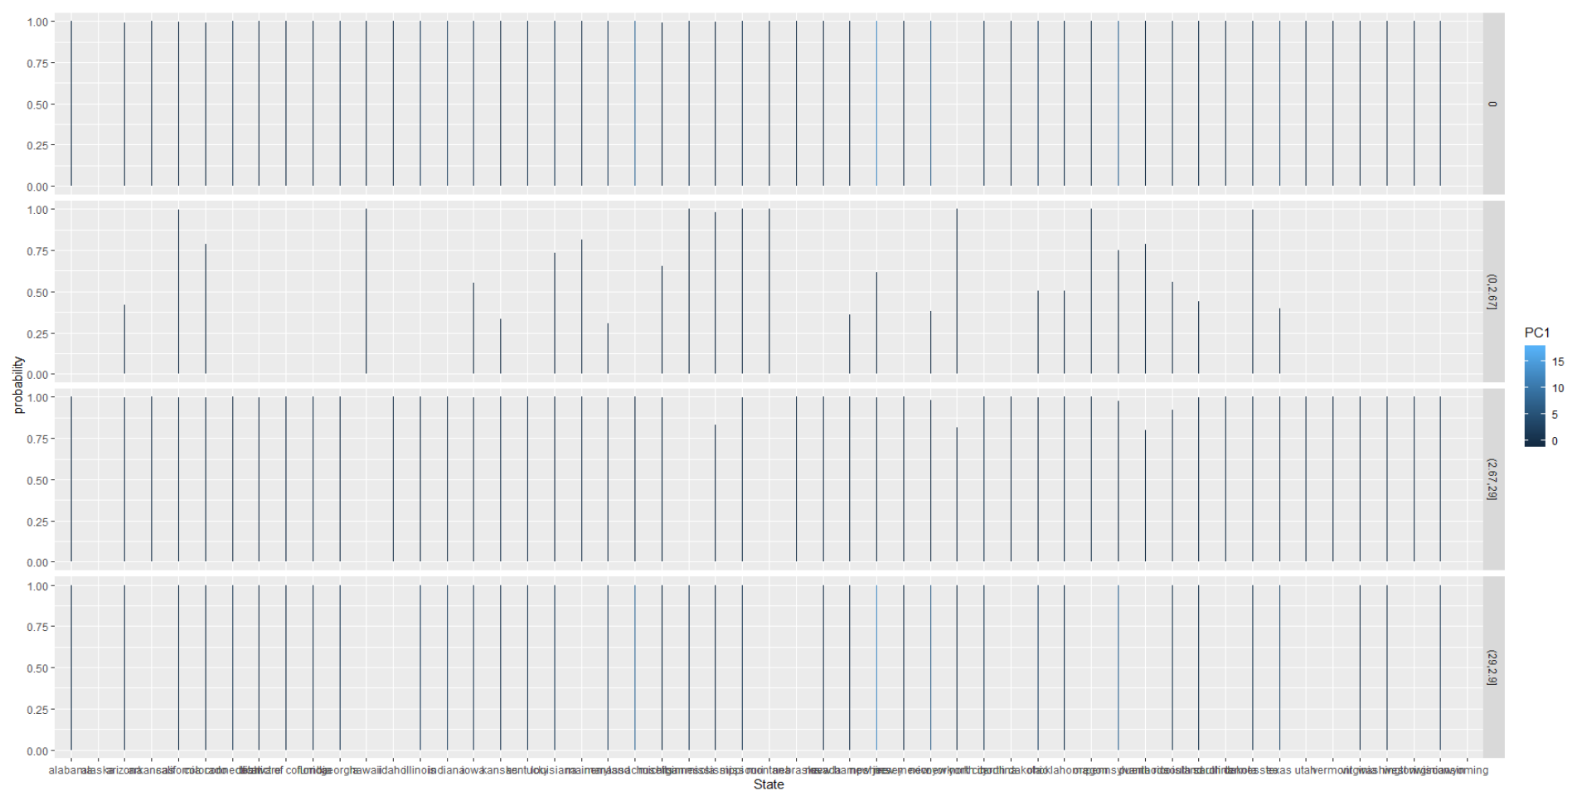

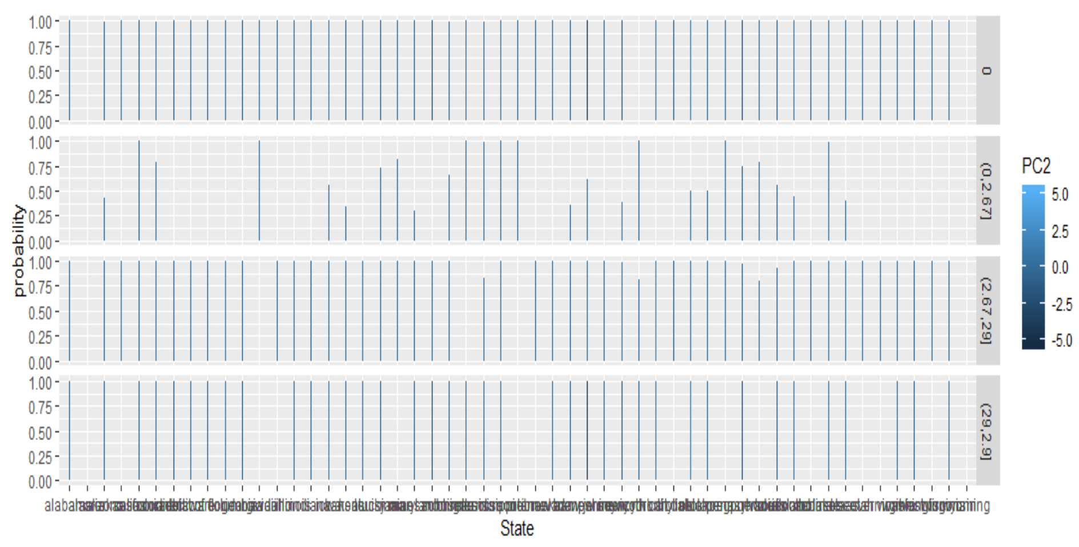

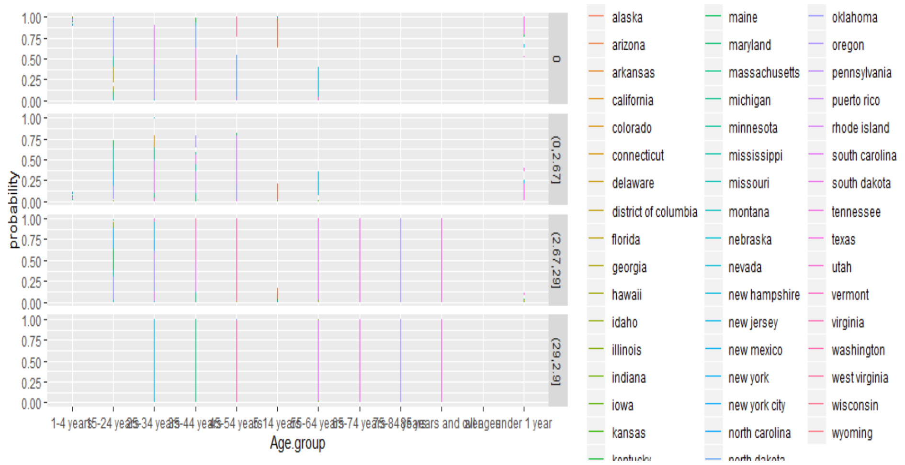

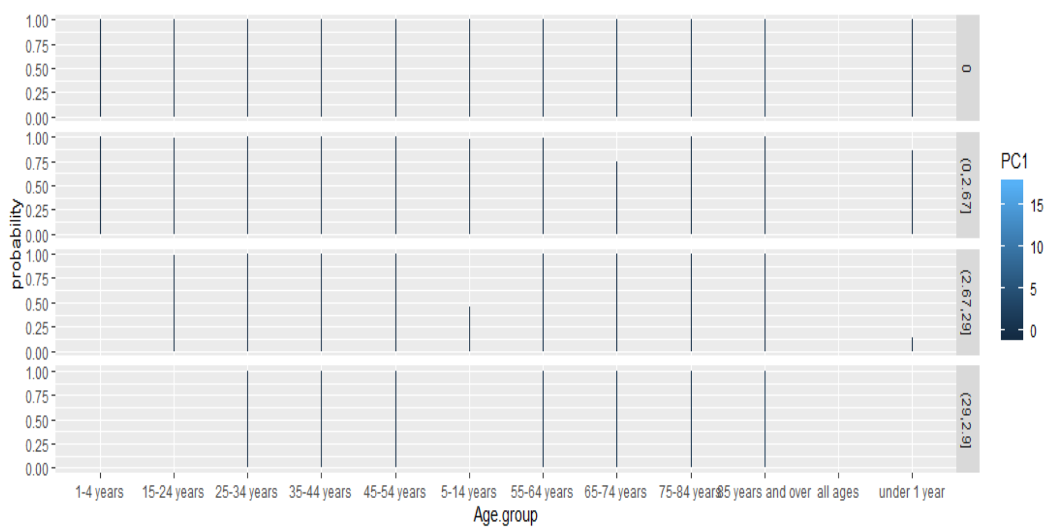

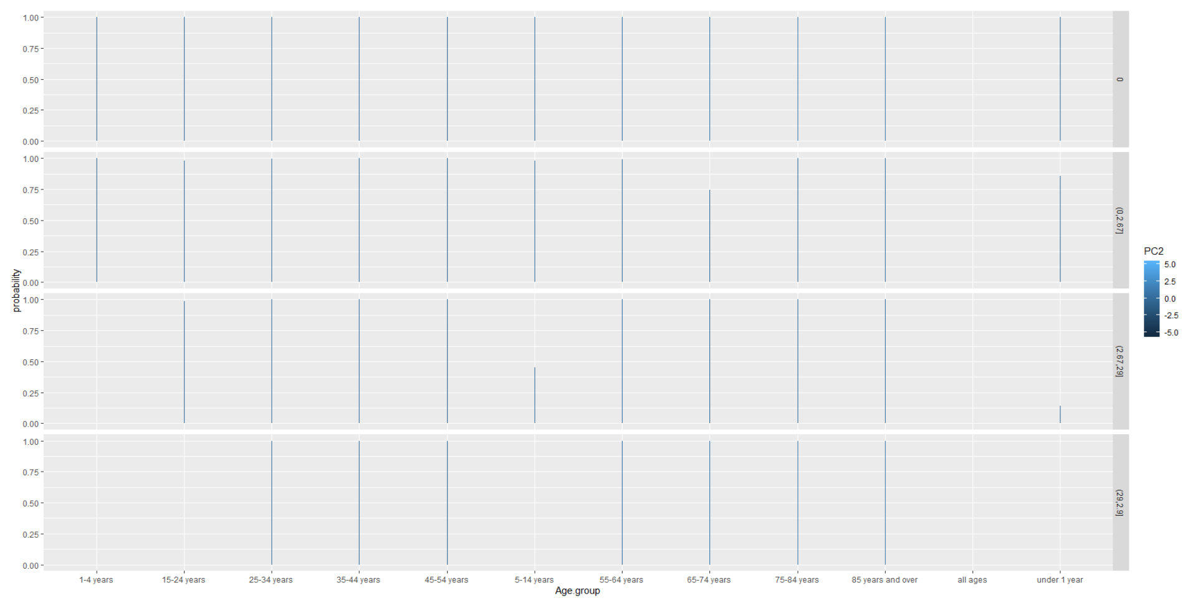



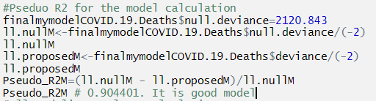

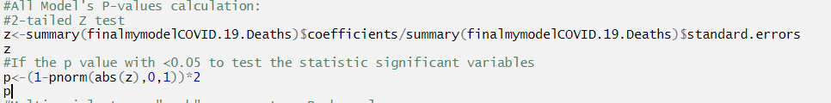

All P-values we get:

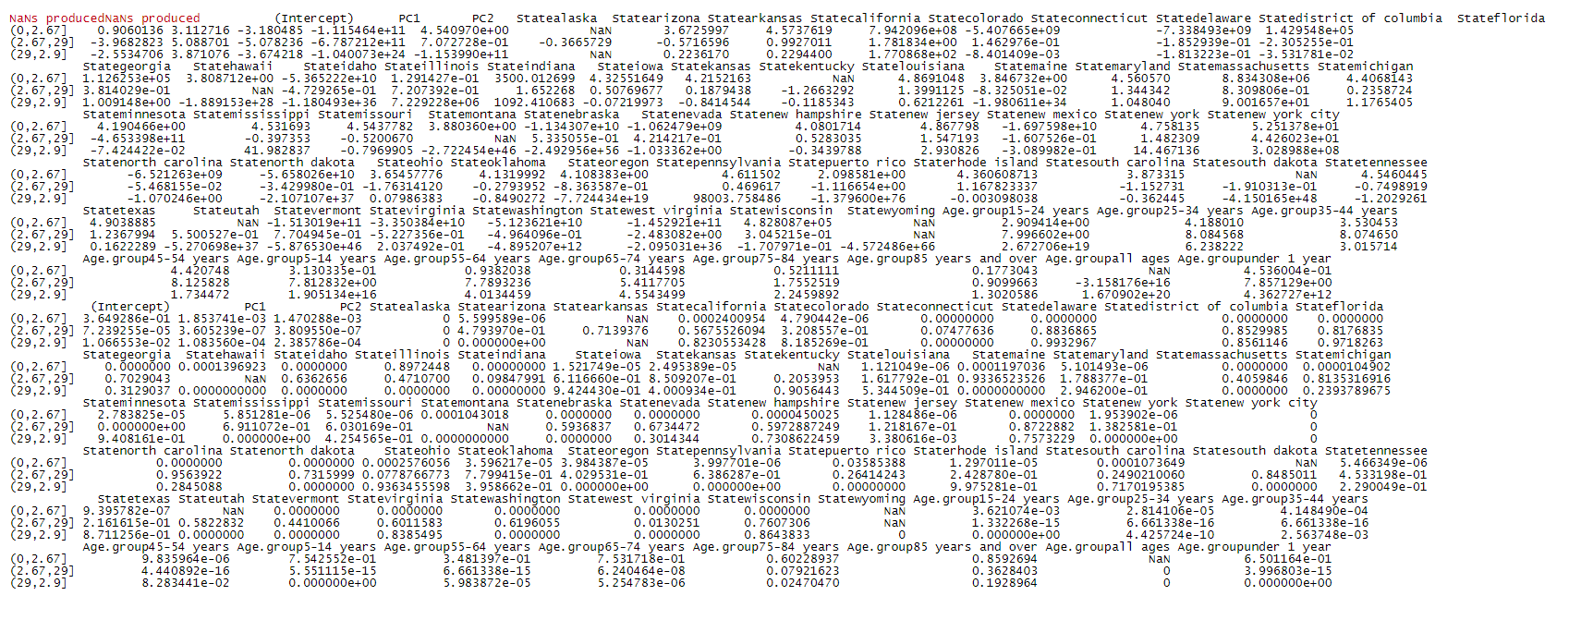

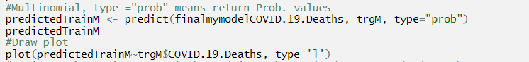

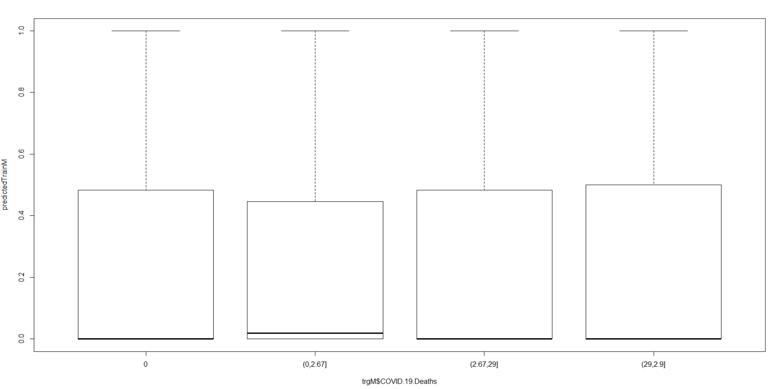

Prediction on the train dataset:

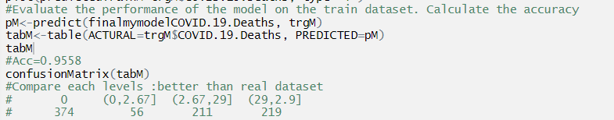

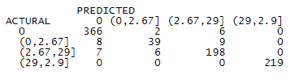

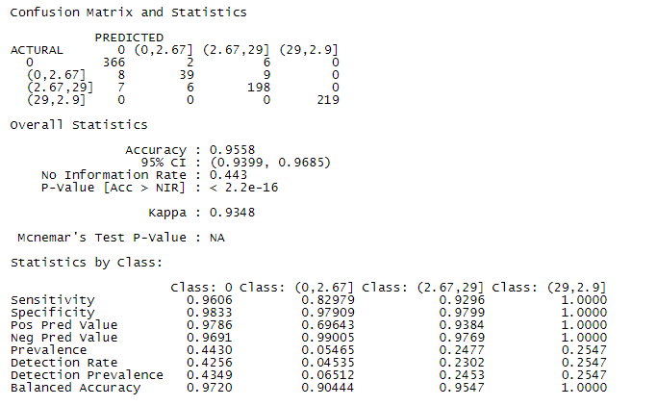

Real values in the train dataset:

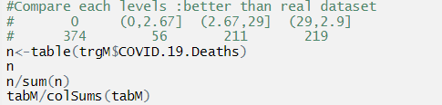

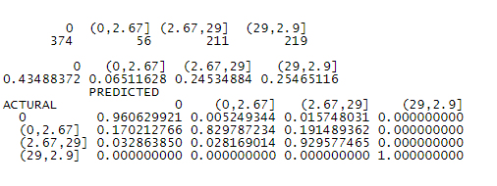

Prediction on test dataset:

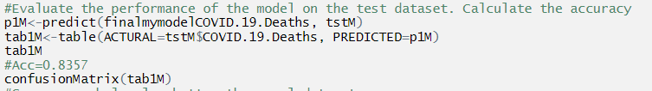

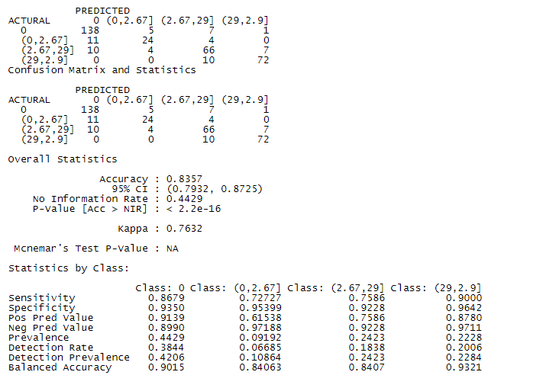

Real values in the test dataset:

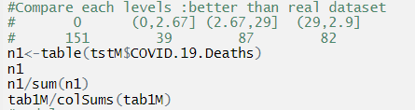

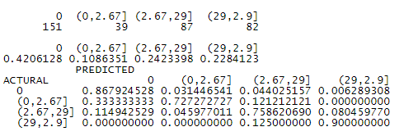

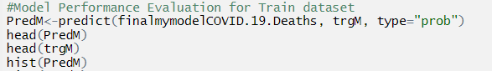

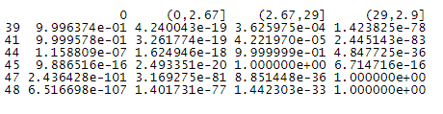

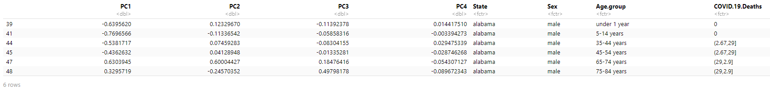

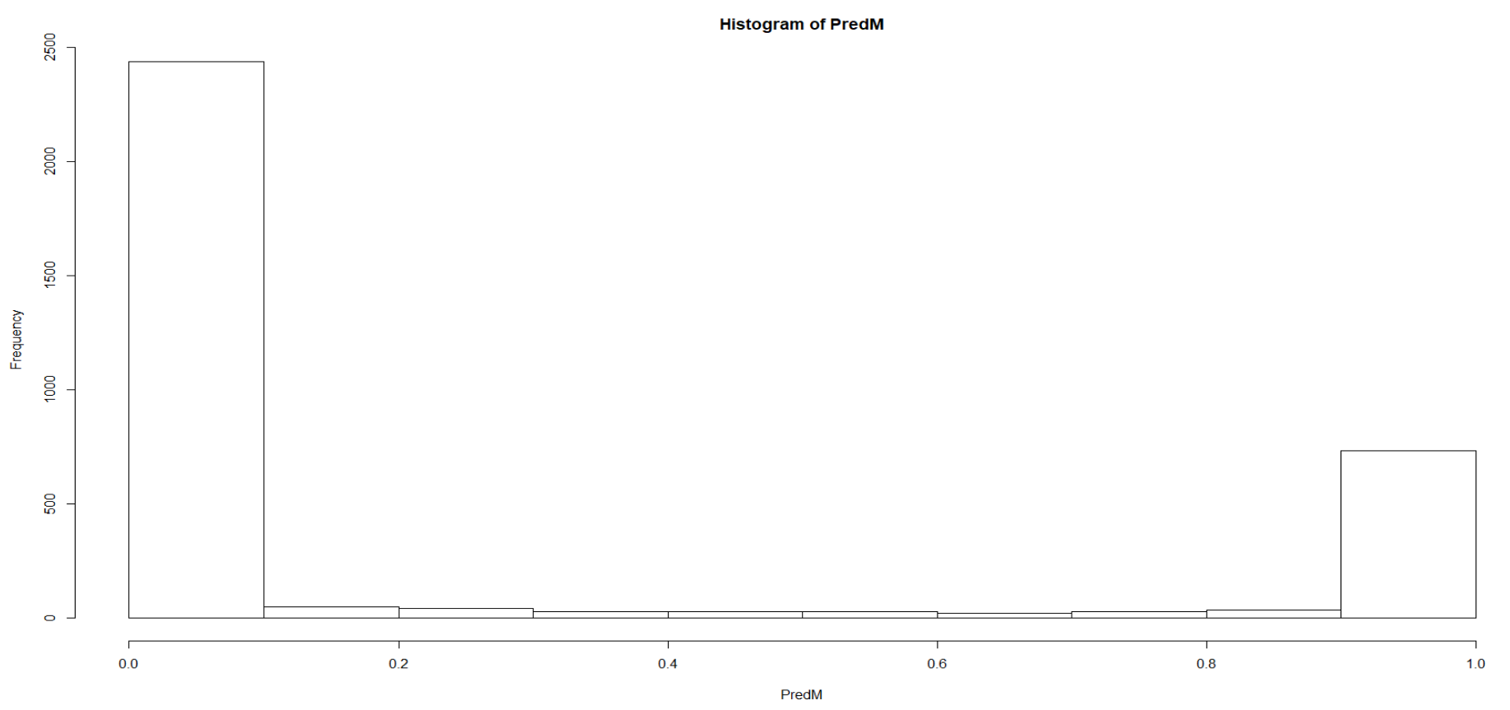

We compare the predicted values (probabilities) with train dataset real values categories. It is good because for first 6 data they are all matched correctly.

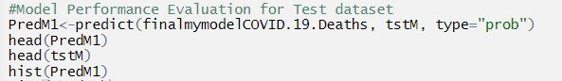

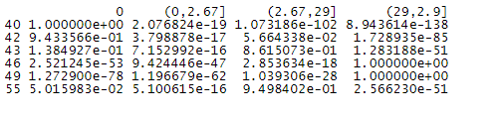

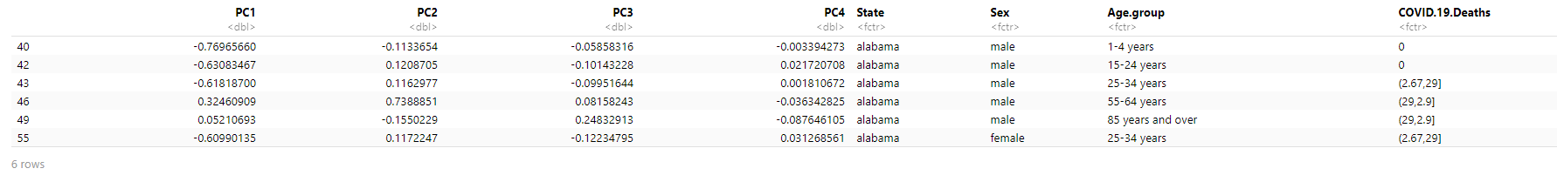

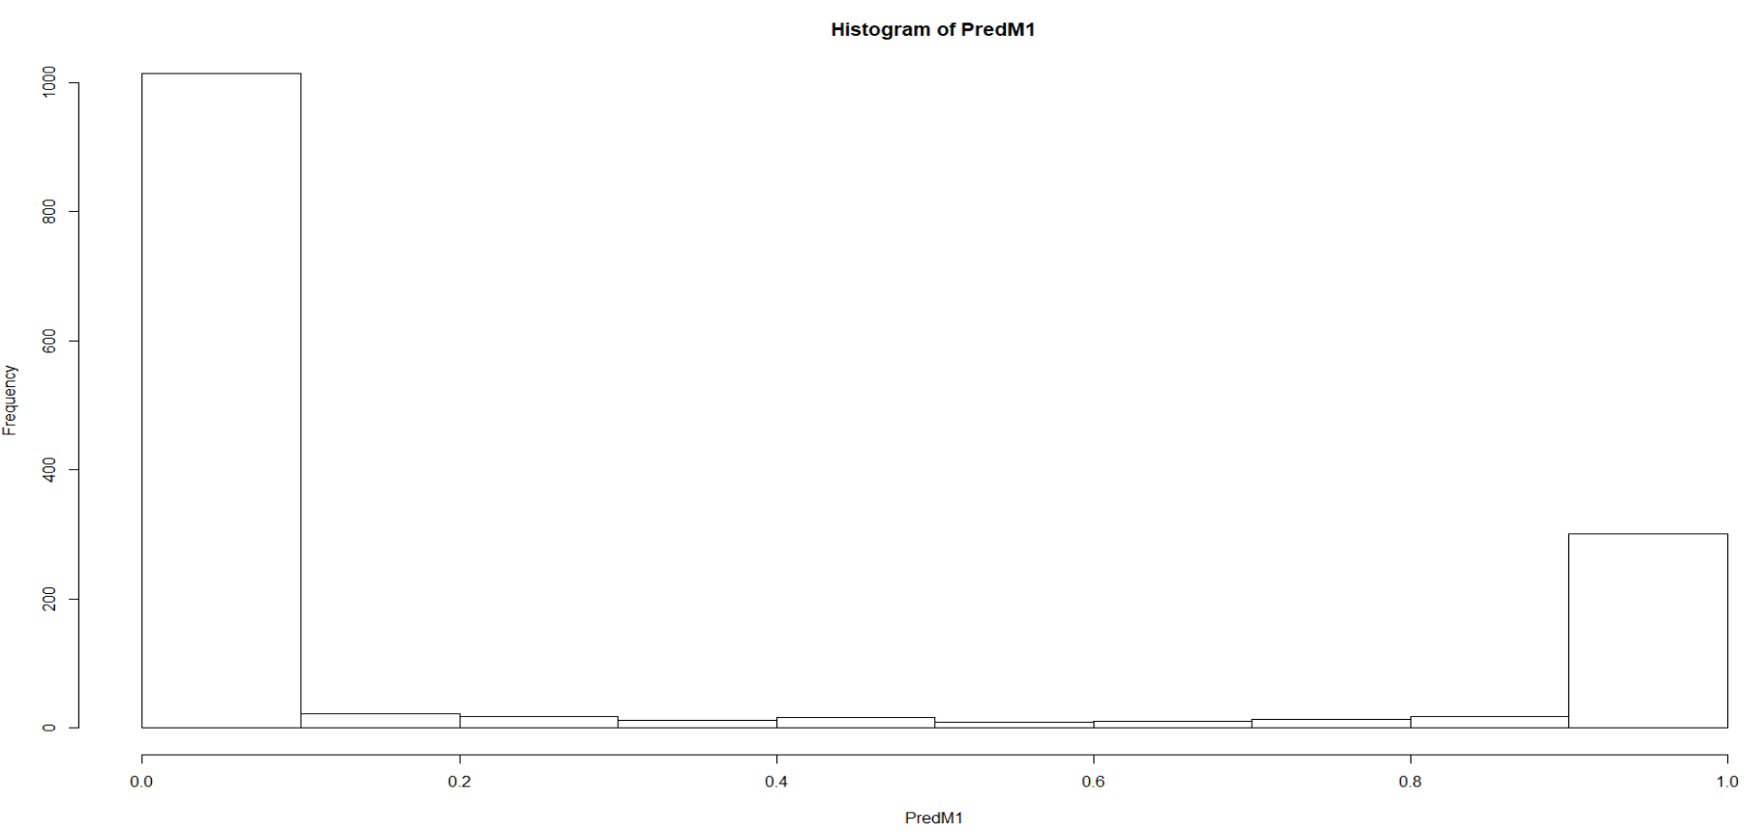

We compare the predicted values (probabilities) with test dataset real values categories. It is good because for first 6 data they are all matched correctly.

We can draw the ROC curves for multinomial logistic regression: the overall average area of AUC is 99.27236%. It is a good model to do prediction on COVID-19 Deaths.



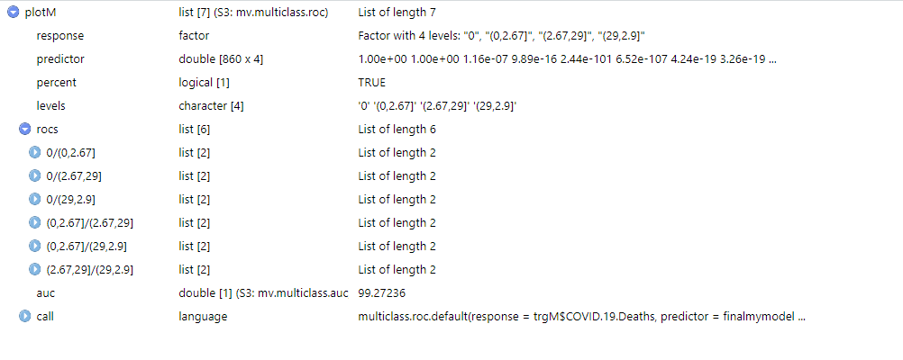

Random Forest:

Random Forest can be classification (y is categorical). The No. of variables (features) tried at each split mtry=sqrt (#of features). Outer of Bag error is accuracy. Random Forest can be regression (y is continuous). The No. of variables (features) tried at each split mtry= (#of features)/3. Outer of Bag error is R2 or RMSE. It is good for avoiding overfitting. For Classification: use majority rule. For Regression: use average for regression ntree trees. The ntree is default=500.



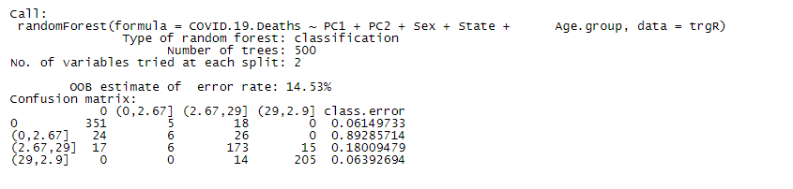

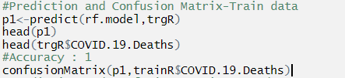

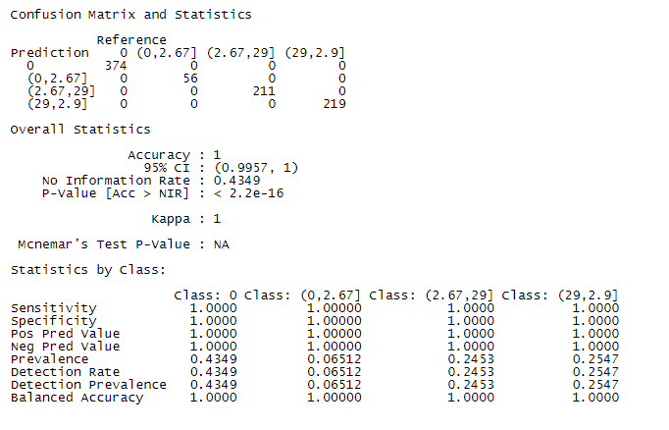

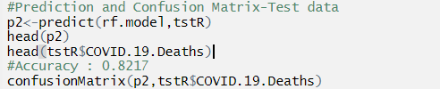

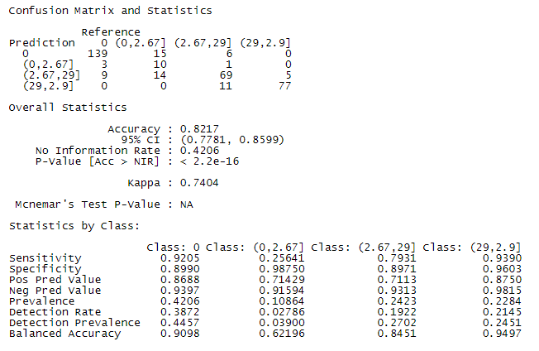

We can see ntree=300 for all of errors be approximately straight line:

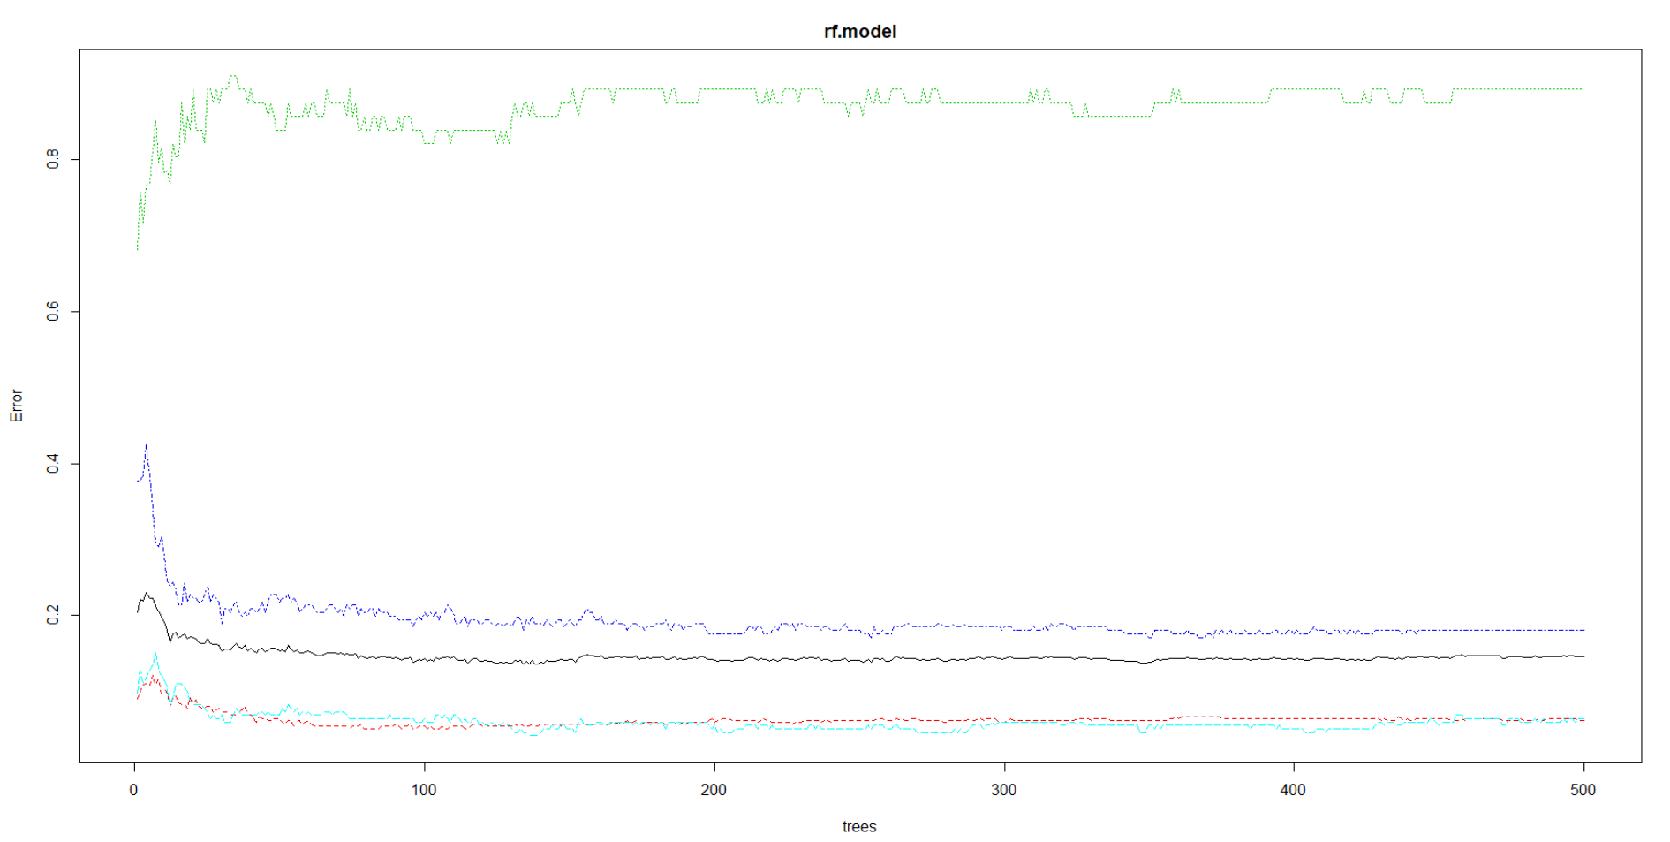

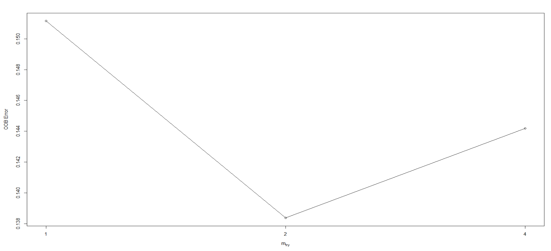

We get mtry=2 to get minimum OOB error.



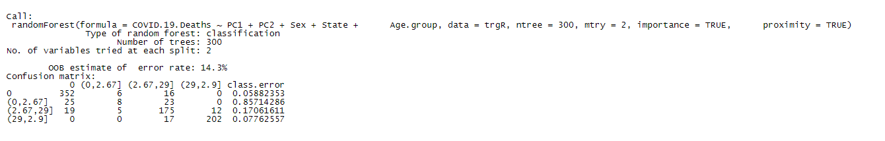

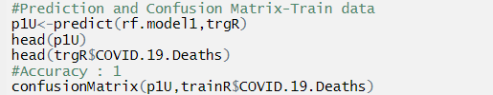

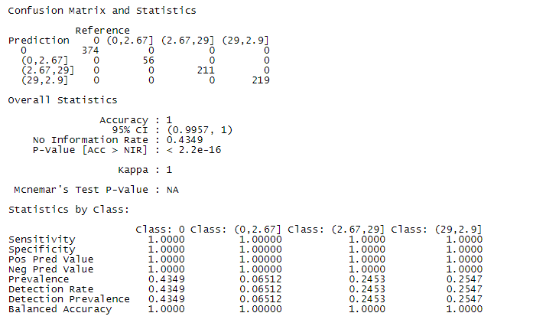

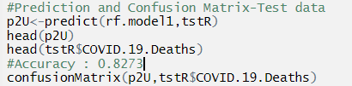

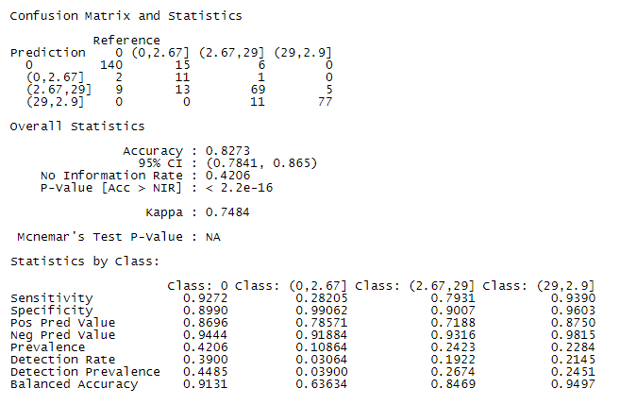

We can see 70 trees have 95 nodes:

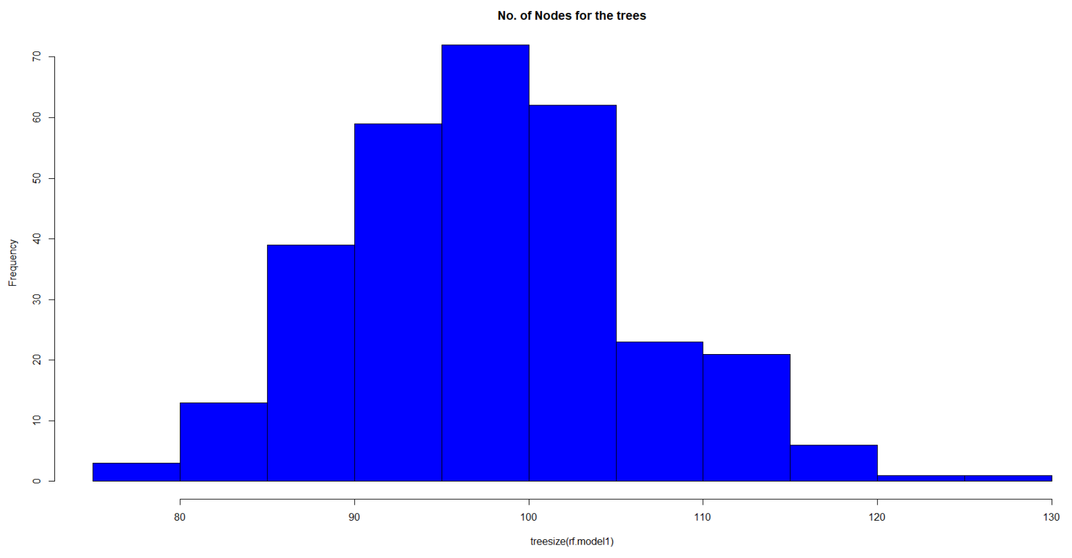

Variable Importance: How worse the model performs without each variable (variable importance). How pure the nodes are at end of the tree without each variable (variable contributions). We can see Sex is not important at all and has lowest contributions.

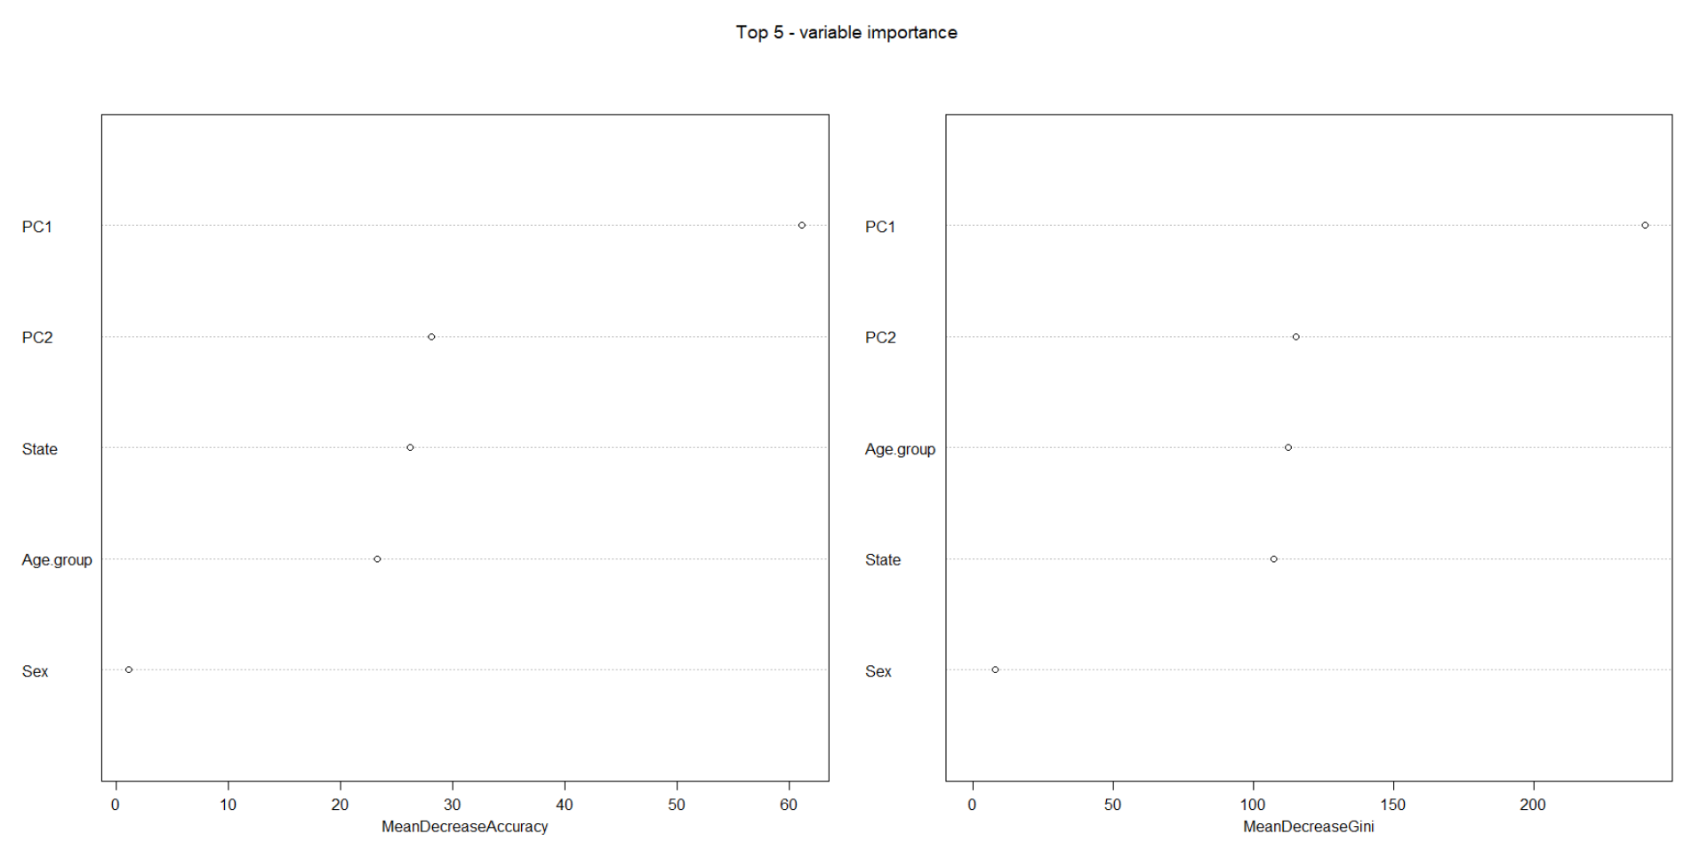

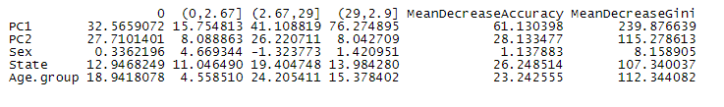

The number of times the variables occurred.

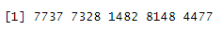

ROC curve: the average AUC area is 0.9403274=94.03274%.





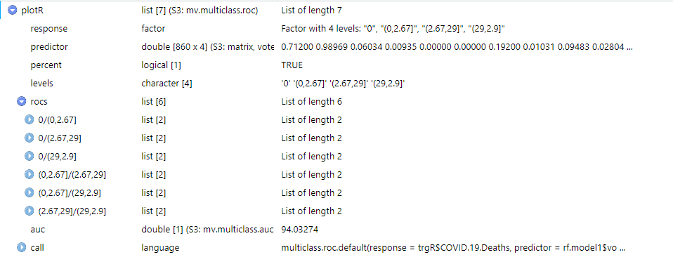

Decision Tree (Non-parametric measure):



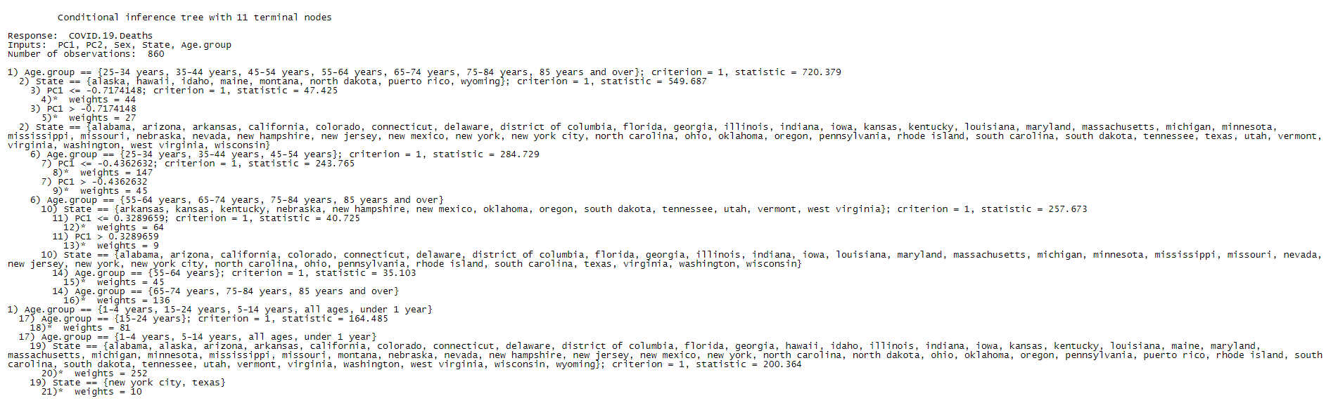

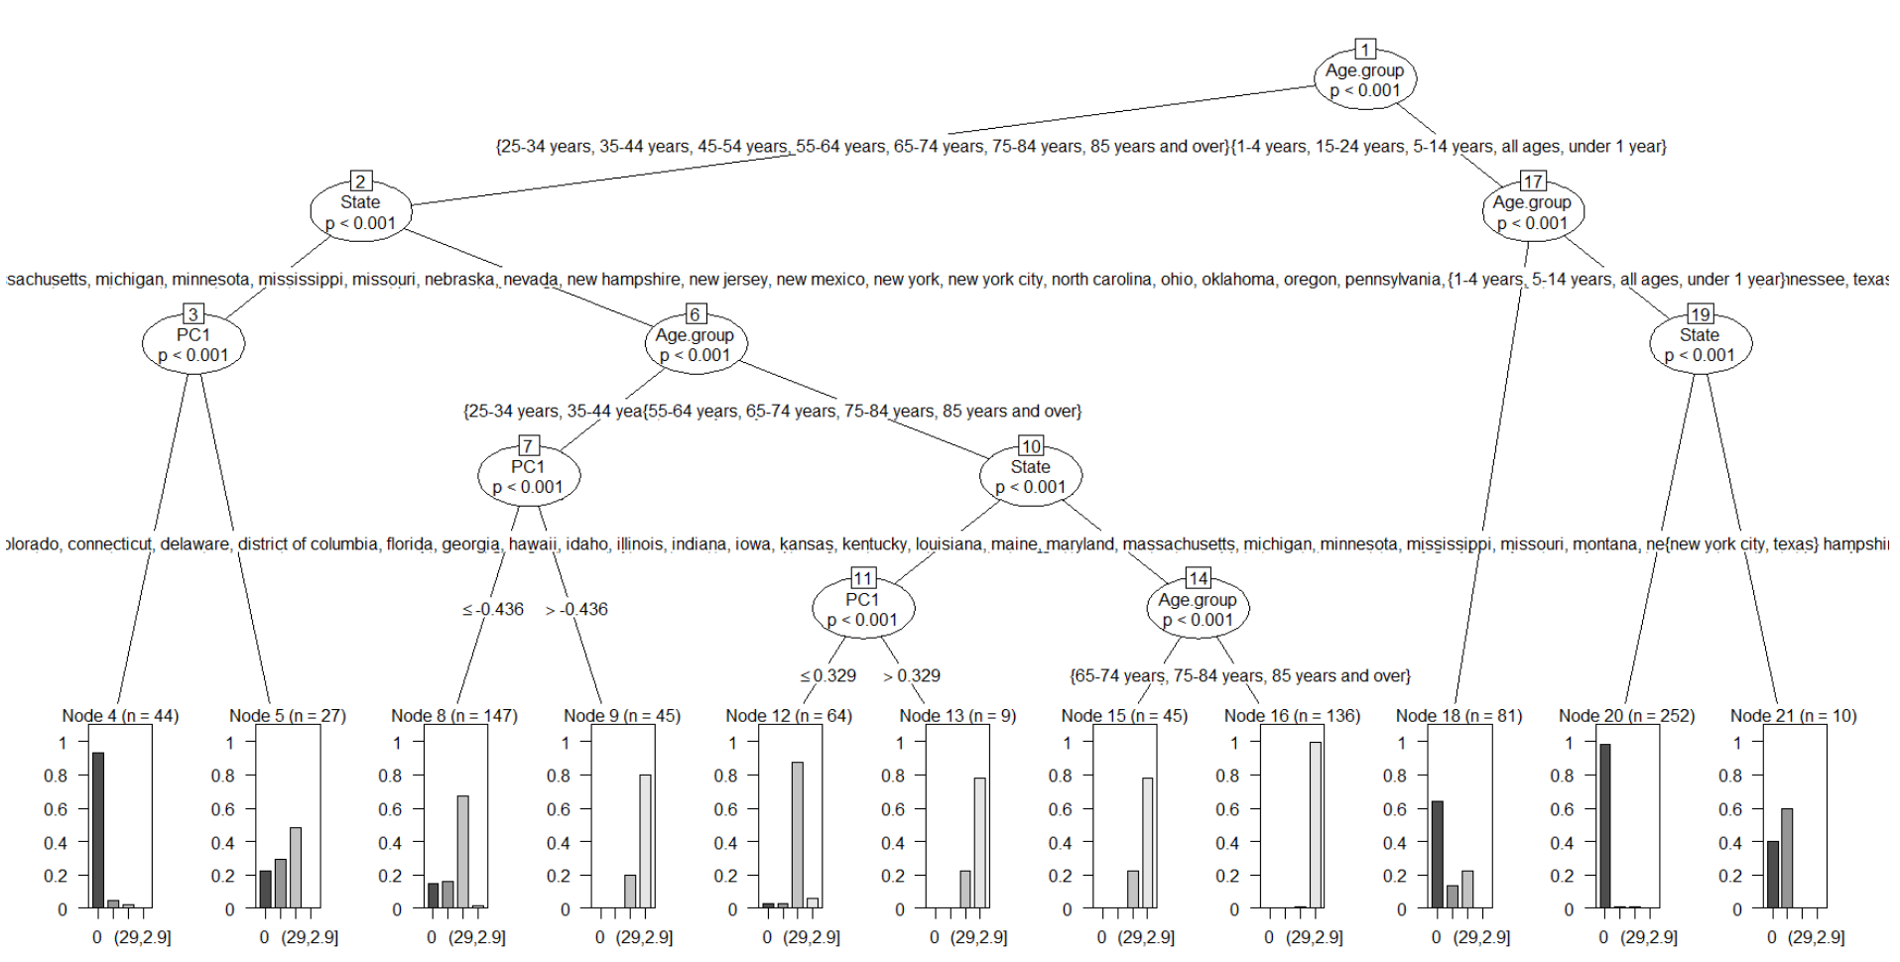

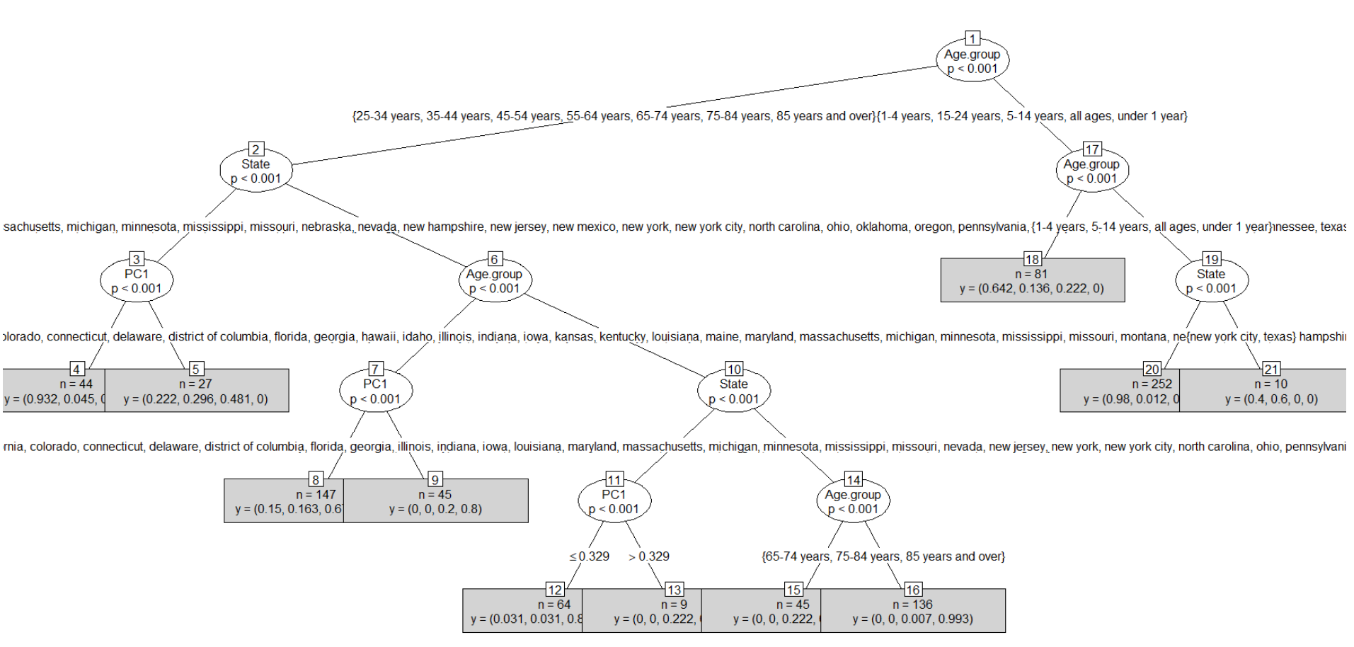

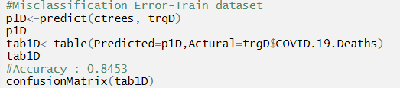

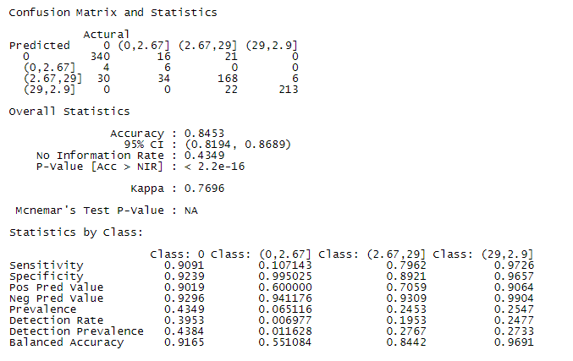

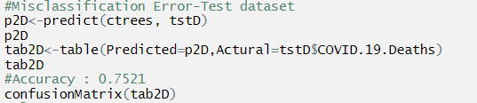

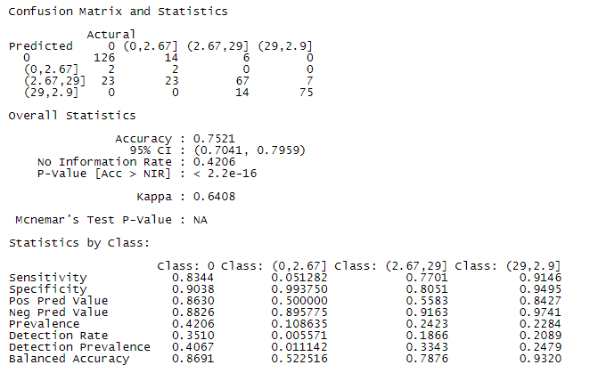

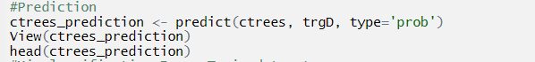



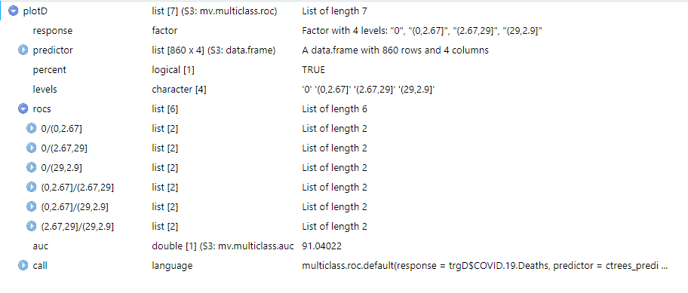

ROC curve: the average AUC area is 0.9104022=91.04022%.

Naive Bayes:

Bayes' theorem: P (A|B) = P (A)*P (B|A)/P (B). Assumption of independence among predictors. All are probability values.



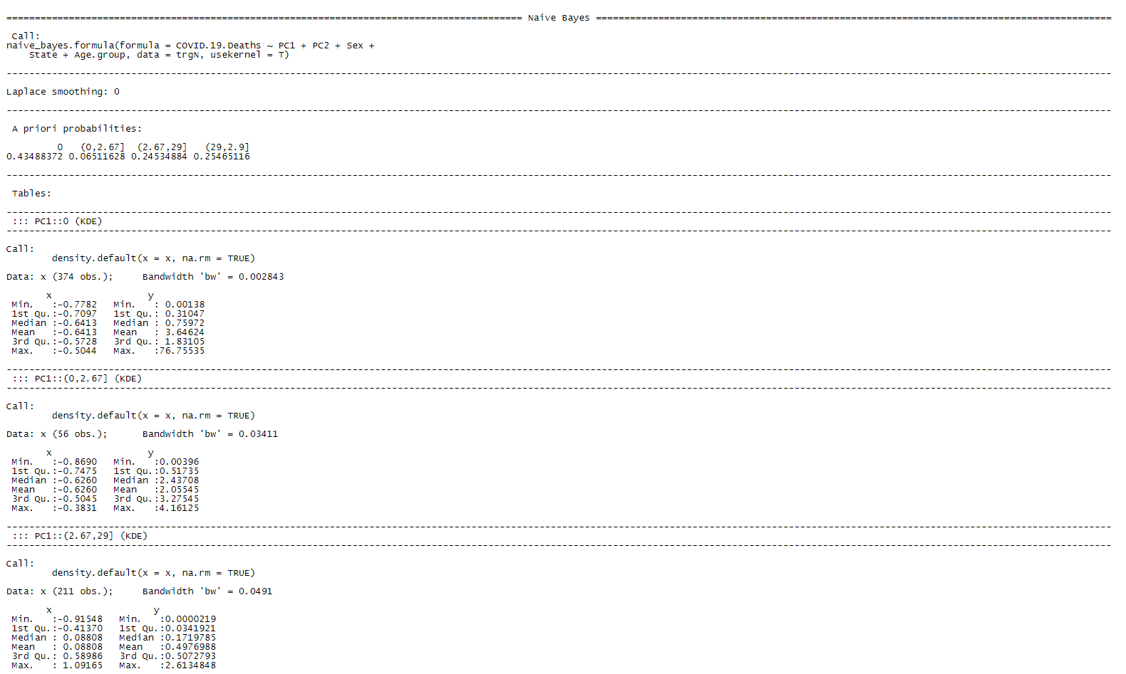

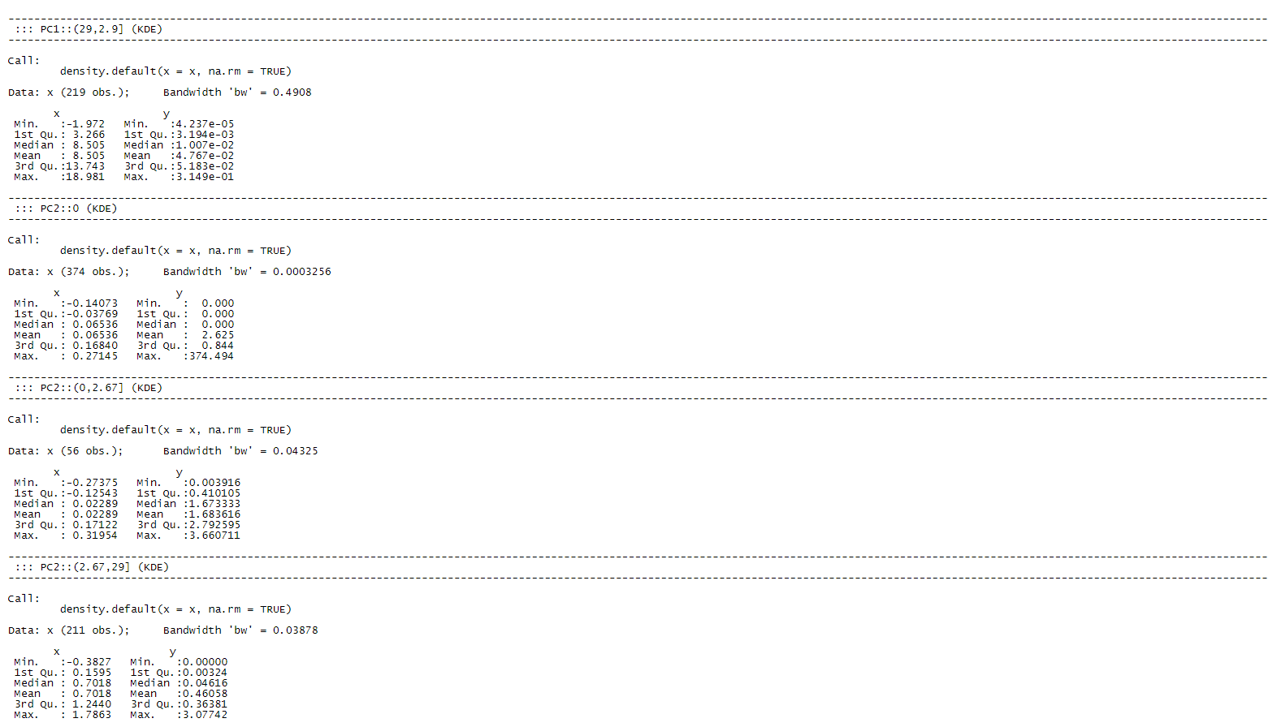

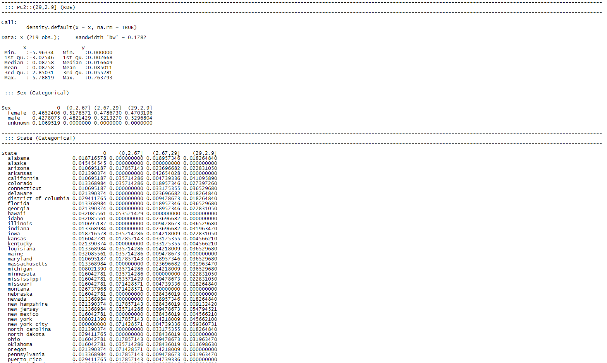

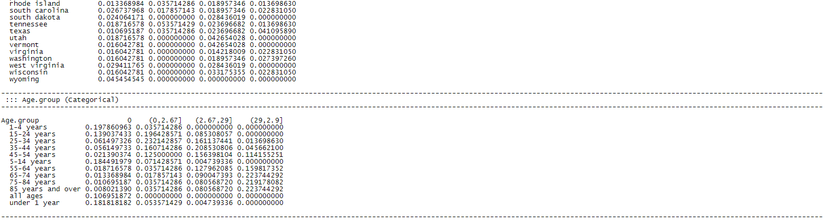

Visualization of Naive Bayes plots of 5 predictors:

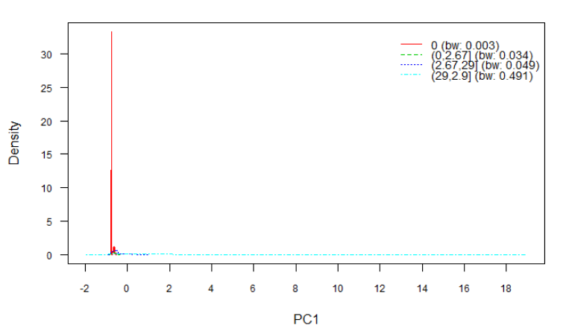

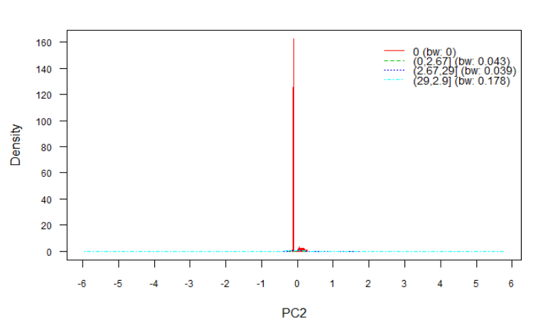

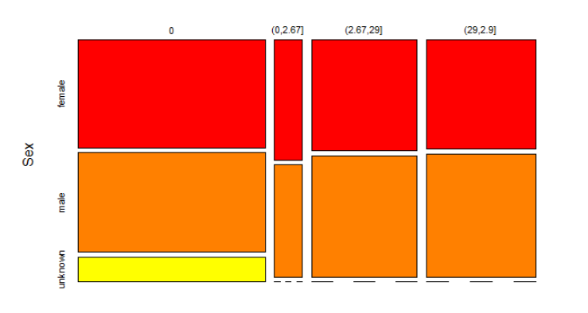

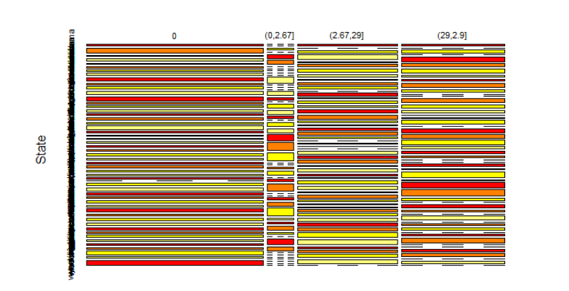

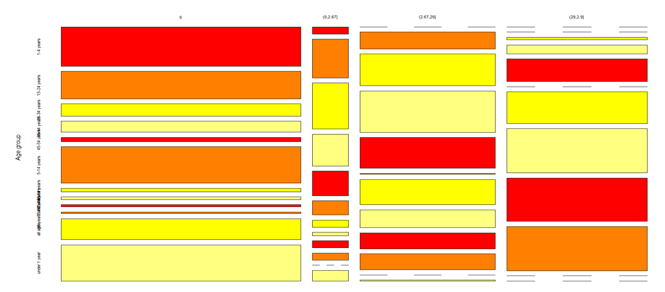

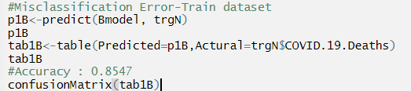

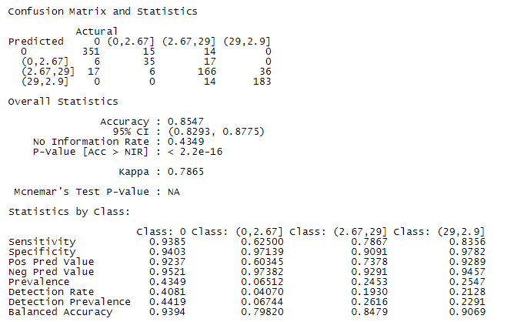

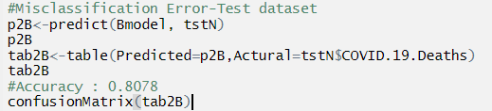

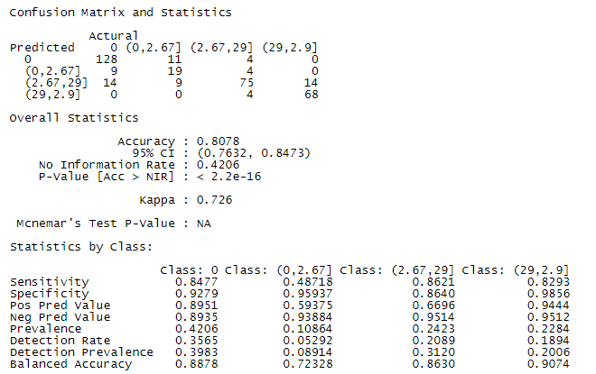

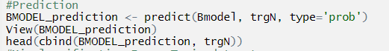



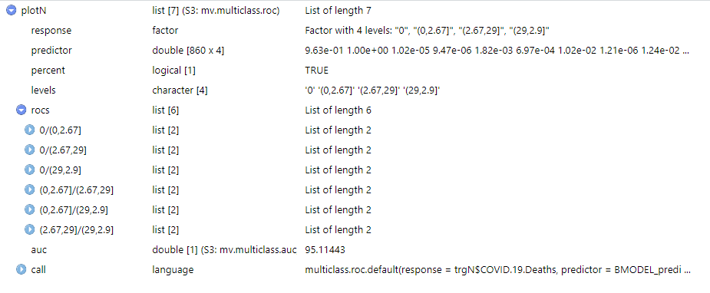

ROC curve: the average AUC area is 0.9511443=95.11443%.

KNN:

KNN is non-parametric method for classification: majority rule used and for regression: average values of all odd k neighbors used.



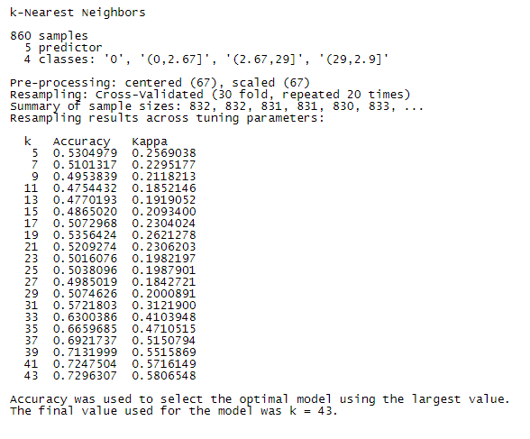

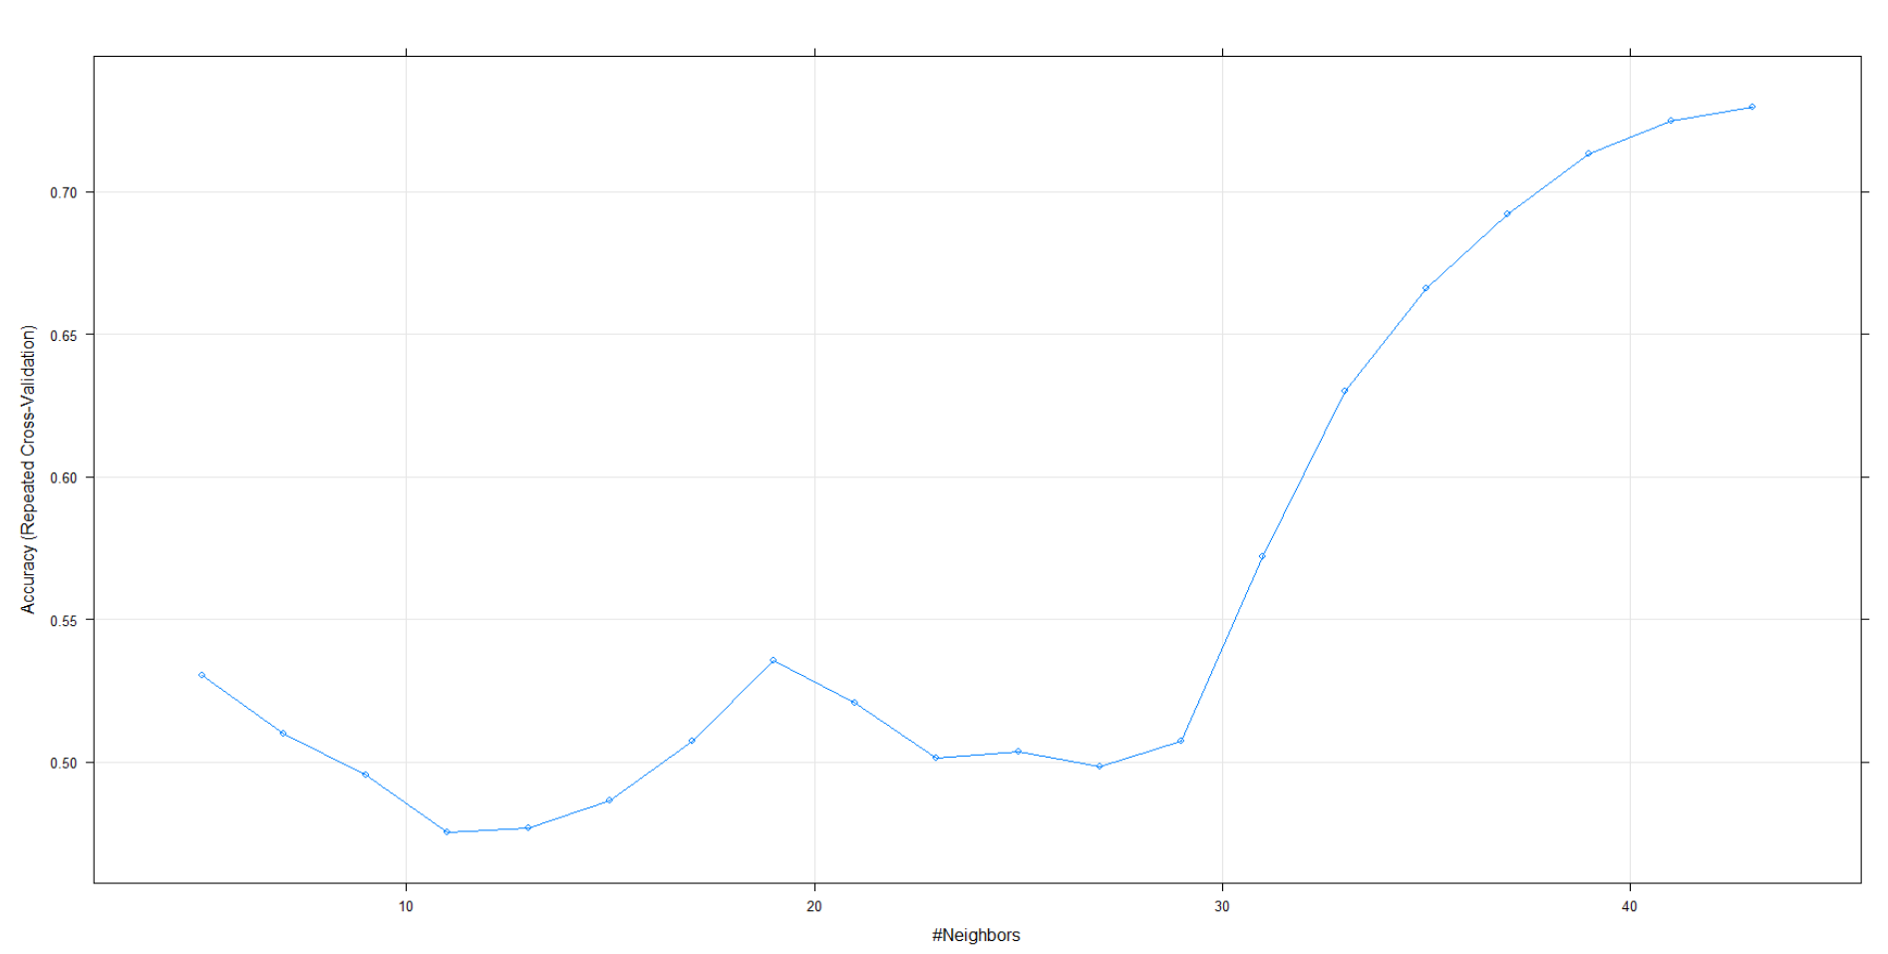



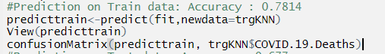

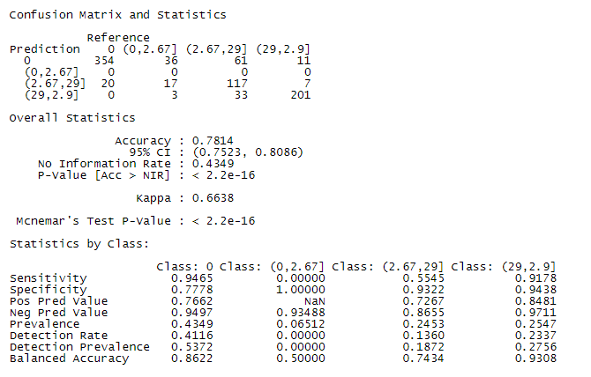

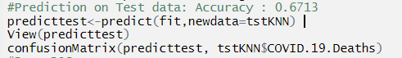

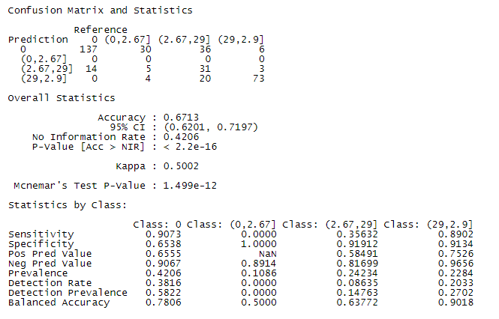



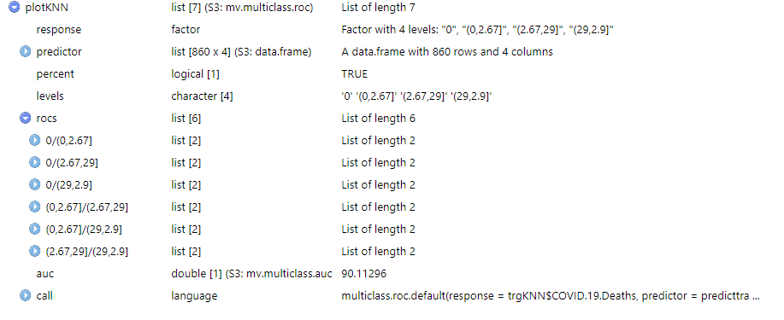

ROC curve: the average AUC area is 0.9011296=90.11296%.

**Unsupervised Classification Methods Analysis:**

K-means Clustering:

We should indicate the number of clusters K. Since COVID.19.Deaths has 4 levels, let's have K = 4 clusters. Computes K prototypes clustering for mixed type data.



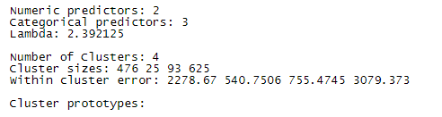

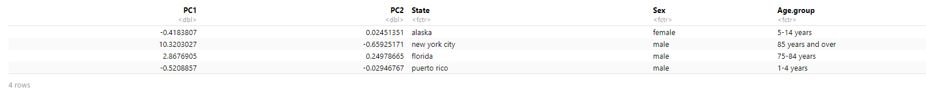

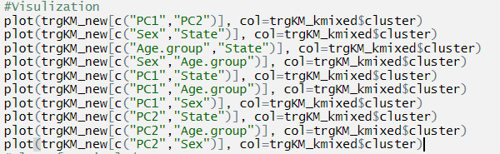

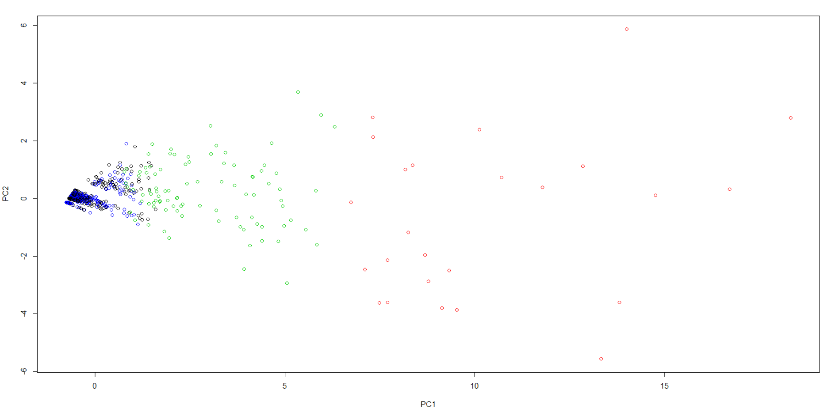

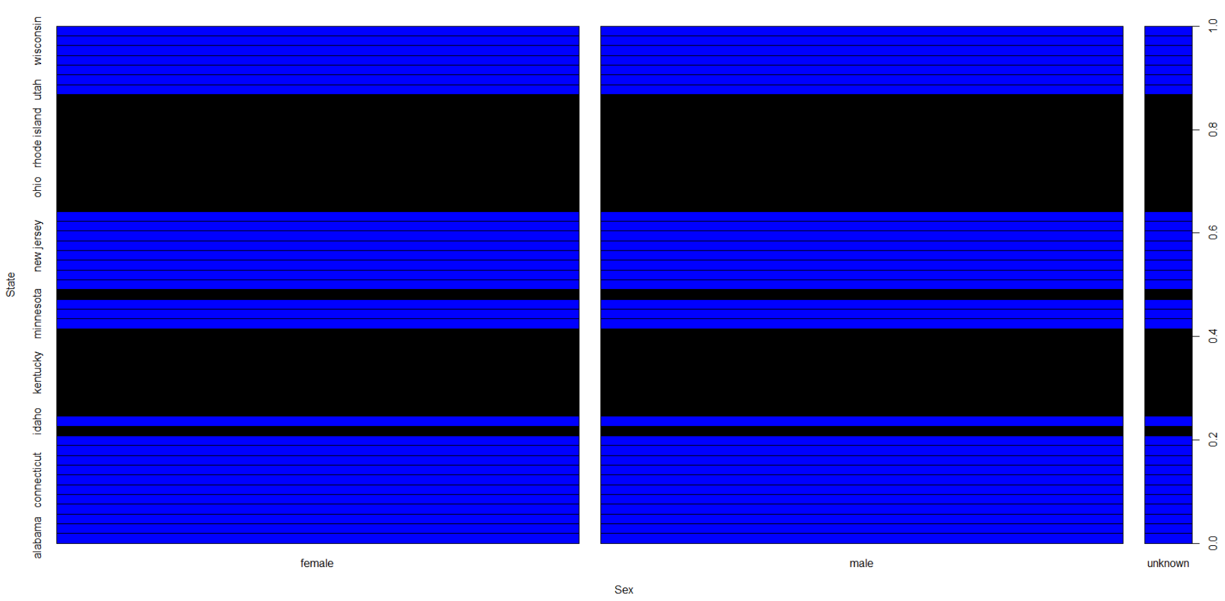

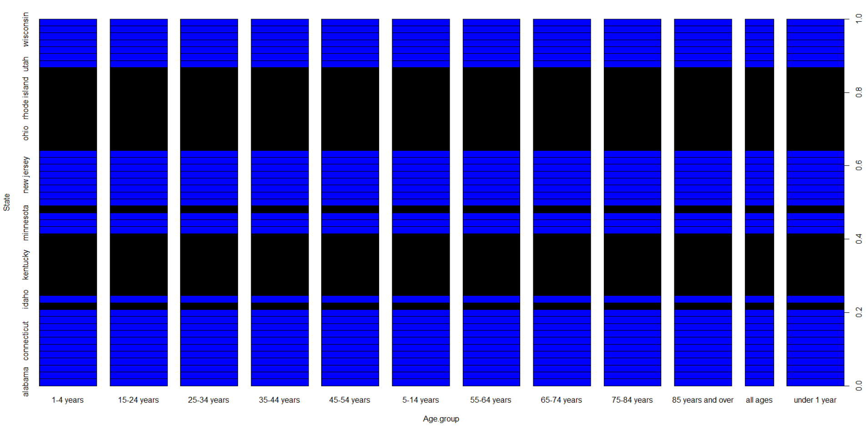

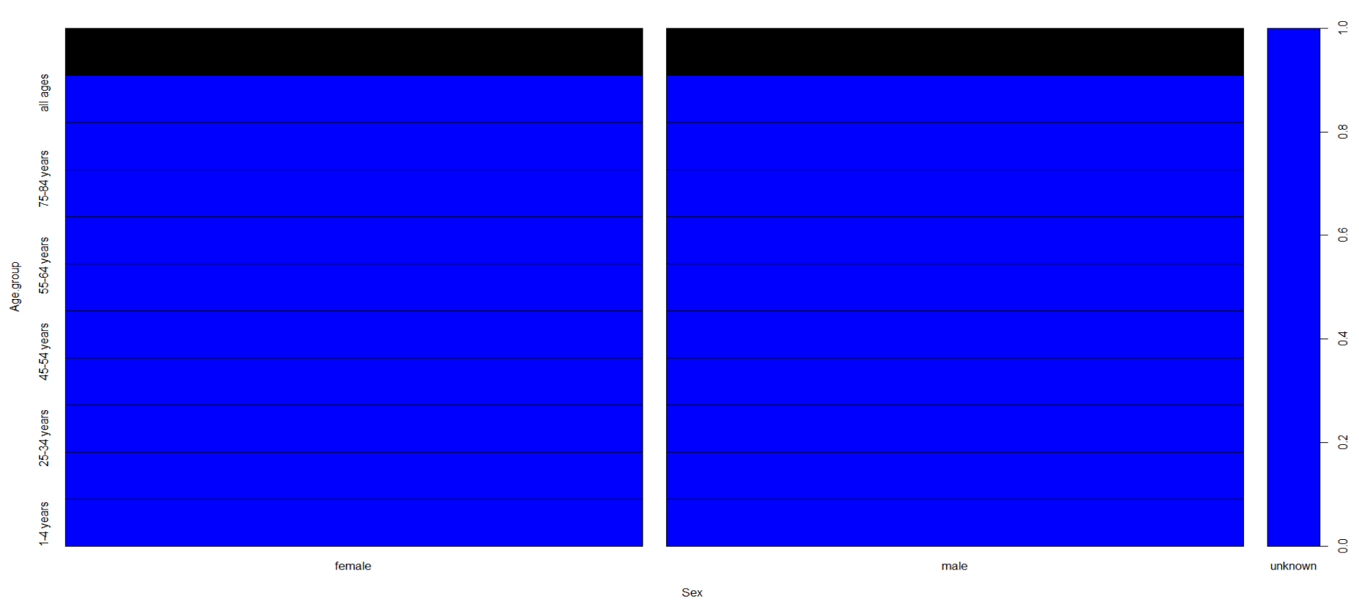

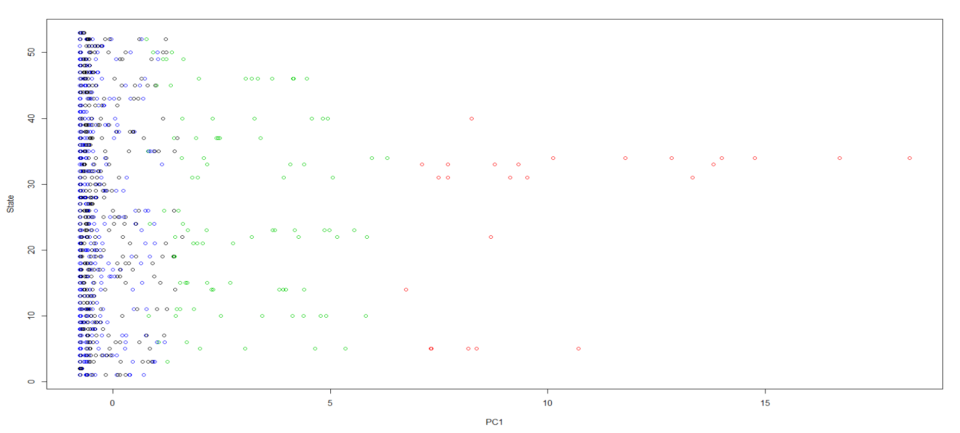

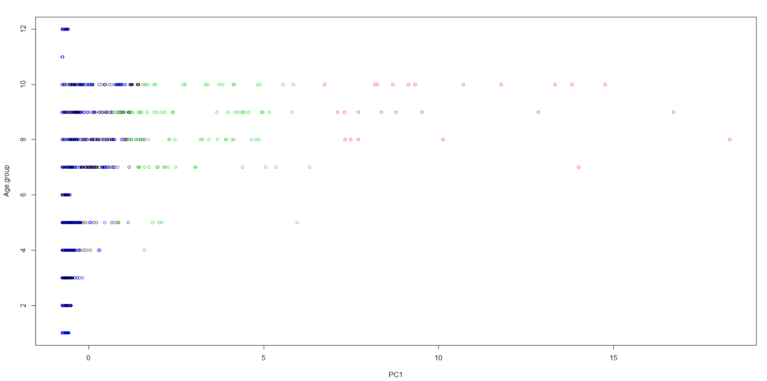

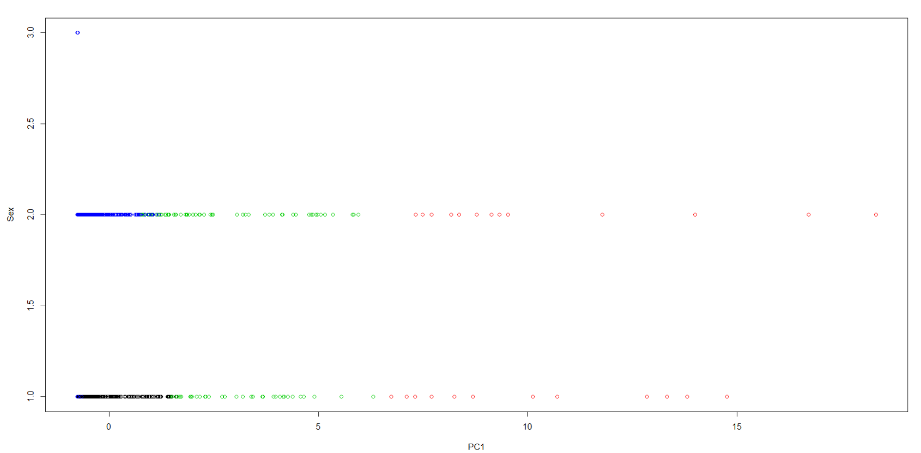

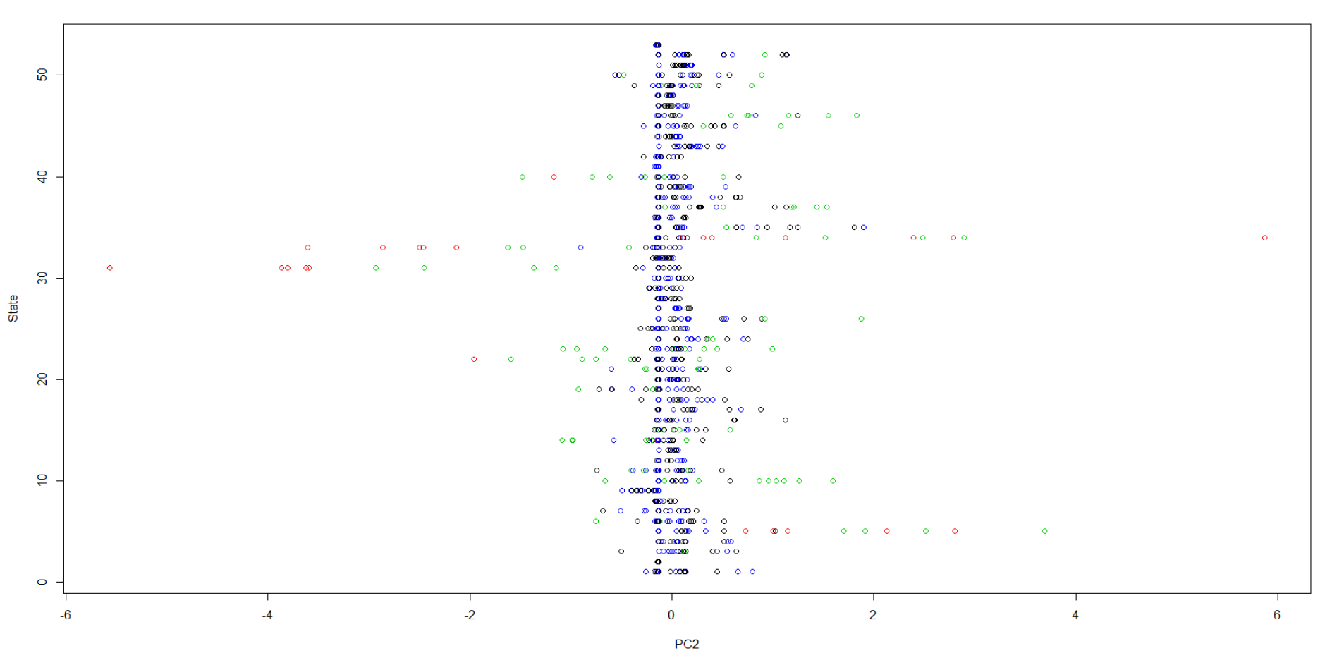

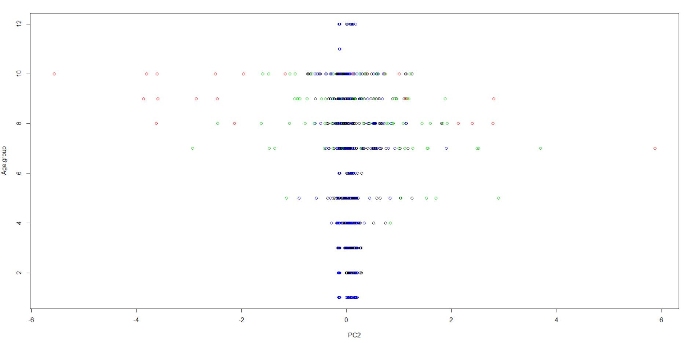

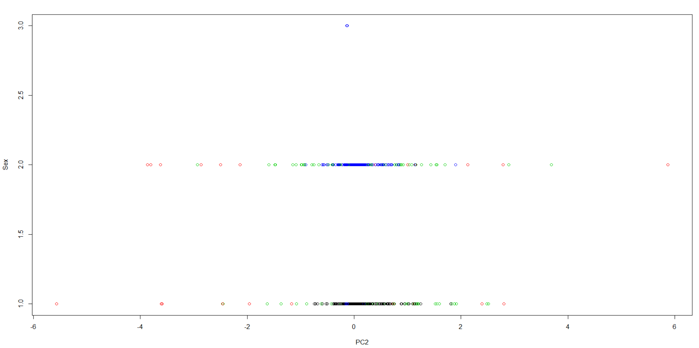

We can compare the predicted clusters with the following COVID-19 Deaths real clusters:

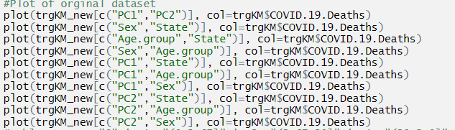

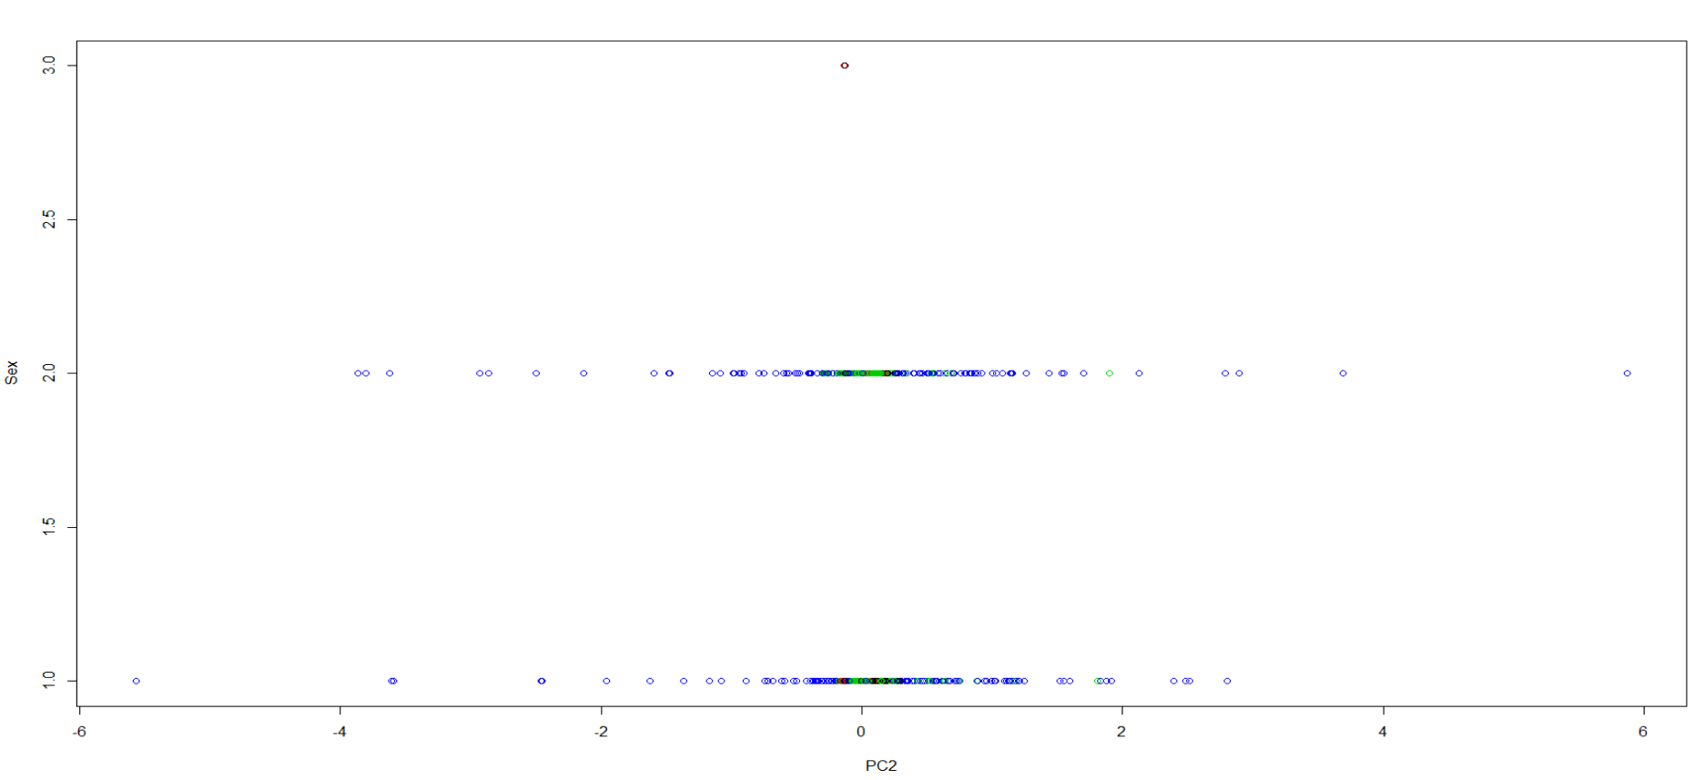

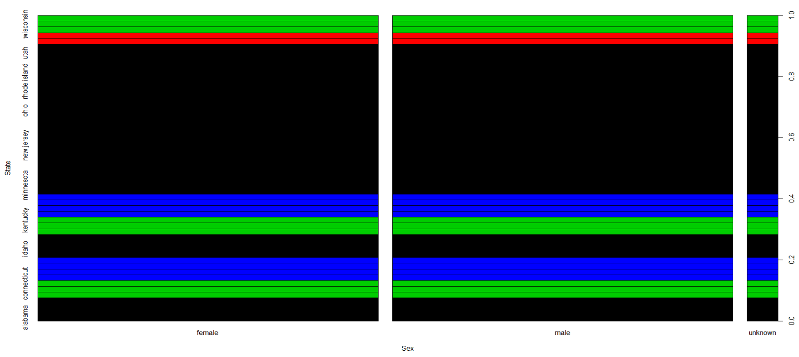

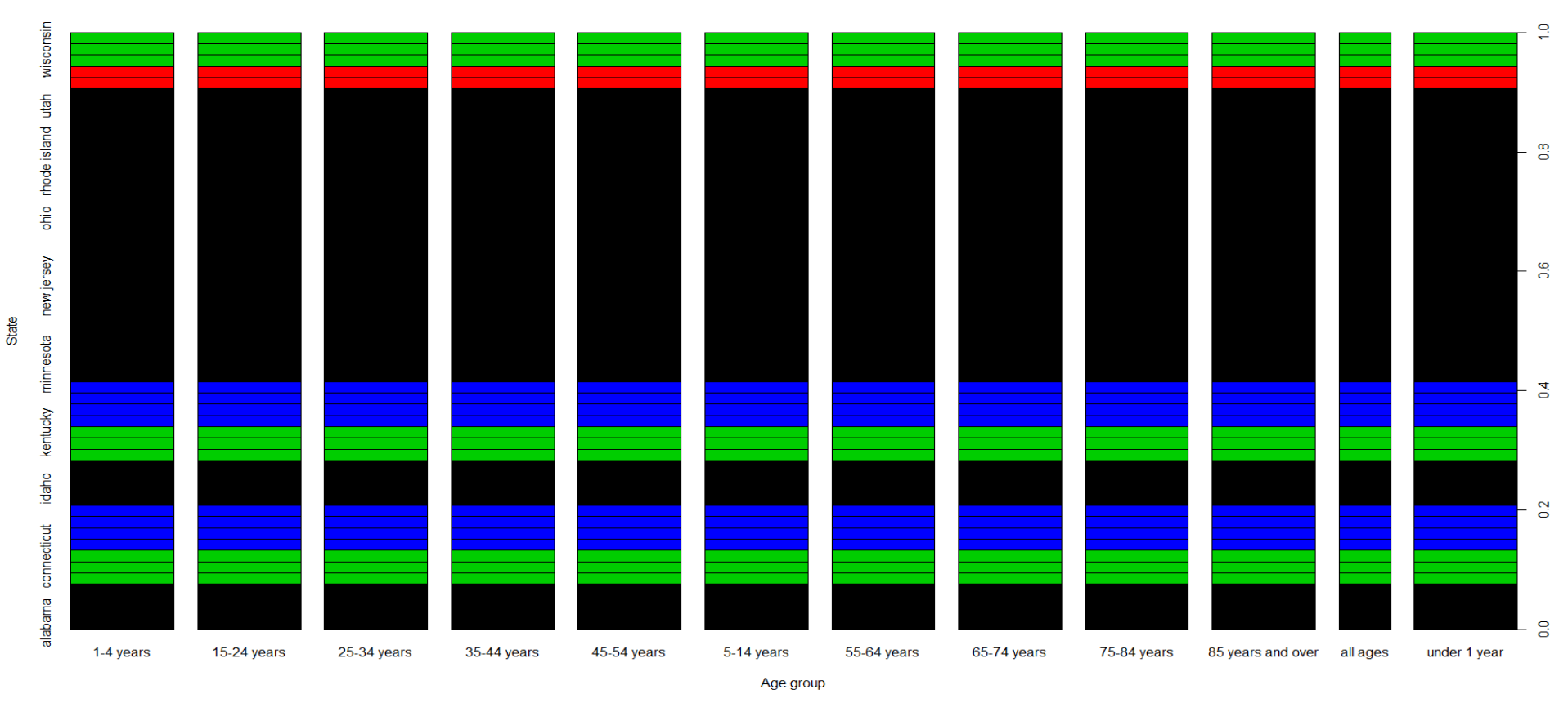

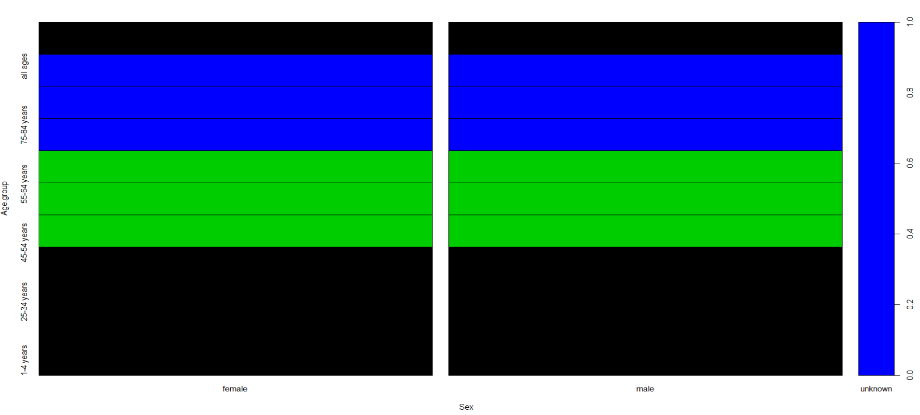

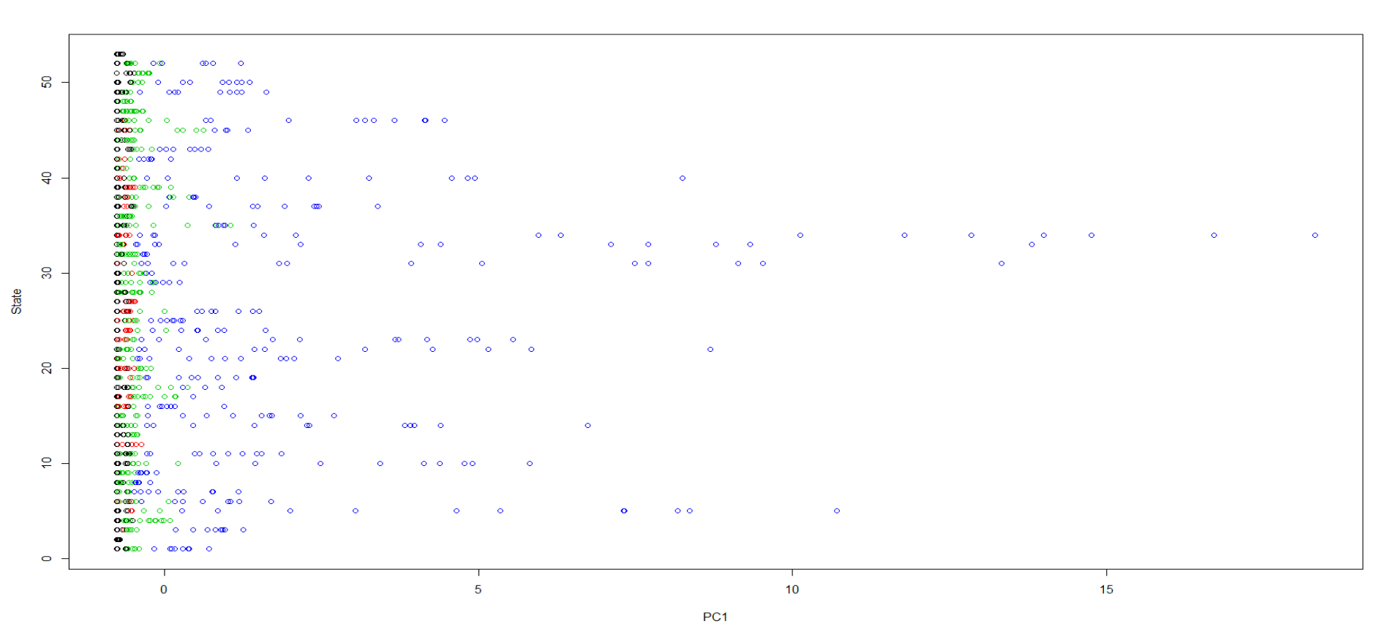

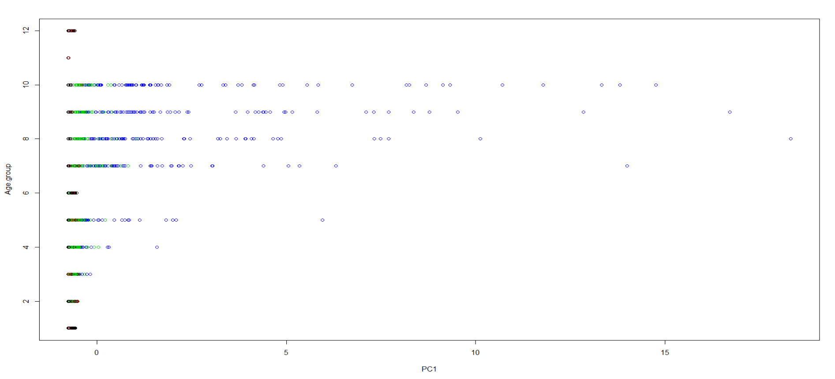

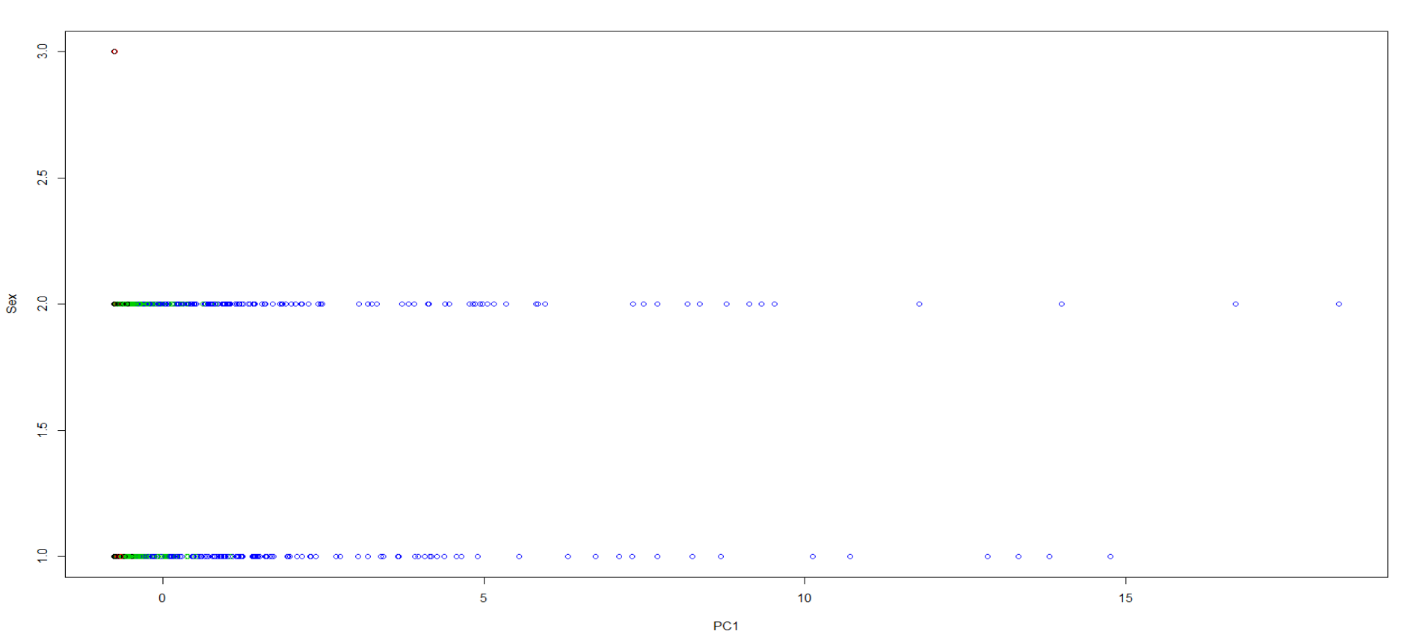

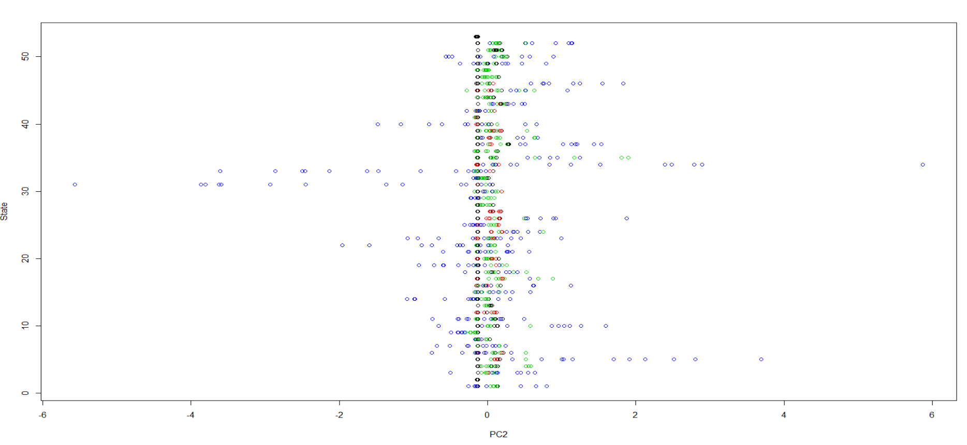

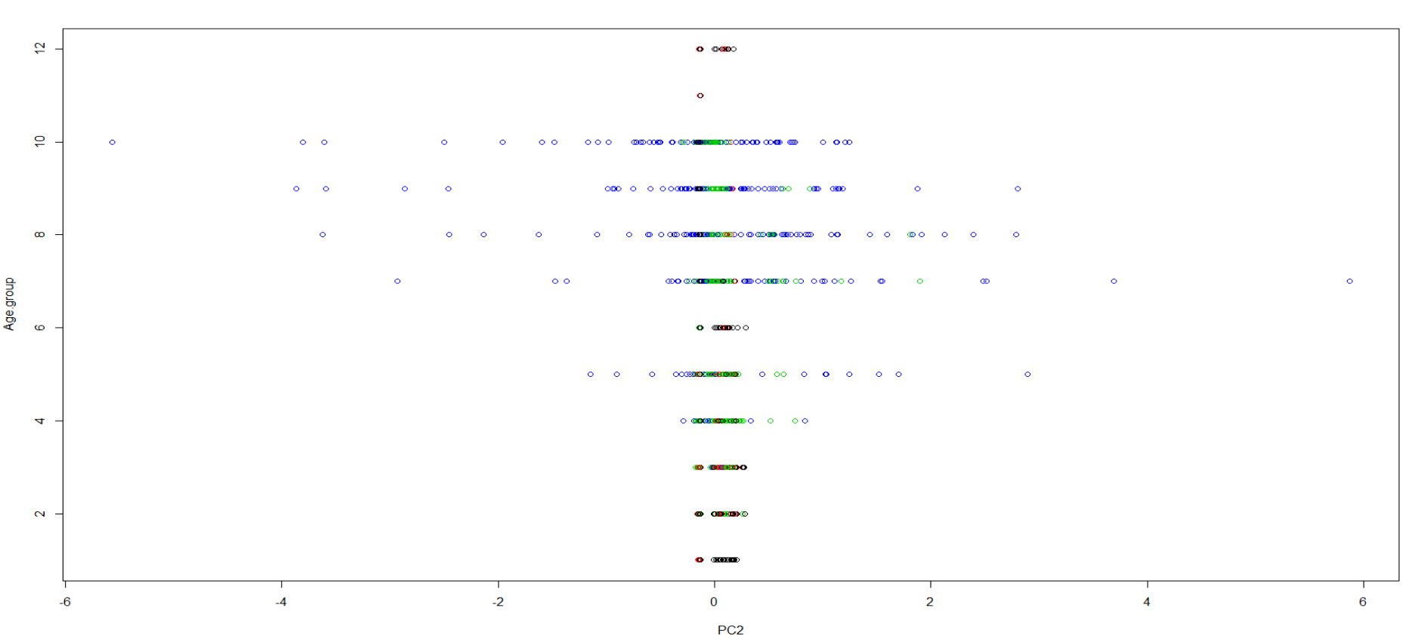

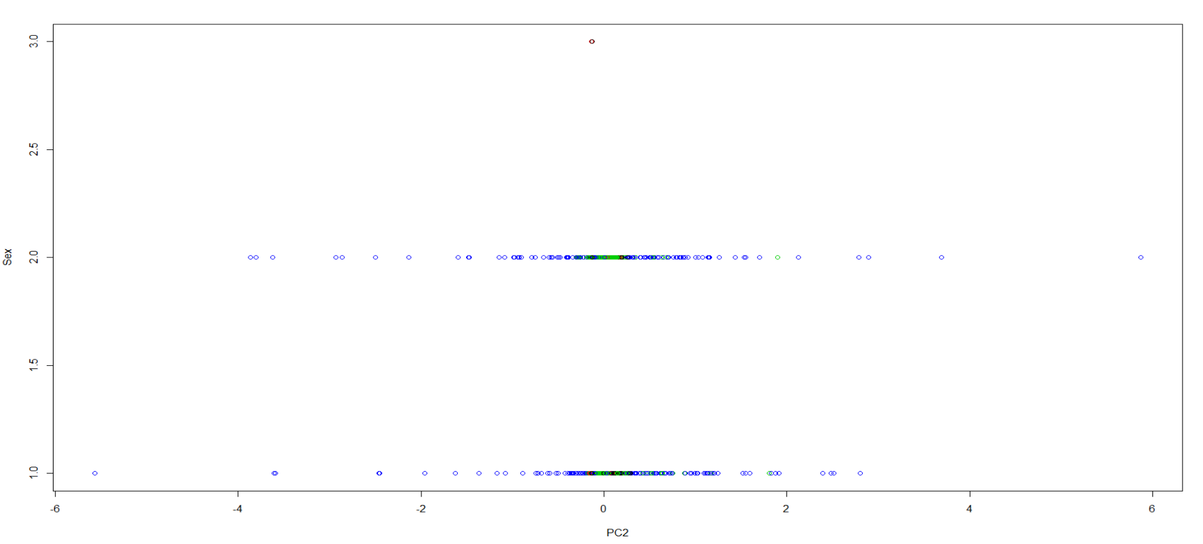



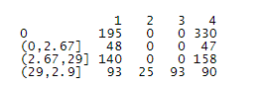

We see the clustering is not good model to do the prediction for this dataset. Because cluster 2 is not assigned to any COVID-19 Deaths level. Cluster 4 has been assigned to 2 levels of COVID-19 Deaths.

Association Rules:

We need to create transactions. The transactions means we need to convert each column into a factor or a logical to ensure that the column takes values only from a fixed dataset.

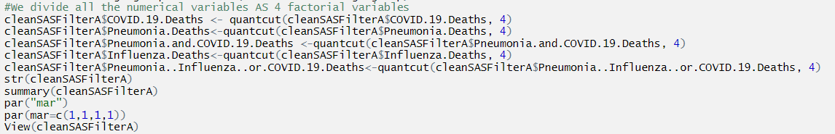



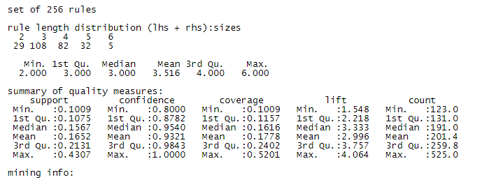





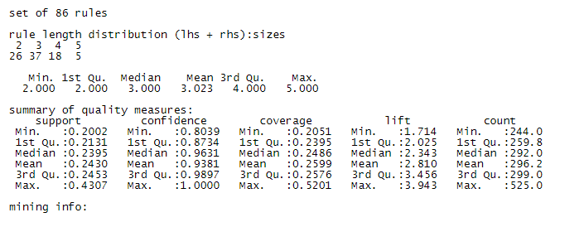





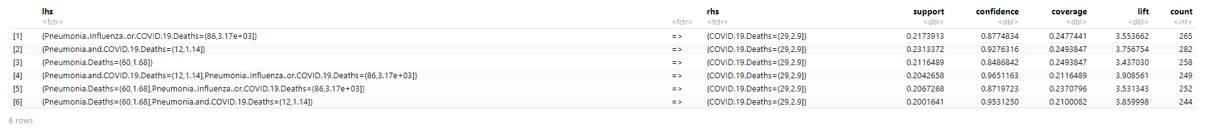

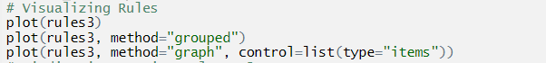

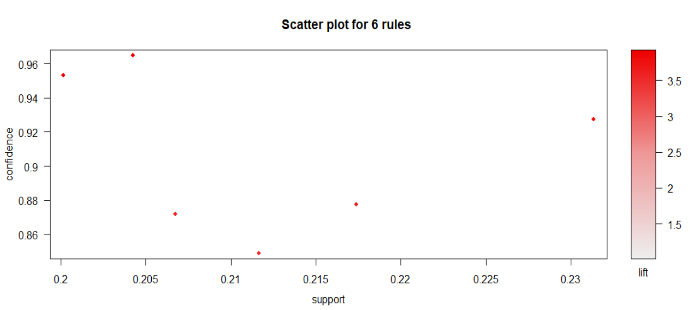

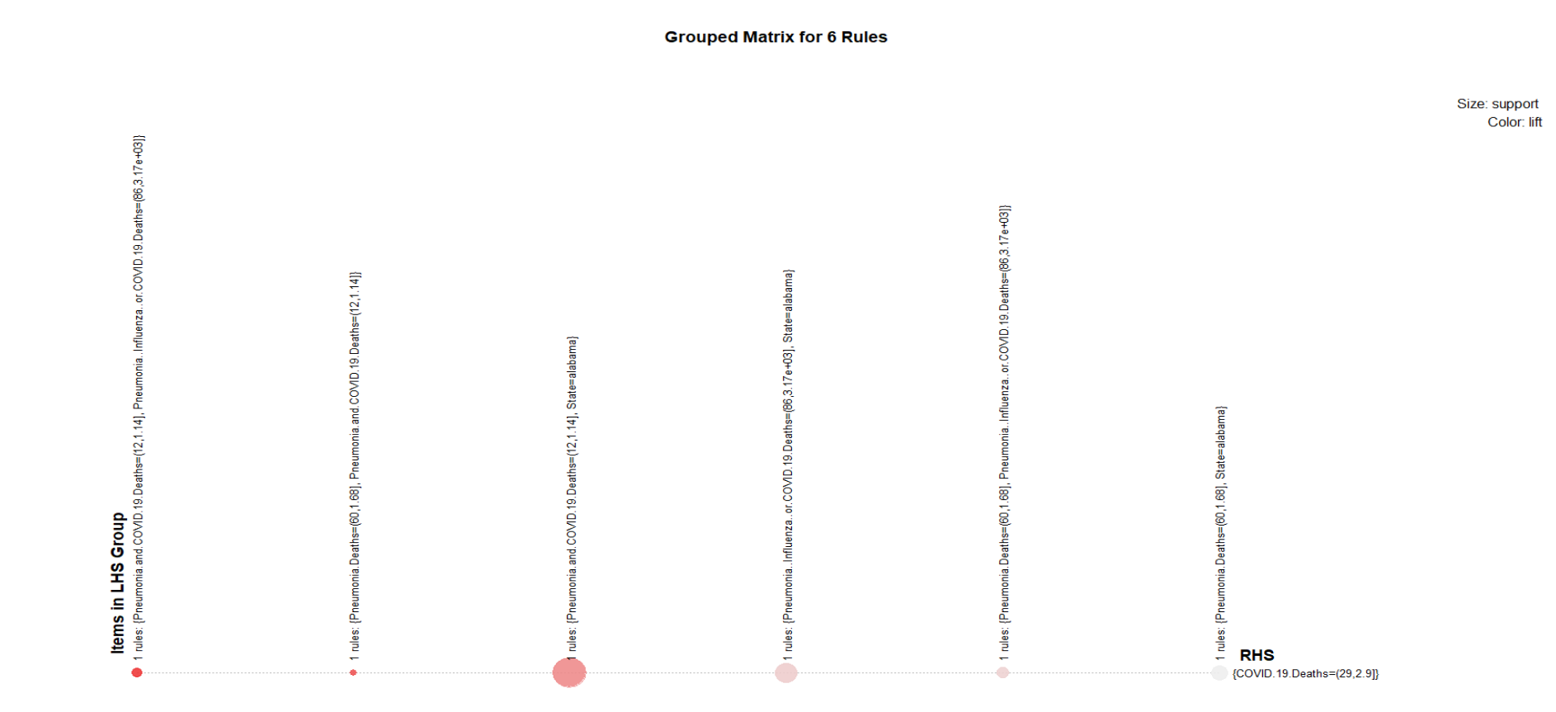

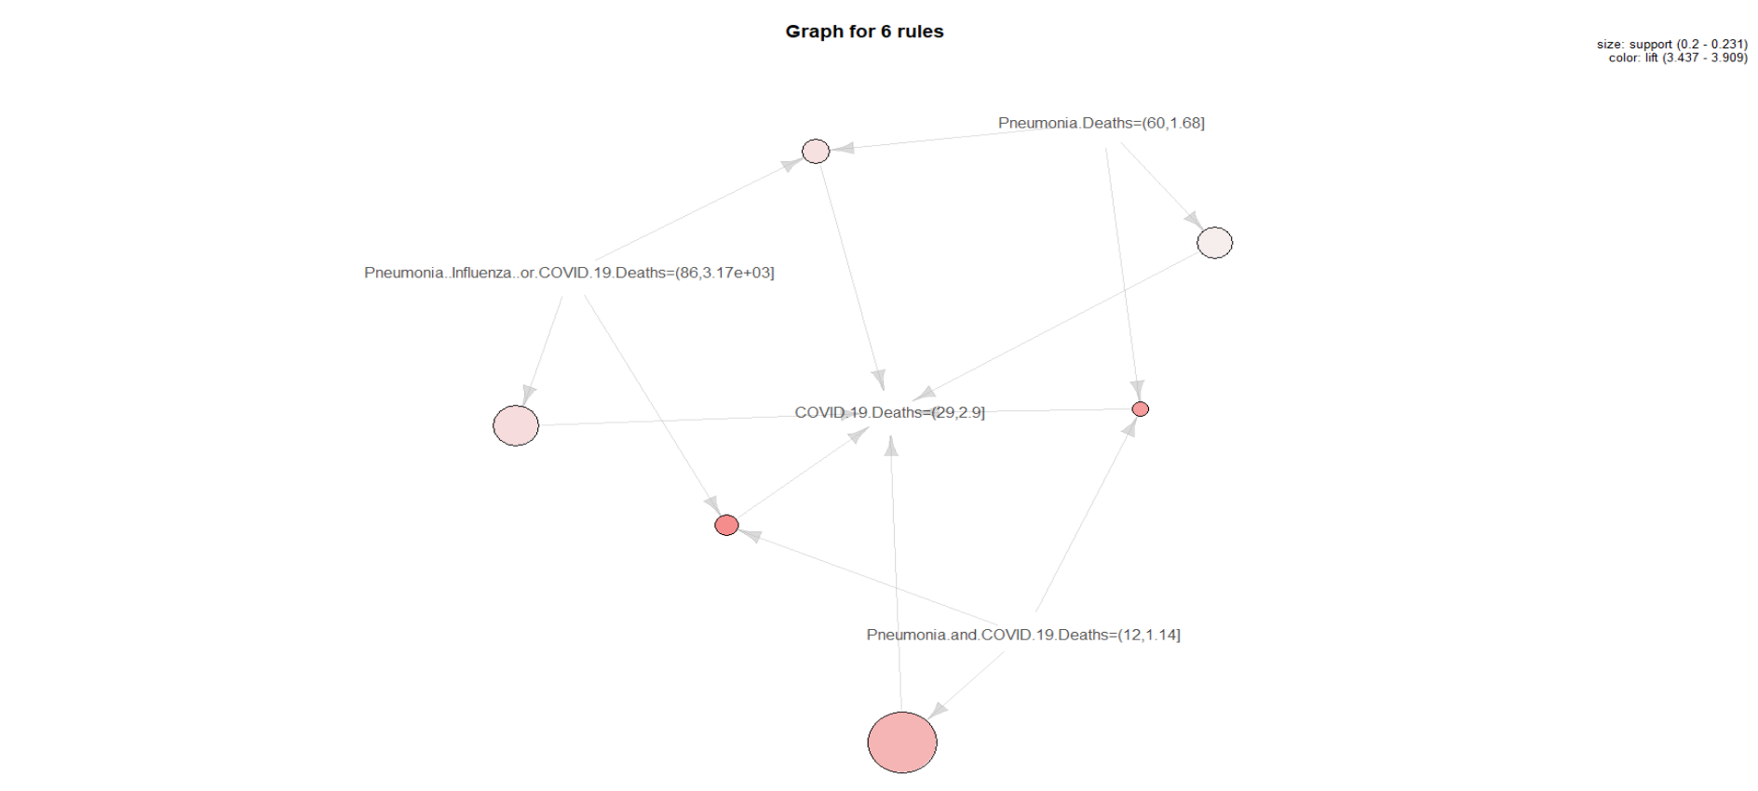



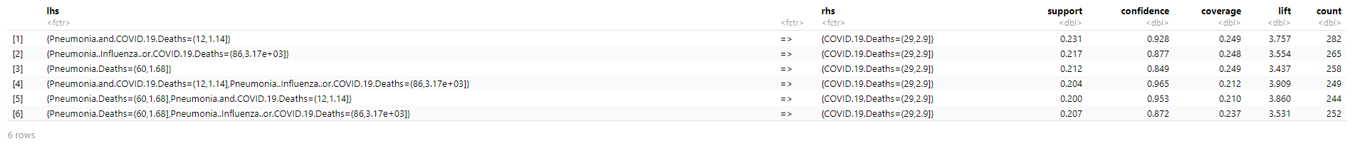

**Step 5: Evaluation Improving**

For Linear Regression Model: Adjusted R-squared is 96.75%. The training model RMSE is 0.02251613 and the error of model is around 2.4%. The training model accuracy is 97.6%. Similarly, the testing model RMSE is 0.03794173 and the error of model is around 4%. The testing model accuracy is 96%. The Linear Regression Model is good but not perfect.

For Classification Model:

- Multinomial Logistic Regression: pseudo R-squared is 90.4401%. The training model accuracy is 95.58%. The testing model accuracy is 83.57%. The overall average area of AUC is 99.27236%.

- Random Forest: The overall model accuracy is 100%-14.3%=85.7%. The model accuracy on training dataset is 100%. The model accuracy on testing dataset is 82.73%. The overall average AUC area is 94.03274%.

- Decision Tree: The model accuracy on training dataset is 84.53%. The model accuracy on testing dataset is 75.21%. The overall average AUC area is 91.04022%.

- Naive Bayes: The model accuracy on training dataset is 85.47%. The model accuracy on testing dataset is 80.78%. The overall average AUC area is 95.11443%.

- KNN: The overall model accuracy is 72.96307% when K=43. The model accuracy on training dataset is 78.14%. The model accuracy on testing dataset is 67.13%. The overall average AUC area is 90.11296%.

We can see the best model is Linear Regression Model. The best classification model is Multinomial Logistic Regression Model.

# Conclusions

From the linear regression, we get New York City with age group of 75-84 has most significant effect on COVID-19 Deaths. The result matches our initial analysis and exploratory analysis part: New York City has both female and male maximum numbers of COVID-19 deaths in age group of 65-74 and 85 and over, respectively.

The Wilcox Rank Sum Test shows variable Sex is not informative to be predicted. The Kruskal-Wallis test shows age group of 85 and over, which P-value (4.097889e-37) is smallest, has the most significant effect to COVID-19 Deaths. Also, the Kruskal-Wallis test shows that the state of New York City, which P-value (2.083535e-09) is smallest, has the most significant effect to COVID-19 Deaths. The results totally match our initial analysis and exploratory analysis part: For all sexes in USA, the older the people, the higher number of deaths in COVID-19. New York City has both female and male maximum numbers of COVID-19 deaths. The Friedman test is a lower power test to be applied and it shows all COVID-19 DEATHS, Pneumonia Deaths and Influenza Deaths have same distributed data for all age groups. COVID-19 DEATHS, Pneumonia Deaths and Influenza Deaths have strong correlations. This result has been matched that multicollinearity does exist among numeric variables in our initial analysis and exploratory analysis part.

Binomial Logistic Regression gives us the proof that Sex is not informative to be predicted as The Wilcox Rank Sum Test has. Multinomial Logistic Regression Model is the best classification model to predict COVID-19 Deaths as 4 factor levels. It gives us the highest accuracy.

K-means Clustering is not a good model to do 4 clusters classification for COVID-19 Deaths. Because cluster 2 is not assigned to any COVID-19 Deaths level. Cluster 4 has been assigned to 2 levels of COVID-19 Deaths.

Association Rules shows to get highest COVID-19 Deaths, male of age of 85 and over from New York City has the same 6 rules as just simply to get highest COVID-19 Deaths with default lhs. It means male of age of 85 and over from New York City has association with highest number of COVID-19 Deaths.

# Reference

<https://www.youtube.com/watch?v=NMffLbFql5k>

<https://courses.ryerson.ca/d2l/le/content/374818/Home>

<https://en.wikipedia.org/wiki/COVID-19_pandemic>

<https://en.wikipedia.org/wiki/COVID-19_pandemic_in_the_United_States>

<https://catalog.data.gov/dataset/provisional-covid-19-death-counts-by-sex-age-and-state>

<https://catalog.data.gov/dataset/provisional-covid-19-death-counts-by-sex-age-and-state>

<https://www.doh.wa.gov/Emergencies/Coronavirus>

<https://catalog.data.gov/dataset/covid-19-daily-dph-reports-library/resource/fadf2d86-72b2-4cfc-8ad2-db1e1ce19d0b>

<https://www.bloomberg.com/opinion/articles/2020-05-07/comparing-coronavirus-deaths-by-age-with-flu-driving-fatalities>

<https://www.worldometers.info/coronavirus/coronavirus-age-sex-demographics/>

<https://data.cdc.gov/NCHS/Provisional-COVID-19-Death-Counts-by-Sex-Age-and-S/9bhg-hcku>

<https://www.cdc.gov/nchs/nvss/vsrr/covid_weekly/index.htm>

<https://stats.idre.ucla.edu/r/dae/multinomial-logistic-regression/>

<https://www.analytics-tuts.com/association-rules-in-r/>